

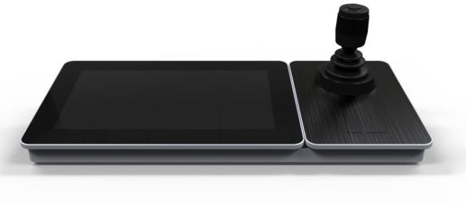



**HKB-1600KI**

**Network Keybord**

# Overview

HKB-1600KI is the new generation of fully touch-enabled and detachable network keyboard independently developed by Hikvision. In addition to displaying images, the 10.1" capacitive touchscreen supports DVI and HDMI video output. It runs on Android and has the brand new UI interaction design. It also supports all series of front-end and back-end devices of Hikvision, as well as control center devices such as video management platform (VMS). It has open settings of the monitoring point number, and users can arrange the numbers freely as needed. In application, users can call the numbers quickly to display the video on the video wall, or output videos to the touchscreen or external displays. It supports recording, picture capturing and two-way audio, as well as the screen control and scene switch of VMS and decoding device. The 4-axis joystick can be used to the PTZ control to locate the target quickly. The joystick panel is detachable for the convenience of user operation. This keyboard can be widely used in public security and finance and other fields.

# Module

HKB-1600KI

# Main Features

* 10.1" capacitive touchscreen;
* Detachable design of the touchscreen and joystick;
* Wired and WiFi network connection;
* POE power supply;
* Capable of decoding 2-ch at 1080P decoding; up to 16-division window display;
* Live view on touch panel;
* DVI and HDMI output to monitor;
* Controllable of 2000 devices;
* Access to Hikvision products including DVR, DVS, NVR, network camera, speed dome, etc.;
* Control of MVC and decoders for video decoding and output on video wall;
* PTZ control, setting and calling preset, patrol and pattern;
* Support upgrade and configuration files import/export by USB flash disk;
* Support recording and picture capturing; saving files in USB flash disk or uploading to FTP server;
* Two-level user authority and up to 16 user accounts are configurable: one admin and 15 operators.

# Typical Application

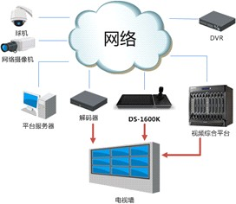

Network

DVR

IPC

Decoding Device DS-1600KI

Platform Server

VMS

Video Wall

IP Dome

**Specification**

|  |  |
| --- | --- |
| **Model** | **HKB-1600KI** |
| **Operating System** | Android 4.4 |
| **TFT LCD Screen** | 10.1" TFT LCD touchscreen |
| Resolution: 1024 × 600 |
| **Joystick** | 4-axis joystick |
| **Local Decoding** | Local live view at  1080P/720P/HD1/BCIF/CIF/QCIF resolution, and up to 16-division window display |
| **Two-way Audio**  **Input** | 1-ch, 3.5mm connector  (2.0Vp-p, >1kΩ) |
| **Audio Output** | 1-ch, 3.5mm connector (2.0 Vp-p, 600 Ω) |
| **Network Interface** | 10M/100M/1000M Adaptive Ethernet port |
| **WiFi** | Supported |
| **USB Interface** | USB 2.0 × 2 |
| **Video Interface** | HDMI, DVI |
| **Power Supply** | 12V DC /POE |
| **Consumption** | ≤15W |
| **Working**  **Temperature** | -10°C --＋55°C |
| **Working Humidity** | 10％--90％ |
| **Dimensions**  **(W × D × H)** | 404 × 180 × 163 mm |
| **Weight** | 1.7 Kg |