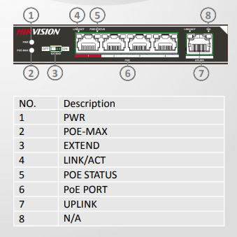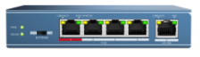

**Features**

• **IEEE 802.3at and IEEE 802.3af Power over Ethernet (PoE) compliant**

**• 4 x 10/100Mbps Auto-MDIX PoE ports**

**• Provides up to 30 watts per PoE port**

**• PoE power budget 58W**

**• 4 kV surge protection for PoE ports**

**• IEEE 802.3x flow control support**

**• Plug-and-play installation**

**• 1 Gbps switching fabric**

**• 448 Kbits RAM Data Buffer**

**• 1K MAC address entries**

**• Sturdy metal enclosure**

**HPE-0105 is an 4 10/100Mbps ports unmanaged switch that requires no configuration and provides 4 PoE (Power over Ethernet) ports. It can automatically detect and supply power with all IEEE 802.3af/at compliant Powered Devices (PDs). In this situation, the electrical power is transmitted along with data in one single cable allowing you to expand your network to where there are no power lines or outlets, where you wish to fix devices such as IP Cameras or IP Phones, etc.**

**Overview**

**HPE-0105**

**4 Port PoE + 1-port Gigabit Switch**

|  |  |
| --- | --- |
| **Specifications** | |
| ***Ports*** | |
| Network Ports | 5 |
| PoE Ports | 4, 10/100Mbps RJ45 ports |
| Uplink Port | 1, 100M Ethernet Port |
| ***Standard*** | |
| Network Protocol | IEEE802.3,802.3u,802.3x, 802.3af, 802.3at |
| ***Performance*** | |
| Switching Capacity | 1Gbps |
| Max Forwarding Rate | 0.75Mpps |
| High Priority Ports | Port 1 |
| Forwarding Mode | Store-and-forward |
| MAC Address Table | 1k |
| Flow Control | IEEE802.3x full duplex |
| ***Power Over Ethernet*** | |
| PoE Standard | IEEE802.3af, IEEE802.3at |
| PoE Power Budget | 58W |
| Working Mode | Extend On:250m,10M,CAT 5e  Extend Off:100m |
| ***General*** | |
| Power Supply | 51V DC, 1.25A |
| Power Consumption | ≤63W |
| Surge Protection | 4KV |
| Working Temperature | Temperature: 0℃-40℃ |
| Working Humidity | Humidity: 10%-90% , non-condensing |
| Storage Temperature | Temperature: -40℃-70℃ |
| Storage Humidity | Humidity: 5%-90% , non-condensing |
| Weight | 0.299kg |
| Dimension | 132 mm* 93.3mm * 27.6mm |