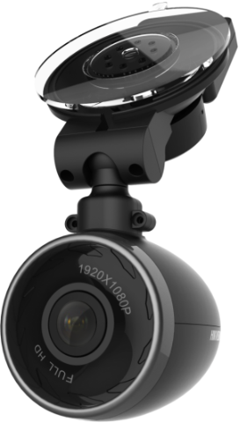

**• Up to 1080P full HD camera, wide field angle up to 135°(diagonal)**

**• Support built-in MIC and speaker for audio in and out**

**• Built-in WIFI module and WIFI AP function supported**

**• Built-in G-Sensor module, support video recording linkage at car crash or strong vibration (Linkage**

**video record can be configured be no-overwritten )**

**• SD card for video recording, up to 128GB (Overwriting supported )**

**• Phone App: live view, record playback and parameter configuration**

**• Magnetic connection between camera and bracket, easy for disassemble**

**• Easy installation and user friendly, plug and play (Automatically recording after power on )**

**• Low power consumption and high performance**

**HDN2016-F3**

**1080P HD Dashboard Camera**

**Key Features**

|  |  |
| --- | --- |
| **Specifications** | |
| ***Camera*** | |
| Image Sensor | 1/3" Progressive Scan CMOS |
| Camera Resolution | 1080P(1920*1080) |
| View Angle | 135°( diagonal), 115°(horizontal) |
| Recording Resolution | 1080P@25fps, 720P@25fps (1080P default) |
| Video Compression | H.264 |
| Picture Format | JPEG |
| OSD Overlay | Date, time |
| Storage | 1 TF card, up to 128GB |
| Communication module | Wifi |
| Sensor | Built-in G-Sensor |
| ***Interfaces*** | |
| USB Port | 1 USB 2.0 |
| Audio | Built-in Mic and speaker |
| ***General*** | |
| Working Temperature/Humidity | -10°C to 60°C (14°F to 140°F), Humidity 95% or less (non-condensing) |
| Power Supply | 5VDC 2A |
| Power Consumption | Max 2W |
| Dimensions | 44.5mm×44.5mm×52mm (1.75"×1.75"×2.47") |
| Weight | Approx. 120g (0.265lb) |

**Available Models:**

HDN2016-F3

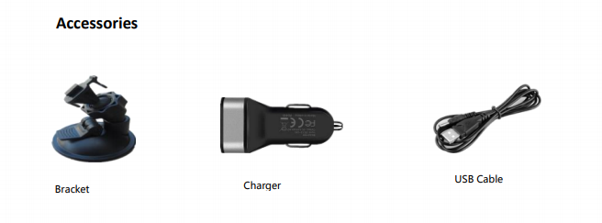

**050401160509**

**050401160405**