

**HHR315 SERIES TVI DVR**

**Video Input and Transmission**

* Connectable to HD-TVI, AHD, network and analog cameras
* Up to 32-ch 8MP ONVIF conformant IP cameras input
* Long distance transmission over twisted-pair cable & coax cable

**Compression and Recording**

* H.264+ compression improves encoding efficiency by up to 50% and reduces data storage costs
* Full channel recording at up to 3MP resolution

**Video Output**

* HDMI/VGA output at up to 1080p resolution
* CVBS output improves compatibility at the most possibility

**Storage and Playback**

* One or two SATA interfaces (up to 6TB of capacity per HDD)
* 4/8/16-ch synchronous playback at up to 3MP resolution
* Smart search for efficient playback
* Supports the 3rd party cloud storage (Dropbox/Google Drive/Microsoft OneDrive)

**Smart Function**

* Supports multiple VCA(Video Content Analytics) events for both analog and smart IP cameras
* VQD(Video Quality Diagnostics)

**Network & Ethernet Access**

* Cloud P2P for easy network management
* Gigabit Ethernet network interface (HHR315-8, HHR315-16)

**Features and Functions**

**Specifications**

| **Model** |  | **HHR315-4** | | **HHR315-8** | **HHR315-16** |
| --- | --- | --- | --- | --- | --- |
| **Video/Audio input** | **Video compression** | H.264+/H.264 | | |  |
| **Video input** | 4-ch | | 8-ch | 16-ch |
| BNC interface (1.0Vp-p, 75 Ω), supporting coaxitron connection | | | |
| **HD-TVI input** | 3MP, 1080p/25Hz, 1080p/30Hz, 720p/60Hz, 720p/50Hz, 720p/30Hz, 720p/25Hz | | | |
| **Supported AHD input** | 1080p/30Hz, 1080p/25Hz | | | |
| **CVBS input** | Support | | | |
| **IP video input** | 4-ch (up to 8-ch) | | 8-ch (up to 16-ch) | 16-ch (up to 32-ch) |
| Up to 8 MP resolution | | | |
| **Network bandwidth** | 96 Mbps | | 128 Mbps | 140 Mbps  (incoming bandwidth:  Up to 72 Mbps) |
| **Audio compression** | G.711u | | | |
| **Audio input** | 4-ch, RCA (2.0 Vp-p, 1 KΩ) | | | |
| **Video/Audio output** | **CVBS output** | 1-ch, BNC (1.0 Vp-p, 75 Ω), resolution: PAL: 704 × 576, NTSC: 704 × 480 | | | |
| **HDMI/VGA output** | 1-ch, 1920 × 1080/60Hz, 1280 × 1024/60Hz, 1280 × 720/60Hz, 1024 × 768/60Hz | | | |
| **Encoding resolution** | 3MP: 15fps  1080p/720p/WD1/4CIF/VGA/CIF: 25 fps (P)/30 fps (N) | | | |
| **Frame rate** | Main stream: 25 fps (P)/30 fps (N) | | | |
| Sub-stream: WD1/4CIF: 12fps  CIF/QVGA/QCIF: 25 fps (P)/30 fps (N) | | | |
| **Video bit rate** | 32 Kbps to 10 Mbps | | | |
| **Audio output** | 1-ch, RCA (Linear, 1 KΩ) | | | |
| **Audio bit rate** | 64 Kbps | | | |
| **Dual-stream** | Support | | | |
| **Stream type** | Video, Video & Audio | | | |
| **Synchronous playback** | 4-ch | | 8-ch | 16-ch |
| **Network management** | **Network protocols** | TCP/IP, PPPoE, DHCP, Cloud P2P, DNS, DDNS, NTP, SADP, NFS, iSCSI, UPnP™, HTTPS, ONVIF | | | |
| **Hard disk** | **SATA** | 1 SATA interface | | 2 SATA interfaces | 2 SATA interfaces |
| **Capacity** | Up to 6TB capacity | | | |
| **External interface** | **Two-way audio input** | 1-ch, RCA (2.0 Vp-p, 1 KΩ) (using the audio input) | | | |
| **Network interface** | 1, RJ45 10M/100Mbps self-adaptive Ethernet interface | | 1, RJ45 10M/100M/1000Mbps self-adaptive Ethernet interface | 1, RJ45 10M/100M/1000Mbps self-adaptive Ethernet interface |
| **USB interface** | 2 × USB 2.0 | | 1, USB 2.0 on the front panel  1, USB 3.0 on the rear panel | 1, USB 2.0 on the front panel  1, USB 3.0 on the rear panel |
| **Serial interface** | 1; RS-485 serial interface, half-duplex | | | |
| **Alarm in/out** | 4/1 | | 8/4 | 16/4 |
| **General** | **Power supply** | 12 VDC | | | |
| **Consumption**  **(without HDD)** | ≤ 15W | | ≤ 20W | ≤ 40W |
| **Working temperature** | -10 ºC to +55 ºC (14 ºF to 131 ºF) | | | |
| **Working humidity** | 10% to 90% | | | |
| **Dimensions**  **(W × D × H)** | 315 × 242 × 45 mm  (12.4 × 9.5 × 1.8 inch) | 380 × 320 × 48 mm  (14.9× 12.6 × 18.9 inch ) | | 380 × 320 × 48 mm  (14.9× 12.6 × 18.9 inch ) |
| **Weight**  **(without HDD)** | ≤ 2 kg (4.4 lb) | | | |

 Each two video channels are grouped in sequence, e.g., CH01 and CH02, CH03 and CH04..., and each two channels in the same group must be connected with the same type of video source selected on GUI.

|  |  |  |  |
| --- | --- | --- | --- |
| **Index** | **Description** | **Index** | **Description** |
| **1** | VIDEO IN | **8** | RS-485 Serial Interface |
| **2** | AUDIO IN, RCA Connector | **9** | 12VDC Power Input |
| **3** | AUDIO OUT, RCA Connector | **10** | Power Switch |
| **4** | VGA Interface | **11** | GND |
| **5** | HDMI Interface | **12** | VIDEO OUT |
| **6** | USB Interface | **13** | Alarm in/out |
| **7** | LAN Network Interface |  |  |

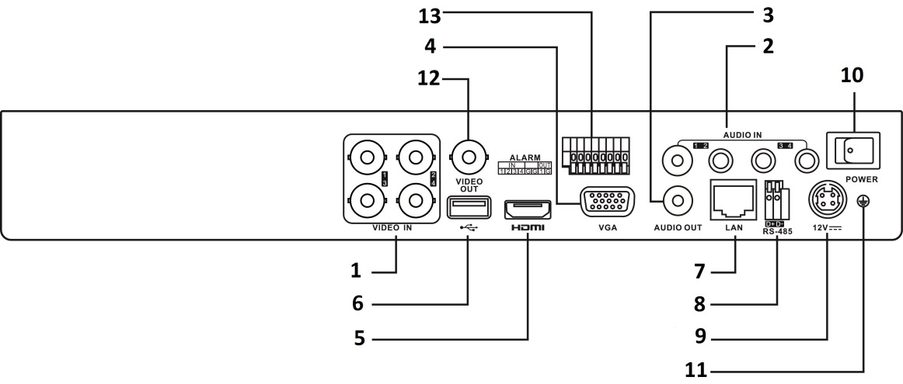

 The rear panel of HR315-8 and HR315-16 provides 8 or 16 video input interfaces.

**Available Models**

HHR315-8, HHR315-16

2016.07

**Physical Interfaces**