

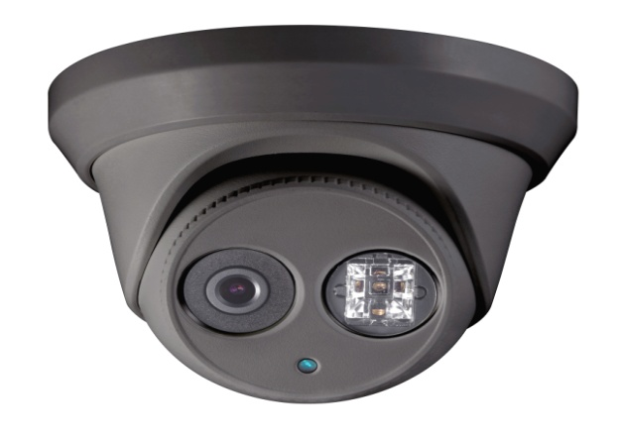

**HNC304-XDB/2.8**

**4 MP EXIR Bullet Network Camera**

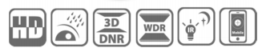

* **4 Megapixel High Resolution**
* **Grey color housing**
* **Full HD 1080p Video Output**
* **Dual Video Streams**
* **2.8mm Fixed Lens Options**
* **120 dB Wide Dynamic Range**
* **3D Digital Noise Reduction**
* **Smart Features**
* **Supports H.264+**
* **IP67 Protection**
* **IR Range: 30 meters (100 feet)**
* **PoE (802.3af)**
* **EXIR High Performance LED**

**Key Features**

|  |  |
| --- | --- |
| **Specifications** | |
| ***Camera*** | |
| Image Sensor | 1/3” Progressive Scan CMOS |
| Min. Illumination | Color: 0.028 @ F2.0, AGC on; B/W: 0 with IR |
| Shutter Speed | 1/3 s to 1/10,000 s |
| Slow Shutter | N/A |
| Auto-Iris | N/A |
| Day & Night | IR Cut Filter with auto switch |
| Digital Noise Reduction | 3D DNR |
| Wide Dynamic Range | 120 dB |
| Pan/Tilt/Rotation | Pan: 0° to 360°, tilt: 0° to 75°, rotation: 0° to 360° |
| ***Lens*** | |
| Lens | 2.8mm Fixed |
| Angle of View | 106° |
| Lens Mount | Φ12 |
| ***IR*** |  |
| IR Range | 30 meters |
| ***Compression Standard*** |  |
| Video Compression | H.264+/H.264/ MJPEG |
| H.264 Type | Main profile |
| Video Bit Rate | 32 Kbps - 16 Mbps |
| Dual Streams | Yes |
| ***Image*** | |
| Max. Resolution | 2688 x 1520 |
| Frame Rate | 20 fps (2688 x 1520); 30 fps (1920 x 1080) |
| Backlight Compensation | Yes, zone configured |
| Image Setting | Compression, color, rotate mode, saturation, brightness, contrast, sharpness, privacy mask |
| ROI | Yes |
| ***Network*** | |
| Network Storage | NAS (Support NFS,SMB/CIFS), ANR |
| Alarm Trigger | Tampering alarm, Network disconnect , IP address conflict, Storage exception, Intrusion detection, Line crossing detection, Motion detection |
| Protocols | TCP/IP, UDP, ICMP, HTTP, HTTPS, FTP, DHCP, DNS, DDNS, RTP, RTSP, RTCP, NTP, UPnP, SMTP, SNMP, IGMP, 802.1X, QoS, IPv6, Bonjour |
| Standard | ONVIF (Profile S, Profile G), PSIA, CGI, ISAPI |
| Security | Three level user authentication, password authentication, HTTPS and SSH certificate, IEEE802.1X, basic and digest authentication, watermark, IP address filtering, log-in lockout |
| ***Interface*** |  |
| Communication Interface | 1 RJ45 10M/100M self-adaptive Ethernet port |
| ***General*** | |
| Operating Conditions | -30 °C to +60 °C (-22 °F to +140 °F), Humidity 95% or less (non-condensing) |
| Power Supply | 12 VDC ± 10%, PoE (802.3af) |
| Power Consumption and Current | Max 7.5W (with ICR on) |
| Protection Level | IP67 |
| Impact Protection | N/A |
| IR Range | 30 meters (100 feet) |
| Dimensions | 127 mm x 97.5 mm (5.0” x 3.8”) |
| Weight | 670g (1.5 lbs) |

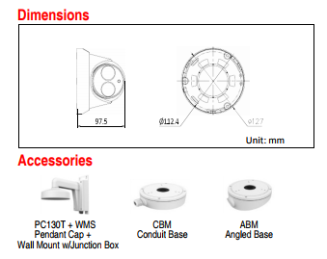

**20170509**

**050401160509**

**050401160405**