**NC322-VDZ**

**2 MP IR VF Dome Network Camera**

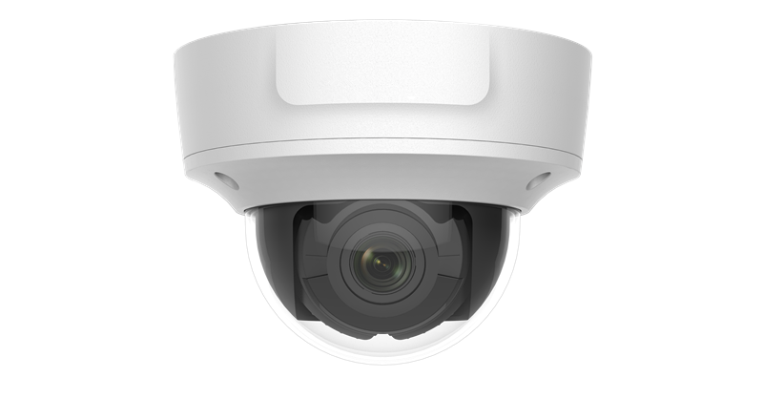

**Key Features**

* BLC/3D DNR/ROI
* Built-in micro SD/SDHC/SDXC card slot, up to 128 GB
* IP67, IK10
* 1/2.8" Progressive Scan CMOS
* 1920 × 1080@30fps
* 2.8 to 12 mm varifocal lens
* Color: 0.01 Lux @(F1.2, AGC ON), 0.028Lux @(F2.0, AGC ON);
* H.265+, H.265, H.264+, H.264
* 120dB WDR
* 2 Behavior analyses

|  |  |
| --- | --- |
| **Specifications** | |
| ***Camera*** | |
| Image Sensor | 1/2.8" Progressive Scan CMOS |
| Min. Illumination | Color: 0.01 Lux @(F1.2, AGC ON), 0.028Lux @(F2.0, AGC ON);  B/W: 0.001 Lux @(F1.2, AGC ON), 0.0028 Lux @(F2.0, AGC ON), 0 Lux with IR |
| Shutter Speed | 1/3 s to 1/100,000 s |
| Slow Shutter | Yes |
| Auto-Iris | No |
| Day & Night | IR Cut Filter |
| Digital Noise Reduction | 3D DNR |
| WDR | 120 dB |
| 3-Axis Adjustment | Pan: 0° to 355°, tilt: 0° to 75°, rotation: 0° to 355° |
| ***Lens*** | |
| Focal Length | 2.8 to 12 mm |
| Aperture | F2.0 |
| Focus | Z: Auto |
| FOV | Horizontal FOV: 99.6° to 35°, vertical FOV: 53.5° to 20°, diagonal FOV: 118.6° to 40.2° |
| Lens Mount | Φ14 |
| ***IR*** |  |
| IR Range | Up to 30 m |
| Wavelength | 850nm |
| ***Compression Standard*** |  |
| Video Compression | Main stream: H.265/H.264  Sub-stream: H.265/H.264/MJPEG |
| H.264 Type | Baseline Profile/Main Profile/High Profile |
| H.264+ | Main stream supports |
| H.265 Type | Main Profile |
| H.265+ | Main stream supports |
| Video Bit Rate | 32 Kbps to 8 Mbps |
| Audio Compression | G.711/G.722.1/G.726/MP2L2/PCM |
| Audio Bit Rate | 64Kbps(G.711)/16Kbps(G.722.1)/16Kbps(G.726)/32-192Kbps(MP2L2) |
| ***Smart Feature-set*** |  |
| Behavior Analysis | Line crossing detection, intrusion detection |
| Region of Interest | 1 fixed region for main stream |
| ***Image*** | |
| Max. Resolution | 1920 × 1080 |
| Main Stream | 50Hz: 25fps (1920 × 1080, 1280 × 960, 1280 × 720)  60Hz: 30fps (1920 × 1080, 1280 × 960, 1280 × 720) |
| Sub-Stream | 50Hz: 25fps (640 × 480, 640 × 360, 320 × 240)  60Hz: 30fps (640 × 480, 640 × 360, 320 × 240) |
| Image Enhancement | BLC/3D DNR |
| Image Settings | Rotate mode, saturation, brightness, contrast, sharpness adjustable by client software or web browser |
| Target Cropping | No |
| Day/Night Switch | Day/Night/Auto/Schedule/Triggered by alarm in |
| ***Network*** | |
| Network Storage | Support built-in microSD/SDHC/SDXC card (128G), local storage and NAS (NFS,SMB/CIFS), ANR |
| Alarm Trigger | Motion detection, video tampering, network disconnected, IP address conflict, illegal login, HDD full, HDD error |
| Protocols | TCP/IP, ICMP, HTTP, HTTPS, FTP, DHCP, DNS, DDNS, RTP, RTSP, RTCP, PPPoE, NTP, UPnP™, SMTP, SNMP, IGMP, 802.1X, QoS, IPv6, Bonjour |
| General Function | One-key reset, anti-flicker, heartbeat, three streams, mirror, password protection, privacy mask, watermark, IP address filter |
| Firmware Version | V5.5.6 |
| API | ONVIF (PROFILE S, PROFILE G), ISAPI |
| Simultaneous Live View | Up to 6 channels |
| User/Host | Up to 32 users  3 levels: Administrator, Operator and User |
| Client | CMS, Guarding vision |
| Web Browser | IE8+, Chrome 31.0-44, Firefox 30.0-51, Safari 8.0+ |
| ***Interface*** |  |
| Audio | 1 input (line in), 1 output (line out), mono sound |
| Communication Interface | 1 RJ45 10M/100M self-adaptive Ethernet port |
| Alarm | 2 inputs, 2 outputs |
| Video Output | CVBS |
| On-board Storage | Built-in microSD/SDHC/SDXC slot, up to 128 GB |
| SVC | H.264 and H.265 encoding support |
| Reset Button | Yes |
| ***Audio (-S)*** |  |
| Environment Noise Filtering | Yes |
| Audio Sampling Rate | 8 kHz/16 kHz/32 kHz/44.1 kHz/48 kHz |
| ***General*** | |
| Operating Conditions | -30 °C to +60 °C (22 °F to +140 °F), humidity 95% or less (non-condensing) |
| Power Supply | 12 VDC ± 25%, Φ 5.5 mm coaxial plug power  PoE (802.3af, class 3) |
| Power Consumption and Current | 12 VDC, 0.8 A, max. 10 W  PoE: (802.3af, 36V-57V), 0.4 A to 0.2 A, max. 12 W |
| Protection Level | IP67, IK10 |
| Material | Front cover & Base: metal, bubble: plastic |
| Dimensions | Φ 153.3 × 111.6 mm (Φ 6" × 4.4") |
| Weight | Camera: approx. 880 g (1.9 lb.)  With package: approx. 1300 g (2.9 lb.) |

**Available Model:**

NC322-VDZ (2.8 to 12 mm)

**Dimensions**



**Accessories**

|  |  |
| --- | --- |
| C:\Users\sunyuanyuan7\Desktop\26 27降成本 郑健峰\DS-1273ZJ-155.png | C:\Users\sunyuanyuan7\Desktop\26 27降成本 郑健峰\DS-1271ZJ-155.png |
| 1273ZJ-155 | 1271ZJ-155 |

**05050320171113**