**NC324-WDA**

**4 MP EXIR Fixed Mini Dome Network Camera**

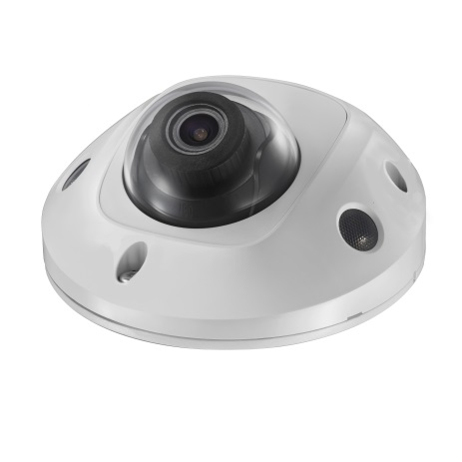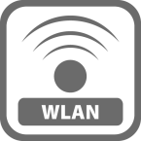

* 2688 × 1520 @30fps
* IR: Up to 10 m
* H.265+. H.265
* 120dB WDR
* Built-in MicroSD/SDHC/SDXC slot, up to 128G
* PoE
* EXIR

**Key Features**

|  |  |
| --- | --- |
| **Specifications** | |
| ***Camera*** | |
| Image Sensor | 1/3" Progressive Scan CMOS |
| Min. Illumination | Color: 0.01 Lux @ (F1.2, AGC ON), 0.018 lux @(F1.6, AGC ON), 0 lux with IR |
| Shutter Speed | 1/3 s to 1/100,000 s |
| Slow Shutter | Yes |
| Day & Night | IR Cut Filter |
| Digital Noise Reduction | 3D DNR |
| WDR | 120dB |
| 3-Axis Adjustment | Pan: -30° to +30°, tilt: 0° to 75°, rotate: 0° to 360° |
| ***Lens*** | |
| Focal Length | 2.8, 4, 6 mm |
| Aperture | F1.6 |
| FOV | 2.8 mm: Horizontal field of view: 98°, Vertical field of view: 55°, Diagonal field of view: 114°  4 mm: Horizontal field of view: 78°, Vertical field of view: 42°, Diagonal field of view: 93°  6 mm: Horizontal field of view: 48°, Vertical field of view: 27°, Diagonal field of view: 54° |
| Lens Mount | M12 |
| ***IR*** |  |
| IR Range | Up to 10 m |
| Wavelength | 850nm |
| ***Compression Standard*** |  |
| Video Compression | Main stream: H.265/H.264  Sub stream: H.265/H.264/MJPEG  Third stream: H.265/H.264 |
| H.264 Type | Main Profile/High Profile |
| H.264+ | Yes |
| H.265 Type | Main Profile |
| H.265+ | Yes |
| Video Bit Rate | 256 Kbps to 16 Mbps |
| Audio Compression | G722.1/G711ulaw/G711alaw/G726/MP2L2/PCM |
| Audio Bit Rate | 64Kbps(G.711)/16Kbps(G.722.1)/16Kbps(G.726)/32-192Kbps(MP2L2) |
| ***Smart Feature-set*** |  |
| Behavior Analysis | Line crossing detection, intrusion detection |
| Face Detection | Yes |
| Region of Interest | Support 1 fixed region for main stream and sub-stream separately |
| ***Image*** | |
| Max. Resolution | 2688 × 1520 |
| Main Stream | 50Hz: 25fps (2688 × 1520, 2304 × 1296, 1920 × 1080)  60Hz: 30fps (2688 × 1520, 2304 × 1296, 1920 × 1080) |
| Sub Stream | 50Hz: 25fps (640 × 480, 640 × 360, 320 × 240)  60Hz: 30fps (640 × 480, 640 × 360, 320 × 240) |
| Third Stream | 50Hz: 25fps (1280 × 720, 640 × 360, 352 × 288)  60Hz: 30fps (1280 × 720, 640 × 360, 352 × 240) |
| Image Settings | Rotate mode, saturation, brightness, contrast, sharpness adjustable by client software or web browser |
| Image Enhancement | BLC/3D DNR |
| Day/Night Switch | Auto/Schedule/Day/Night/Triggered by Alarm In |
| ***Network*** | |
| Network Storage | Support MicroSD/SDHC/SDXC card (128G), local storage and NAS (NFS,SMB/CIFS), ANR |
| Alarm Trigger | Motion detection, video tampering, network disconnected, IP address conflict, HDD full, HDD error, illegal login |
| Protocols | TCP/IP, ICMP, HTTP, HTTPS, FTP, DHCP, DNS, DDNS, RTP, RTSP, RTCP, PPPoE, NTP, UPnP™, SMTP, SNMP, IGMP, QoS, IPv6 |
| General Function | One-key reset, anti-flicker, three streams, heartbeat, mirror, password protection, privacy mask, watermark, IP address filter |
| API | ONVIF (PROFILE S, PROFILE G), ISAPI |
| Simultaneous Live View | Up to 6 channels |
| User/Host | Up to 32 users  3 levels: Administrator, Operator and User |
| Client | CMS, Guarding Vision |
| Web Browser | IE8+, Chrome 31.0-44, Firefox 30.0-51, Safari 8.0+ |
| ***Interface*** |  |
| Audio (-S model) | 2 Inputs: line in (3.5 mm) or mic in (built-in microphone), 1 Output: line out (3.5 mm), mono sound |
| Alarm (-S model) | 1 Input: Alarm in (3.5mm), 1 Output: Alarm out (3.5mm) |
| Communication Interface | 1 RJ45 10M/100M self-adaptive Ethernet port |
| On-board storage | Built-in Micro SD/SDHC/SDXC slot, up to 128G |
| SVC | Support H.264 and H.265 encoding |
| ***Audio*** |  |
| Environment Noise Filtering | Yes |
| Audio Sampling Rate | 16 kHz, 32kHz, 44.1kHz, 48kHz |
| ***General*** | |
| Operating Conditions | -30 °C to +60 °C (-22 °F to +140 °F), Humidity 95% or less (non-condensing) |
| Power Supply | 12 VDC ± 25%, PoE (802.3af, class 3) |
| Power Consumption and Current | 12 VDC, 0.7A, max. 8.5W, Φ 5.5mm coaxial plug power  PoE (802.3af, 36V to 57V), 0.3 A to 0.1 A, max. 10W |
| Protection Level | IK08, IP66 |
| Material | Front cover: plastic, Bottom base: metal |
| Dimensions | Φ110 mm × 56.4 mm (Φ4.3" × 2.2") |
| Weight | Camera: Approx. 400 g (0.9 lb.) |

**Available Models:**

NC324-WDA

**Dimensions**



**Accessories**

|  |
| --- |
|  |
| 1280ZJ-DM22  Junction Box |