

# DS-2CD2646G1-IZ(S)

# HNC344-VBZ

**AcuSense 4 MP IR Varifocal Bullet Network Camera**

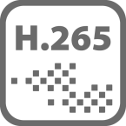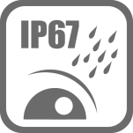

## Key Features

* Max. 2688 × 1520 @ 30fps
* H.265, H.264
* 120dB WDR
* Color: 0.007 Lux @ (F1.2, AGC ON), 0.01 Lux @ (F1.4, AGC ON), 0 Lux with IR
* False alarm filter by target classification
* 12 VDC & PoE (802.3at, class 4)
* IR range: Up to 50 m
* Support on-board storage, up to 128 GB
* IP67, IK10
* BLC/3D DNR/ROI



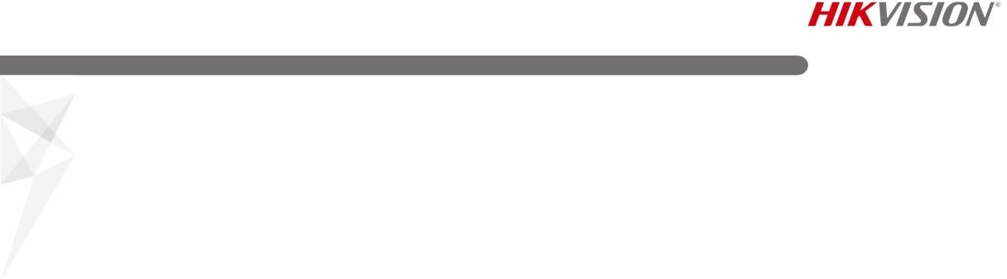

**Specification**

|  |  |
| --- | --- |
| ***Camera*** | |
| Image Sensor | 1/2.7" Progressive Scan CMOS |
| Min. Illumination | Color: 0.007 Lux @ (F1.2, AGC ON), 0.01 Lux @ (F1.4, AGC ON), 0 Lux with IR |
| Shutter Speed | 1/3 s to 1/100,000 s |
| Slow Shutter | Yes |
| Auto-Iris | No |
| Day &Night | IR cut filter |
| Digital Noise Reduction | 3D DNR |
| Wide Dynamic Range | 120dB |
| 3-Axis Adjustment (with bracket) | Pan: 0° to 355°, tilt: 0° to 90°, rotate: 0° to 360° |
| ***Lens*** | |
| Focal length | 2.8 mm to 12 mm |
| Aperture | F1.4 |
| Focus | Auto |
| FOV | Horizontal FOV: 101° to 29°, vertical FOV: 54° to 16°, diagonal FOV: 121° to 34° |
| Lens Mount | Φ14 |
| ***IR*** |  |
| IR Range | Up to 50 m |
| Wavelength | 850 nm |
| ***Compression Standard*** | |
| Video Compression | Main stream: H.265/H.264  Sub stream: H.265/H.264/MJPEG |
| H.264 Type | Main Profile/High Profile |
| H.265 Type | Main Profile |
| Video Bit Rate | 32 Kbps to 16 Mbps |
| ***Smart Feature-set*** | |
| Behavior Analysis | Line crossing detection, intrusion detection, region entrance detection, region exit detection, false alarm filter by target classification |
| ROI (Region of Interest) | Support 1 fixed region for main stream and sub stream separately |
| ***Image*** | |
| Max. Resolution | 2688 × 1520 |
| Main Stream | 50Hz: 25fps (2688 × 1520, 1920 × 1080, 1280 × 720)  60Hz: 30fps (2688 × 1520, 1920 × 1080, 1280 × 720) |
| Sub-Stream | 50Hz: 25fps (640 × 480, 640 × 360, 320 × 240)  60Hz: 30fps (640 × 480, 640 × 360, 320 × 240) |
| Image Enhancement | BLC/3D DNR |
| Image Settings | Saturation, brightness, contrast, sharpness, AGC, white balance adjustable by client software or web browser |
| Day/Night Switch | Day/Night/Auto/Schedule/Triggered by Alarm In(-S) |
| ***Audio (-S)*** |  |
| Environment Noise Filtering | Yes |
| Sampling Rate | 8kHz/16kHz |
| Audio Compression | G.711/G.722.1/G.726/MP2L2/PCM |
| Audio Bit Rate | 64Kbps(G.711)/16Kbps(G.722.1)/16Kbps(G.726)/32-160Kbps(MP2L2) |



|  |  |
| --- | --- |
| ***Network*** | |
| Network Storage | Support micro SD/SDHC/SDXC card (128G) local storage, NAS (NFS,SMB/CIFS), ANR |
| Alarm Trigger | Tampering alarm, network disconnected, IP address conflict, illegal login, HDD full, HDD error |
| Protocols | TCP/IP, ICMP, HTTP, HTTPS, FTP, DHCP, DNS, DDNS, RTP, RTSP, RTCP, PPPoE, NTP, UPnP, SMTP, SNMP, IGMP, 802.1X, QoS, IPv6, UDP, Bonjour |
| General Function | One-key reset, anti-flicker, heartbeat, mirror, password protection, privacy mask, watermark, IP address filtering |
| Firmware Version | V5.5.63 |
| API | ONVIF (PROFILE S, PROFILE G), ISAPI |
| Simultaneous Live View | Up to 6 channels |
| User/Host | Up to 32 users  3 levels: Administrator, Operator and User |
| Client | iVMS-4200, Hik-Connect, iVMS-5200, iVMS-4500 |
| Web Browser | Plug-in required live view:  IE8+, Chrome 31.0-44, Firefox 30.0-51, Safari 8.0+ Plug-in free live view:  Chrome 45.0+, Firefox 52.0+ |
| ***Interface*** |  |
| Communication Interface | 1 RJ45 10M/100M self-adaptive Ethernet port |
| On-board Storage | Built-in micro SD/SDHC/SDXC slot, up to 128 GB |
| SVC | H.265 encoding and H.264 encoding support |
| Reset Button | Yes |
| Audio (-S) | 1 audio input (line in), 1 audio output (line out), mono sound |
| Alarm (-S) | 1 alarm input, 1 alarm output |
| ***General*** | |
| Operating Conditions | -30 °C to +60 °C (-22 °F to +140 °F), humidity 95% or less (non-condensing) |
| Power Supply | 12 VDC ± 25%, 5.5 mm coaxial power plug PoE (802.3at, class 4) |
| Power Consumption and Current | 12 VDC, 1.3 A, max. 15.5 W  PoE: (802.3at, 42.5 VDC to 57 VDC), 0.5 A to 0.3 A, max. 19 W |
| Protection Level | IP67, IK10 |
| Material | Front cover & back cover: metal |
| Dimensions | Camera: Φ 105 × 297.5 mm (Φ 4.1" × 11.7") |
| Weight | Camera: 1400 g (3.1 lb.)  With package: 1750 g (3.9 lb.) |

## Available Model

HNC344-VBZ

## Dimension



4-Φ4.2(0.2")

62.6(2.5")

Φ105(4.1")

62.6(2.5")

297.5(11.7")

93(3.7")

## Accessory

288.2(11.3")

Unit: mm(inch)

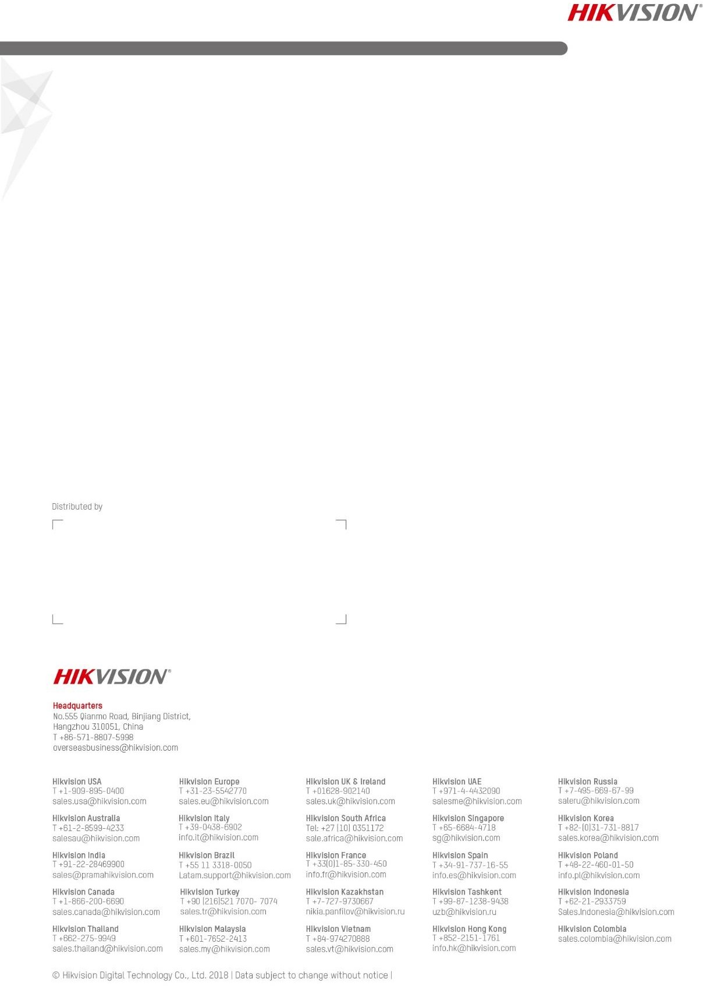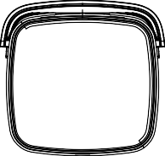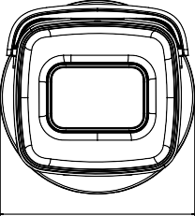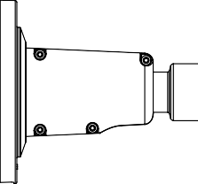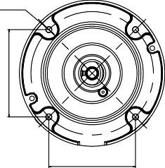

|  |  |  |  |
| --- | --- | --- | --- |
|  |  |  |  |
| HTH-275ZJ  Vertical Pole Mount | HTH-276ZJ  Corner Mount | HTH-260ZJ  Junction Box | HTH-280ZJ-S  Junction Box |



