

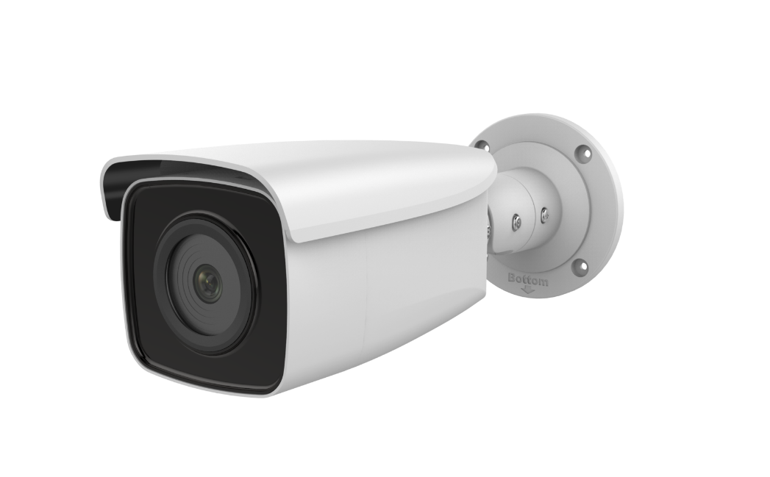

# DS-2CD2T46G1-2I/4I

# 4 MP IR FHNC344-XB-2.8

**4 MP IR Fixed Bullet Network Camera**

**Bullet Network Camera**



## Key Features

* Max. 2688 × 1520 @ 25fps
* 2.8 mm/4 mm/6 mm/8 mm fixed lens
* H.265, H.264
* 120dB WDR
* False alarm filter by target classification
* 12 VDC & PoE (802.3at, class 4)
* IR range: Up to 50 m, 80 m, optional
* Support on-board storage, up to 128 GB
* IP67
* BLC/3D DNR/ROI
* Color: 0.007 Lux @ (F1.2, AGC ON), 0.012 Lux @ (F1.6, AGC ON)



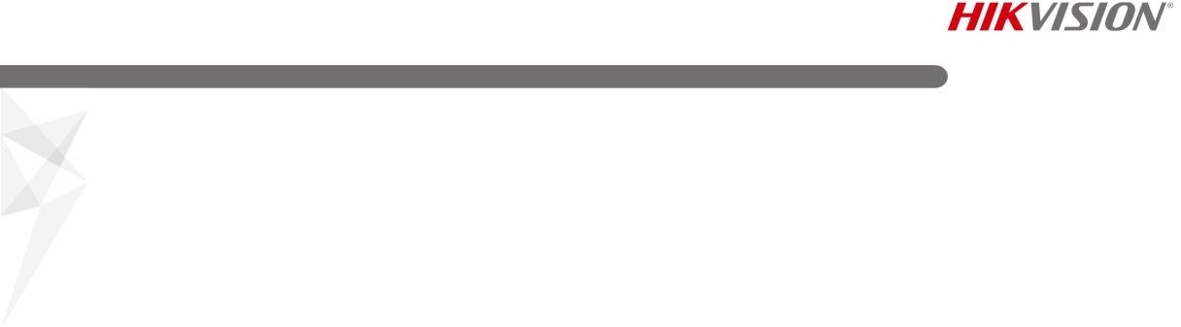

**Specification**

|  |  |
| --- | --- |
| ***Camera*** | |
| Image Sensor | 1/2.7" Progressive Scan CMOS |
| Min. Illumination | 0.007 Lux @ (F1.2, AGC ON), 0.012 Lux @ (F1.6, AGC ON) |
| Shutter Speed | 1/3 s to 1/100,000 s |
| Slow Shutter | Yes |
| Focal length | 2.8/4/6/8 mm |
| Focus | Fixed |
| Aperture | F1.6 |
| FOV | 2.8 mm, horizontal FOV: 104°, vertical FOV: 58°, diagonal FOV: 124° 4 mm, horizontal FOV: 83°, vertical FOV: 44°, diagonal FOV: 99°  6 mm, horizontal FOV: 51°, vertical FOV: 28°, diagonal FOV: 58°  8 mm, horizontal FOV: 39°, vertical FOV: 21°, diagonal FOV: 45° |
| Lens Mount | M12 |
| Auto-Iris | No |
| Day &Night | IR cut filter |
| DNR | 3D DNR |
| Wide Dynamic Range | 120dB |
| 3-Axis Adjustment | Pan: 0° to 360°, tilt: 0° to 90°, rotate: 0° to 360° |
| ***Compression Standard*** | |
| Video Compression | Main stream: H.265/H.264  Sub stream: H.265/H.264/MJPEG |
| H.264 Type | Main Profile/High Profile |
| H.264+ | No |
| H.265 Type | Main Profile |
| H.265+ | No |
| Video Bit Rate | 32 Kbps to 16 Mbps |
| ***Image*** | |
| Max. Resolution | 2688 × 1520 |
| Main Stream | 50Hz: 25fps (2688 × 1520, 1920 × 1080, 1280 × 720)  60Hz: 30fps (2688 × 1520, 1920 × 1080, 1280 × 720) |
| Sub Stream | 50Hz: 25fps (704 × 576, 640 × 480, 352 × 288)  60Hz: 30fps (704 × 576, 640 × 480, 352 × 288) |
| Image Enhancement | BLC/3D DNR |
| Image Settings | Saturation, brightness, contrast, sharpness, AGC, white balance adjustable by client software or web browser |
| ROI (Region of Interest) | Support 1 fixed region for main stream and sub stream separately |
| Day/Night Switch | Day/Night/Auto/Schedule |
| ***Network*** | |
| Network Storage | Support micro SD/SDHC/SDXC card (128G) local storage, NAS (NFS,SMB/CIFS), ANR |
| Alarm Trigger | Tampering alarm, network disconnected, IP address conflict, illegal login, HDD full, HDD error |
| Protocols | TCP/IP, ICMP, HTTP, HTTPS, FTP, DHCP, DNS, DDNS, RTP, RTSP, RTCP, PPPoE, NTP, UPnP, SMTP, SNMP, IGMP, 802.1X, QoS, IPv6, UDP, Bonjour |
| General Function | One-key reset, anti-filter |
| Firmware Version | V5.5.61 |
| API | ONVIF (PROFILE S, PROFILE G), ISAPI |



|  |  |
| --- | --- |
| Simultaneous Live View | Up to 6 channels |
| User/Host | Up to 32 users  3 levels: Administrator, Operator and User |
| Client | iVMS-4200, Hik-Connect, iVMS-5200, iVMS-4500 |
| Web Browser | IE8+, Chrome 31.0-44, Firefox 30.0-51, Safari 8.0+ |
| ***Interface*** |  |
| Communication Interface | 1 RJ45 10M/100M self-adaptive Ethernet port |
| On-board Storage | Built-in micro SD/SDHC/SDXC slot, up to 128 GB |
| Reset Button | Yes |
| SVC | H.265 encoding and H.264 encoding support |
| ***Smart Feature-set*** | |
| Behavior Analysis | Line crossing detection, intrusion detection, region entrance detection, region exit detection, false alarm filter by target classification |
| ***General*** | |
| Operating Conditions | -30 °C to +50 °C (-22 °F to +122 °F), humidity 95% or less (non-condensing) |
| Power Supply | 12 VDC ± 25%, 5.5 mm coaxial power plug PoE (802.3at, class 4) |
| Power Consumption | -2I:  12 VDC, 0.9 A, Max: 10.5 W  PoE: (802.3at, 42.5 V to 57 V), 0.3A to 0.1A, Max: 13 W  -4I:  12 VDC, 1.2 A, Max: 14 W  PoE: (802.3at, 42.5 V to 57 V), 0.4A to 0.1A, Max: 17 W |
| IR Range | -2I: 2LEDs, up to 50 m  -4I: 4LEDs, up to 80 m |
| Wavelength | 850 nm |
| Protection Level | IP67 |
| Material | Front cover: metal, back cover: metal |
| Dimensions | Camera: Φ105 × 289.5 mm (Φ4.1″ × 11.4″) |
| Weight | Camera: 1100 g (2.4 lb.)  With package: 1600 g (3.5 lb.) |

## Available Models

HNC344-XB-2.8

## Dimensions

289.5 mm(11.4")

90.4 mm(2.6")

101.8 mm(4.0")

163.4 mm(6.4")

270.2 mm(10.6")

4-Ø 4.2 mm(0.2")

62.6 mm(2.5")

62.6 mm(2.5")



Ø 105 mm(4.1")

## Accessories

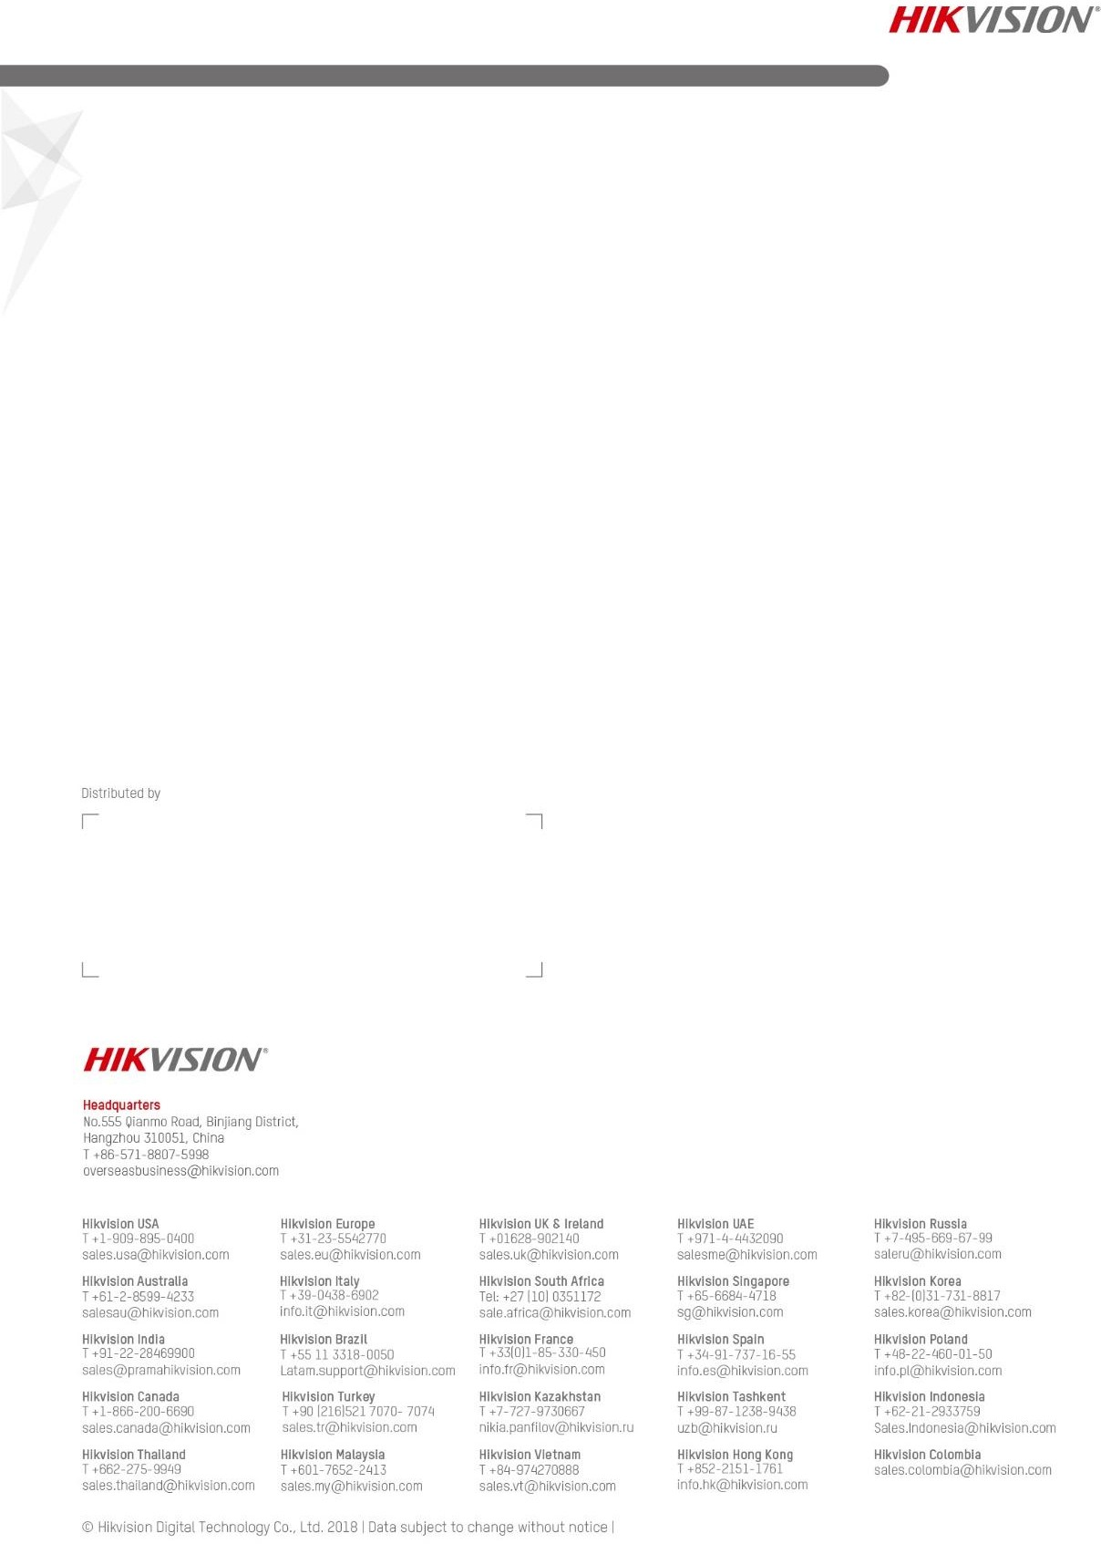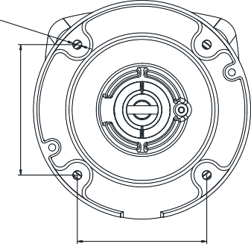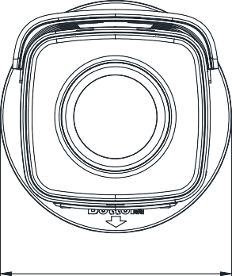

|  |  |  |
| --- | --- | --- |
|  |  |  |
| HTH-275ZJ  Vertical pole mount | HTH-260ZJ  Junction box | HTH-276ZJ  Corner mount |

