

# HNC344-XD-2.8

**AcuSense 4 MP IR Fixed Turrent Network Camera**

# 146G1-I(S)

**4 MP IR Fixed Dome Network Camera**

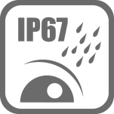

## Key Features

* Max. 2688 × 1520 @ 30fps
* 2.8 mm/4 mm/6 mm fixed lens
* H.265, H.264
* 120dB WDR
* False alarm filter by target classification
* Powered by Darkfighter
* 12 VDC & PoE (802.3af, class 3)
* IR range: Up to 50 m
* Support on-board storage, up to 128 GB
* IP67
* BLC/3D DNR/ROI
* Color: 0.007 Lux @ (F1.2, AGC ON), 0.012 Lux @ (F1.6, AGC ON)



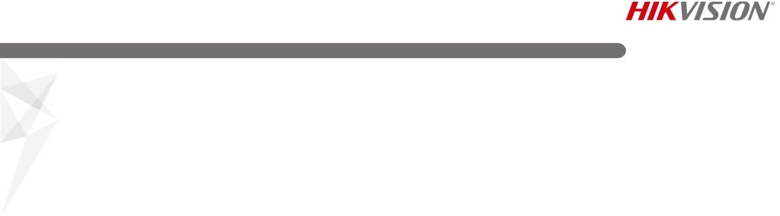

**Specification**

|  |  |
| --- | --- |
| ***Camera*** | |
| Image Sensor | 1/2.7" Progressive Scan CMOS |
| Min. Illumination | 0.007 Lux @ (F1.2, AGC ON), 0.012 Lux @ (F1.6, AGC ON) |
| Shutter Speed | 1/3 s to 1/100,000 s |
| Slow Shutter | Yes |
| Focal length | 2.8/4/6 mm |
| Focus | Fixed |
| Aperture | F1.6 |
| FOV | 2.8 mm, horizontal FOV: 104°, vertical FOV: 58°, diagonal FOV: 124° 4 mm, horizontal FOV: 83°, vertical FOV: 44°, diagonal FOV: 99°  6 mm, horizontal FOV: 51°, vertical FOV: 28°, diagonal FOV: 58° |
| Lens Mount | M12 |
| Auto-Iris | No |
| Day &Night | IR cut filter |
| DNR | 3D DNR |
| Wide Dynamic Range | 120dB |
| 3-Axis Adjustment | Pan: 0° to 360°, tilt: 0° to 70°, rotate: 0° to 360° |
| ***Compression Standard*** | |
| Video Compression | Main stream: H.265/H.264  Sub stream: H.265/H.264/MJPEG |
| H.264 Type | Main Profile/High Profile |
| H.264+ | No |
| H.265 Type | Main Profile |
| H.265+ | No |
| Video Bit Rate | 32 Kbps to 16 Mbps |
| ***Image*** | |
| Max. Resolution | 2688 × 1520 |
| Main Stream | 50Hz: 25fps (2688 × 1520, 1920 × 1080, 1280 × 720)  60Hz: 30fps (2688 × 1520, 1920 × 1080, 1280 × 720) |
| Sub Stream | 50Hz: 25fps (704 × 576, 640 × 480, 352 × 288)  60Hz: 30fps (704 × 576, 640 × 480, 352 × 288) |
| Image Enhancement | BLC/3D DNR |
| Image Settings | Saturation, brightness, contrast, sharpness, AGC, white balance adjustable by client software or web browser |
| ROI (Region of Interest) | Support 1 fixed region for main stream and sub stream separately |
| Day/Night Switch | Day/Night/Auto/Schedule |
| ***Network*** | |
| Network Storage | Support micro SD/SDHC/SDXC card (128G) local storage, NAS (NFS,SMB/CIFS), ANR |
| Alarm Trigger | Tampering alarm, network disconnected, IP address conflict, illegal login, HDD full, HDD error |
| Protocols | TCP/IP, ICMP, HTTP, HTTPS, FTP, DHCP, DNS, DDNS, RTP, RTSP, RTCP, PPPoE, NTP, UPnP, SMTP, SNMP, IGMP, 802.1X, QoS, IPv6, UDP, Bonjour |
| General Function | One-key reset, anti-filter |
| Firmware Version | V5.5.61 |
| API | ONVIF (PROFILE S, PROFILE G), ISAPI |



|  |  |
| --- | --- |
| Simultaneous Live View | Up to 6 channels |
| User/Host | Up to 32 users  3 levels: Administrator, Operator and User |
| Client | iVMS-4200, Hik-Connect, iVMS-5200, iVMS-4500 |
| Web Browser | IE8+, Chrome 31.0-44, Firefox 30.0-51, Safari 8.0+ |
| ***Interface*** |  |
| Communication Interface | 1 RJ45 10M/100M self-adaptive Ethernet port |
| On-board Storage | Built-in micro SD/SDHC/SDXC slot, up to 128 GB |
| Reset Button | Yes |
| SVC | H.265 encoding and H.264 encoding support |
| ***Smart Feature-set*** | |
| Behavior Analysis | Line crossing detection, intrusion detection, region entrance detection, region exit detection, false alarm filter by target classification  When H265+, three streams or motion detection is enabled, the behavior analyses (including line crossing detection, intrusion detection, region entrance detection and region exiting detection) are not supported. |
| ***General*** | |
| Operating Conditions | -30 °C to +50 °C (-22 °F to +122 °F), humidity 95% or less (non-condensing) |
| Power Supply | 12 VDC ± 25%, 5.5 mm coaxial power plug PoE (802.3af, class 3) |
| Power Consumption | 12 VDC, 0.7 A, max: 8.5 W  PoE: (802.3af, 36 V to 57 V), 0.3 A to 0.2 A, max: 10 W |
| IR Range | Up to 50 m |
| Wavelength | 850 nm |
| Protection Level | IP67 |
| Material | Camera: Metal, trim ring: Plastic |
| Dimensions | Camera: Φ 138.3 × 126.3 mm (Φ 5.4" × 5")  With package: 170 × 170 × 150 mm (7" × 7" × 5.9") |
| Weight | Camera: 430 g (0.9 lb.)  With package: 733 g (1.6 lb.) |

## Available Models

HNC344-XD-2.8

## Dimensions

Ø 138.3(5.4")



126.3(5")

98(3.9")

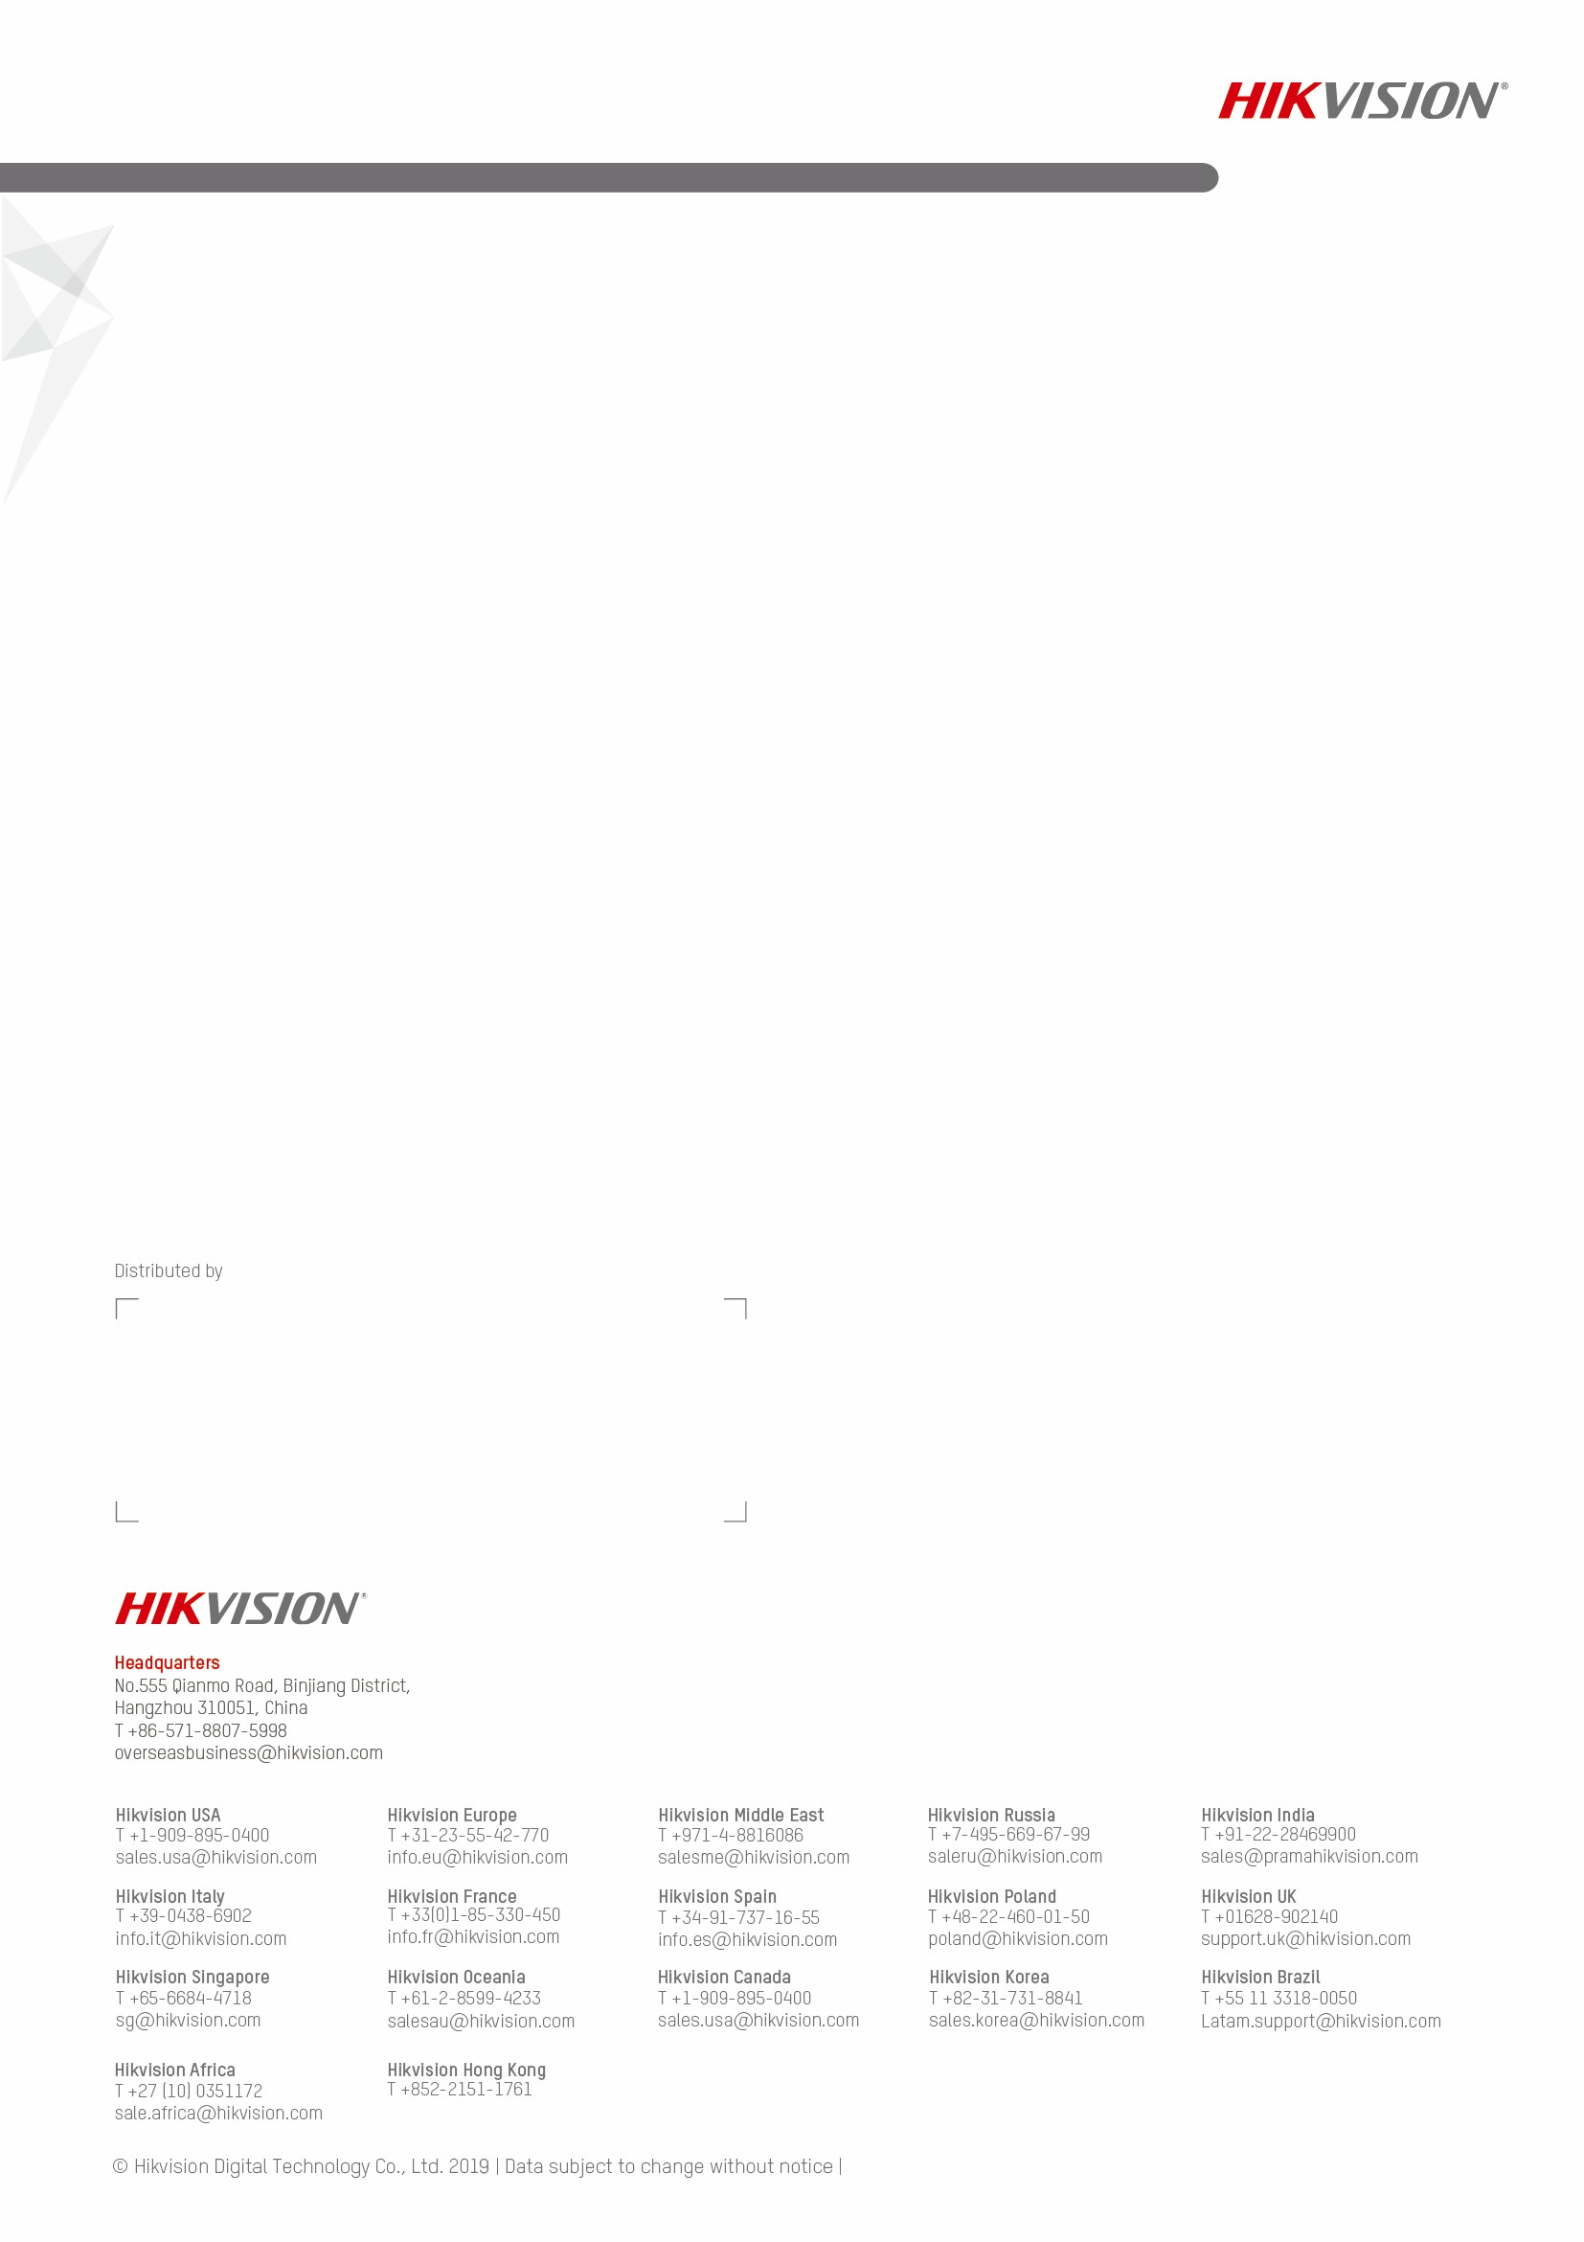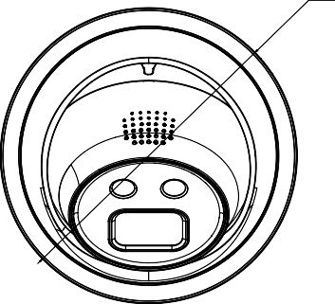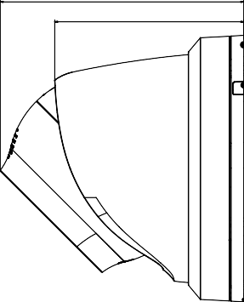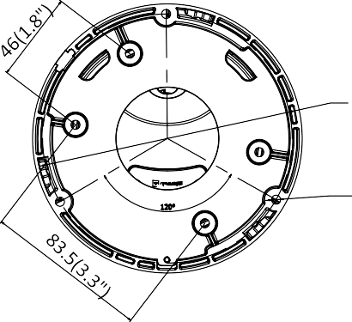

Ø 128(5")

3-Ø 4.6(0.2")

Unit: mm(inch)

## Accessories

|  |  |  |
| --- | --- | --- |
|  |  |  |
| HTH-273ZJ-130B-TRL  Wall Mount | HTH-271ZJ-110  Pendant Mount | HTH-280ZJ-M  Junction Box |

