**HNP104-IR/4X(**

**4MP 4× IR Network PTZ Camera2**

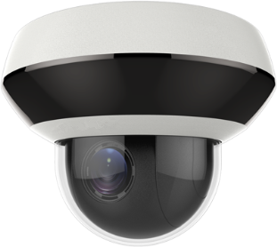

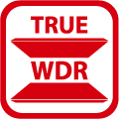   

   

|  |  |
| --- | --- |
| HNP104-IR/4X 4MP 4× IR Network PTZ Camera can be widely used in multiple scenes, such as the corridor, office, convenience store, and restaurant, etc. | **Key Features**   * 1/3" progressive scan CMOS * Up to 2560 × 1440@25fps resolution * Min. illumination:   Color: 0.005 Lux @(F1.6, AGC ON)  B/W: 0.001 Lux @(F1.6, AGC ON)  0 Lux with IR   * 4× optical zoom, 16× digital zoom * 120 dB WDR, 3D DNR, HLC, EIS, Regional Exposure, Regional Focus * 12 VDC & PoE * Up to 20 m IR distance * IK10, IP66 * Support H.265+/H.265 video compression |

**Specification**

|  |  |
| --- | --- |
| **Camera Module** | |
| Image Sensor | 1/3" progressive scan CMOS |
| Min. Illumination | Color: 0.005 Lux @(F1.6, AGC ON)  B/W: 0.001 Lux @(F1.6, AGC ON)  0 Lux with IR |
| White Balance | Auto/Manual/ATW (Auto-tracking White Balance)/Indoor/Outdoor/Fluorescent Lamp/Sodium Lamp |
| Gain | Auto/Manual |
| Shutter Time | 50Hz: 1/1 s to 1/30,000 s  60Hz: 1/1 s to 1/30,000 s |
| Day & Night | IR Cut Filter |
| Digital Zoom | 16× |
| Privacy Mask | 24 programmable privacy masks |
| Focus Mode | Auto/Semi-automatic/Manual |
| WDR | 120 dB WDR |
| **Lens** | |
| Focal Length | 2.8 mm to 12 mm, 4× optical zoom |
| Zoom Speed | Approx. 2 s (optical lens, wide-tele) |
| Field of View | Horizontal field of view: 100° to 33° (Wide-Tele)  Vertical field of view: 53° to 18° (Wide-Tele)  Diagonal field of view: 119° to 37.5° (Wide-Tele) |
| Working Distance | 10 mm to 1500 mm (wide-tele) |
| Aperture Range | F1.6 to F2.7 |
| **PTZ** | |
| Movement Range (Pan) | 0° to 330° |
| Pan Speed | Configurable, from 0.1°/s to 100°/s,  Preset speed: 100°/s |
| Movement Range (Tilt) | From 0° to 90° |
| Tilt Speed | Configurable, from 0.1°/s to 100°/s  Preset Speed: 100°/s |
| Proportional Zoom | Support |
| Presets | 300 |
| Power-off Memory | Support |
| **Compression Standard** | |
| Video Compression | Main Stream: H.265+/H.265/H.264+/H.264  Sub-stream: H.265/H.264/MJPEG  Third Stream: H.265/H.264/MJPEG |
| H.264 Type | Baseline Profile/Main Profile/High Profile |
| H.264+ | Support |
| H.265 Type | Baseline Profile/Main Profile/High Profile |
| H.265+ | Support |
| Video Bitrate | 32 Kbps to 16384 Kbps |
| Audio Compression | G.711alaw/G.711ulaw/G.722.1/G.726/MP2L2/PCM |
| Audio Bitrate | 64 Kbps (G.711)/16 Kbps (G.722.1)/16 Kbps (G.726)/32 Kbps to 160 Kbps(MP2L2) |
| SVC | Support |
| **Smart Features** | |
| Basic Event | Motion Detection, Video Tampering Detection, Exception |
| Smart Event | Face Detection, Intrusion Detection, Line Crossing Detection, Region Entrance Detection, Region Exiting Detection, Object Removal Detection, Unattended Baggage Detection, Audio Exception Detection |
| Smart Record | ANR (Automatic Network Replenishment), Dual-VCA |
| ROI | Main stream, sub-stream, and third stream respectively support two fixed areas. |
| **IR** | |
| IR Distance | 20 m |
| Smart IR | Support |
| **Image** | |
| Max. Resolution | 2560 × 1440 |
| Main Stream | 50Hz: 25fps (2560 × 1440, 2048 × 1536, 1920 × 1080, 1280 × 960, 1280 × 720)  60Hz: 24fps (2560 × 1440), 30fps (2048 × 1536, 1920 × 1080, 1280 × 960, 1280 × 720) |
| Sub-Stream | 50Hz: 25fps (704 × 576, 640 × 480, 352 × 288)  60Hz: 30fps (704 × 480, 640 × 480, 352 × 240) |
| Third Stream | 50Hz: 25fps (1280 × 720, 704 × 576, 640 × 480, 352 × 288)  60Hz: 30fps (1280 × 720, 704 × 480, 640 × 480, 352 × 240) |
| Image Enhancement | 3D DNR, HLC, EIS, Regional Exposure, Regional Focus |
| **Network** | |
| Network Storage | Built-in memory card slot, support Micro SD/SDHC/SDXC, up to 256 GB; NAS (NPS, SMB/ CIPS), ANR |
| Protocols | IPv4/IPv6, HTTP, HTTPS, 802.1x, Qos, FTP, SMTP, UPnP, SNMP, DNS, DDNS, NTP, RTSP, RTCP, RTP, TCP/IP, UDP, IGMP, ICMP, DHCP, PPPoE, Bonjour |
| API | Open-ended, support ONVIF, ISAPI, support SDK and Third-Party Management Platform |
| Simultaneous Live View | Up to 20 channels |
| User/Host | Up to 32 users  3 levels: Administrator, Operator and User |
| Security Measures | User authentication (ID and PW), Host authentication (MAC address); HTTPS encryption; IEEE 802.1x port-based network access control; IP address filtering |
| Client | CMS, Guarding Vision |
| Web Browser | IE 8 to 11, Chrome 31.0 to 44, Firefox 30.0 to 51 |
| **Interface** | |
| Audio Interface | 1-ch audio input and 1-ch audio output |
| Network Interface | 1 RJ45 10 M/100 M Ethernet, PoE |
| **General** | |
| Power | 12 VDC & PoE  Max.: 12 W (Max. 3.9 W for IR) |
| Working Temperature | -20°C to 60°C (-4°F to 140°F) |
| Working Humidity | ≤ 90% |
| Protection Level | IP66 Standard, IK10, TVS 4000V Lightning Protection, Surge Protection and Voltage Transient Protection |
| Material | Aluminum alloy, PC, PC+ABS |
| Dimensions | Φ 130.7 mm × 101.7 mm (Φ 5.15" × 4.00") |
| Weight | Approx. 0.53 kg (1.17 lb) |

**Available Model**

|  |
| --- |
| HNP104-IR/4X, 12 VDC & PoE |
|  |
| **Dimensions** |

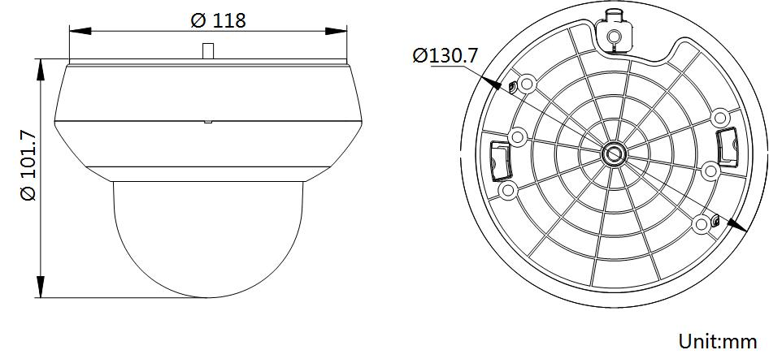

**Accessories**

|  |  |  |
| --- | --- | --- |
| DS-1294ZJ-PT | 1294ZJ-PT | Wall Mounting Bracket |