HNP302A-IR/30X auto tracking

2 MP 30X Network IR PTZ Auto Tracking Dome Camera

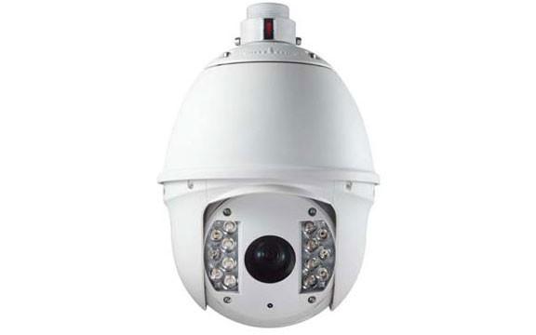

|  |
| --- |
| Features |
| 1/3" Progressive Scan CMOS |
| 30X optical zoom, 16X digital zoom |
| Smart Tracking, Defog, ROI encoding, HLC |
| Smart IR, 120m IR distance |
| 3-Streams |
| True Day/Night, 3D DNR, Digital WDR |
| 3D intelligent positioning |
| 24VAC / High-PoE power supply |
|  |
|  |

**Specification Detail**

Image Sensor: 1/2.8" Progressive Scan CMOS Effective Pixels: 1320K pixels

Min. Illumination: Color: 0.05Lux (F1.6, AGC ON), B/W: 0.005Lux@(F1.6, AGC On); 0 Lux with IR White Balance: Auto/Manual/ATW/Indoor/Outdoor/Daylight lamp/Sodium lamp

AGC: Auto/Manual

S/N Ratio: >50dB

Day & Night: IR Cut Filter

Digital Zoom: 16X

Privacy Masking: Up to 24 zones, maximum 8 zones on a same image, multiple colors and mosaics optional

Backlight Compensation: HLC/BLC Digital Noise Reduction: 3D DNR Wide Dynamic Range: Digital WDR

Shutter Speed: 50Hz: 1~1/30,000s; 60Hz: 1~1/30,000s Focus Mode: Auto/Semiautomatic/Manual Enhancement: Smart Defog: on/off

Focal Length: 4.3 ~ 129.0mm, 30x

Zoom Speed: Approx.3s(Optical Wide-Tele) Angle of View: 57.4 ~ 2.8degree (Wide-Tele) Min. Working Distance: 10 ~ 1,500mm (Wide-Tele) Aperture Range: F1.6 ~ F5.0

Smart Tracking: Support

Pan / Tilt Range: Pan: 360° endless; Tilt: -2° ~ 90° (Auto-Flip)

Pan / Tilt Speed: Pan Manual Speed: 0.1° ~ 160° /s, Pan Preset Speed: 160° /s

Tilt Manual Speed: 0.1° ~ 120° /s, Tilt Preset Speed: 120° /s

Proportional Zoom: Rotation speed can be adjusted automatically according to zoom multiples

Number of Preset: 256

Patrol: 8 patrols, up to 32 presets per patro

Pattern: 4 patterns, with the recording time not less than 10 minutes per pattern

Power-off Memory: Support

Park Action: Preset/Patrol/Pattern/Pan scan/Tilt scan/Random scan/Frame scan, Panorama scan

PTZ Position Display: On/Off

Preset Freezing: Support

Scheduled Task: Preset/Patrol/Pattern/Pan scan/Tilt scan/Random scan/Frame scan/Panorama scan/Dome reboot/Self-test/Alarm output

Smart IR: Support

IR Distance: Up to 600 ft

IR Intensity: Automatically adjusted, depending on the zoom ratio

Alarm Input: 7

Alarm Output: 2 relay outputs, alarm response actions configurable

Alarm Action: Preset, Patrol, Pattern, SD/SDHC card recording, Relay output, Notification on Client

Video Output: Audio Input:

Audio Output:

Ethernet: 10Base-T/100Base-TX, RJ45 connector

Max. Image Resolution: 1920x1080

Frame Rate: 60Hz: 30 fps (1920 x 1080), 30 fps (1280 x 960) 30 fps (1280 x 720) Image Compression: H.264/MPEG4, H.264 encoding with Baseline/Main/High profile

ROI encoding: Support 24 areas with adjustable levels

Audio Compression: G.711u/G.711a/G.726

Protocols: IPv4/IPv6, HTTP, HTTPS, 802.1x, Qos, FTP, SMTP, UPnP, SNMP, DNS, DDNS, NTP, RTSP, RTP, TCP/IP, UDP, IGMP, ICMP, DHCP, PPPoE

Simultaneous Live View: Up to 10

Streams: Three Streams

Mini SD Memory Card: Built-in SD/SDHC Slot, up to 32GB, support manual/alarm/edge recording

User/Host Level: Up to 32 users, 3 Levels: Administrator, Camera control, Live view only

Security Measures: User authentication (ID and PW), Host authentication (MAC address); IP address filtering

Application programming: Open-ended API, support Onvif, PSIA and CGI

Web Browser: IE 7, IE 8, IE 9, Chrome 8+, Firefox 3.5+, Safari 5+, support multi-language

RS-485 Protocols: HIKVISION, Pelco-P, Pelco-D, self-adaptive

Working Temperature: 24VAC: -40°C~65°C (-40°F~149°F) High-PoE: -30°C~65°C (-22°F~149°F)

Humidity: 90% or less

Protection Level: IP66 standard (outdoor dome)

TVS 4,000V lighting protection, surge protection and voltage transient protection

Dimensions:

Weight (approx.): 5.5kg (12.13lbs)

Mount Option: Long-arm wall mount: DS-1614ZJ; Corner mount: DS-1633ZJ, Pole Mount: DS-1622ZJ; Power box mount: DS-1634ZJ

Power: 24VAC: Max. 65W (heater: 45W) High-PoE: Max. 50W (heater: 20W)