

**Human Body Detection**

* Deep learning-based analysis: re-recognition of the human body target in behavior detection to filter false alarm

**Video Input and Transmission**

* Up to 32-ch IP cameras can be connected
* Connectable to the third-party network cameras

**HD Video Output and Decoding**

* H.265/H.265+/H.264/H.264+/MPEG4 self-adaptive
* Up to 8-ch decoding at 1080p resolution
* HDMI1/VGA1 and HDMI2/VGA2 simultaneous outputs provided
* HDMI1 output at up to 4K (4096 x 2160) resolution

**Storage and Playback**

* Full channel recording at up to 12 MP resolution
* Up to 8 TB capacity for each HDD supported
* HDD hot swap with RAID0, RAID1, RAID5, RAID6 and RAID10 storage scheme configurable
* 8-ch synchronous playback at 1080p resolution

**Smart & POS Function**

* Supports multiple VCA(Video Content Analytics) events
* Smart search for the selected area in the video; and smart playback to improve the playback efficiency
* Supports VCA search for fire/ship/temperature/temperature difference detection triggered video files
* POS information overlay on live view and playback
* POS triggered recording and alarm

**Network & Ethernet Access**

* ANR technology to enhance the storage reliability when the network is disconnected
* Configurable normal or hot spare working mode to constitute an N+1 hot spare system

**Network & Ethernet Access**

* Cloud P2P for easy network management
* 2 Gigabit Ethernet network interface

**HNRA10-32/S Network Video Recorder**

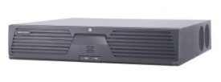

**Features and Functions**

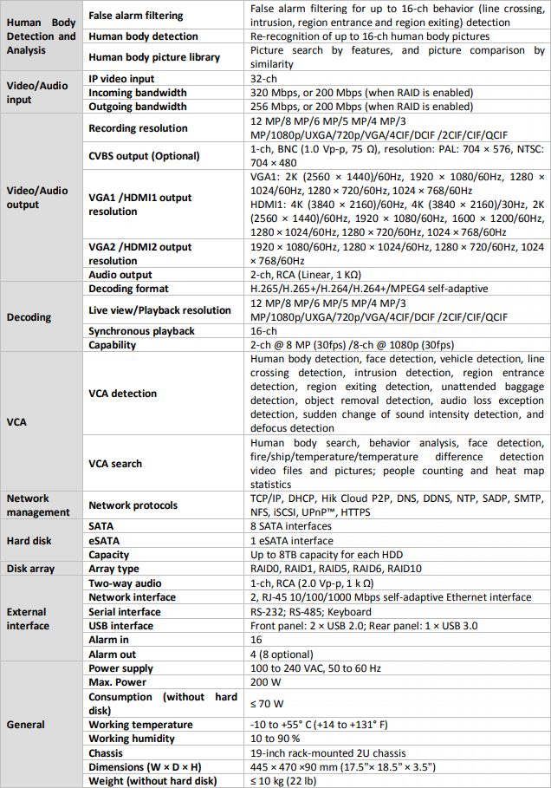

**Specifications**

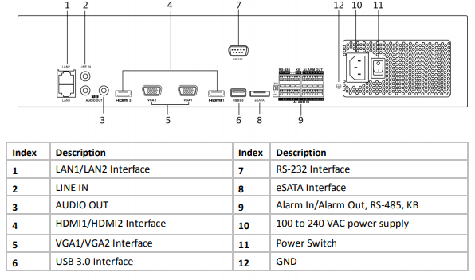

**Available Models**

HNRA10-32/S

**Physical Interfaces**