

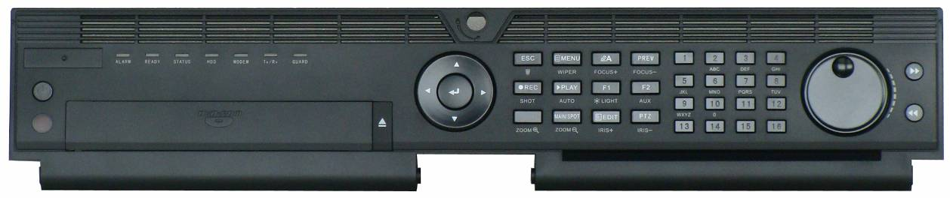

**NRA10 SERIES NVR**

**Features and Functions**

**Professional and Reliable**

* New logical and visualized GUI design
* Dual-OS design to ensure high reliability of system running
* ANR technology to enhance the storage reliability when the network is disconnected
* HDD hot swap with RAID0, RAID1, RAID5, RAID6 and RAID10 storage scheme configurable
* Configurable normal or hot spare working mode to constitute an N+1 hot spare system

**Video Input and Transmission**

* Adopt stream over TLS encryption technology (enhanced SDK service and RTP over HTTPS protocol) which provides more secure stream transmission service (max. 128 Mbps TLS stream outgoing bandwidth, when RAID is enabled, it will restrict TLS stream outgoing bandwidth to 64 Mbps)
* Up to 64-ch IP cameras can be connected (up to 12 MP)
* Connectable to the third-party network cameras

**Compression and Recording**

* H.265+ compression effectively reduces the storage space by up to 75%
* Full channel recording at up to 12MP resolution

**HD Video Output**

* HDMI1/VGA1 and HDMI2/VGA2 outputs provided
* HDMI1 Video output at up to 4K (3840 × 2160) resolution

**Storage and Playback**

* Up to 8 SATA interfaces and 1 eSATA interface for HDD connection
* 10TB capacity for each HDD
* 8/16-ch synchronous playback at up to 1080p resolution
* Important files management
* HDD health monitoring

**Smart &POS Function**

* Supports multiple VCA (Video Content Analytics) events
* Smart search for the selected area in the video; and smart playback to improve the playback efficiency
* Supports VCA search for fire/ship/temperature/temperature difference detection triggered video files
* POS information overlay on live view and playback
* POS triggered recording and alarm

**Network & Ethernet Access**

* Hik-Connect for easy network management
* 2 Gigabit Ethernet network interfaces

**Specifications**

|  |  |  |  |  |  |
| --- | --- | --- | --- | --- | --- |
| **Model** |  | **9608NI-I8** | **9616NI-I8** | **NRA10-32** | **NRA10-64** |
| **Video/Audio input** | **IP video input** | 8-ch | 16-ch | 32-ch | 64-ch |
| Up to 12 MP resolution | | | |
| **Two-way audio** | 1-ch, RCA (2.0 Vp-p, 1 k Ω) | | | |
| **Network** | **Incoming bandwidth** | 128 Mbps | 256 Mbps | 320 Mbps | 320 Mbps |
| or 200 Mbps (when RAID is enabled) | | |
| **Outgoing bandwidth** | 256 Mbps, or 200 Mbps (when RAID is enabled) | | | |
| **Remote connection** | 128 | | | |
| **Video/Audio output** | **Recording resolution** | 12 MP/8 MP/6 MP/5 MP/4 MP/3 MP/1080p/UXGA/720p/VGA/4CIF/DCIF  /2CIF/CIF/QCIF | | | |
| **CVBS output (Optional)** | 1-ch, BNC (1.0 Vp-p, 75 Ω), resolution: PAL: 704 × 576, NTSC: 704 × 480 | | | |
| **VGA1 /HDMI1 output**  **resolution** | HDMI1: 4K (3840 × 2160)/60Hz, 4K (3840 × 2160)/30Hz, 2K (2560 × 1440)/60Hz, 1920 × 1080p/60Hz, 1600 × 1200/60Hz, 1280 × 1024/60Hz, 1280 × 720/60Hz, 1024 × 768/60Hz | | | |
| VGA1: 2K (2560 × 1440)/60Hz, 1920 × 1080p/60Hz, 1600 × 1200/60Hz, 1280 × 1024/60Hz, 1280 × 720/60Hz, 1024 × 768/60Hz | | | |
| **VGA2 /HDMI2 output**  **resolution** | 1920 × 1080p/60Hz, 1280 × 1024/60Hz, 1280 × 720/60Hz, 1024 × 768/60Hz | | | |
| **Audio output** | 2-ch, RCA (2.0Vp-p, 1 KΩ) | | | |
| **Decoding** | **Decoding format** | H.265/H.265+/H.264/H.264+/MPEG4 | | | |
| **Live view/Playback resolution** | 12 MP/8 MP/6 MP/5 MP/4 MP/3 MP/1080p/UXGA/720p/VGA/4CIF/DCIF  /2CIF/CIF/QCIF | | | |
| **Synchronous playback** | 8-ch | 16-ch | | |
| **Capability** | 2-ch @ 12 MP (20fps) / 4-ch @ 8 MP (25fps) / 8-ch @ 4MP (30fps) / 16-ch @ 1080p (30fps) | | | |
| **Network management** | **Network protocols** | TCP/IP, DHCP, Hik-Connect, DNS, DDNS, NTP, SADP, SMTP, NFS, iSCSI, UPnP™, HTTPS | | | |
| **Hard disk** | **SATA** | 8 SATA interfaces | | | |
| **eSATA** | 1 eSATA interface | | | |
| **Capacity** | Up to 10TB capacity for each HDD | | | |
| **Disk array** | **Array type** | RAID0, RAID1, RAID5, RAID6, RAID10 | | | |
| **Number of arrays** | 4 | | | |
| **External interface** | **Network interface** | 2, RJ-45 10/100/1000 Mbps self-adaptive Ethernet interface | | | |
| **Serial interface** | RS-232; RS-485; Keyboard | | | |
| **USB interface** | Front panel: 2 × USB 2.0; Rear panel: 1 × USB 3.0 | | | |
| **Alarm in/out** | 16/4 | | | |
| **General** | **Power supply** | 100 to 240 VAC, 50 to 60 Hz | | | |
| **Max. Power** | 200 W | | | |
| **Consumption**  **(without hard disk)** | ≤ 30 W | | | |
| **Working temperature** | -10 °C to 55 °C (14 °F to 131 °F) | | | |
| **Working humidity** | 10 to 90 % | | | |
| **Dimensions(W × D × H)** | 445 × 470 ×90 mm (17.5"× 18.5" × 3.5") | | | |
| **Weight**  **(without hard disk)** | ≤ 10 kg (22 lb) | | | |

|  |  |  |  |
| --- | --- | --- | --- |
| **Index** | **Description** | **Index** | **Description** |
| **1** | LAN1/LAN2 Interface | **7** | RS-232 Interface |
| **2** | LINE IN | **8** | eSATA Interface |
| **3** | AUDIO OUT | **9** | Alarm In/Alarm Out |
| **4** | HDMI1/HDMI2 Interface | **10** | 100 to 240 VAC power supply |
| **5** | VGA1/VGA2 Interface | **11** | Power Switch |
| **6** | USB 3.0 Interface | **12** | GND |

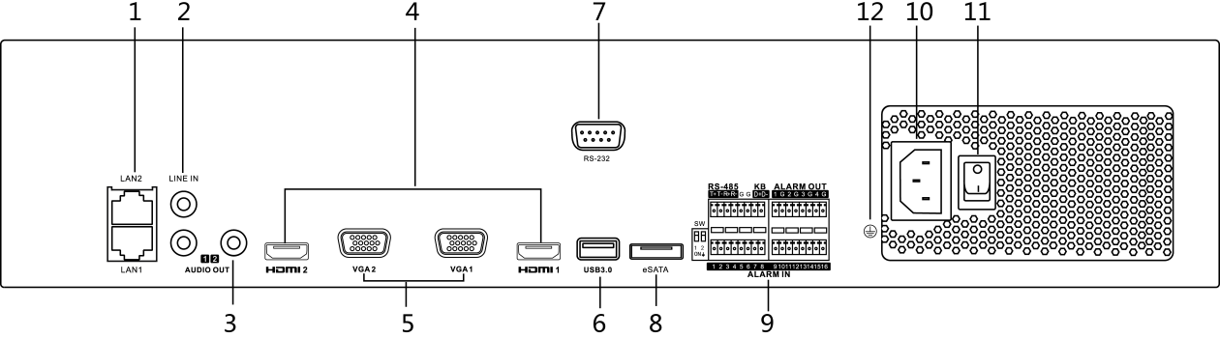

**NRA10-32**, **NRA10-64**

**Available Models**

**Physical Interfaces**