

**Professional and Reliable**

* Pluggable HDD design provides a convenient HDD installation and maintenance way; Unique chassis based on patented design ensures environmental friendly and low-noise running.
* Adopts professional embedded hardware and software, and pioneering dual-OS design to ensure the reliability of system running.
* Supports redundant power supply to improve the system stability.
* Adopts ANR technology to enhance the storage reliability when the network disconnected.
* Supports HDD hot swap with RAID0, RAID1, RAID5, RAID6, and RAID10 storage scheme configurable.
* Either normal or hot spare working mode is configurable to constitute an N+1 hot spare system.
* Extension board is optional

**HD Input**

* Connectable to the third-party network cameras like ACTI, Arecont, AXIS, Bosch, Brickcom, Canon, ONVIF, PANASONIC, Pelco, PSIA, SAMSUNG, SANYO, SONY, Vivotek and ZAVIO
* Up to 128/256 IP cameras can be connected.
* Supports live view, storage, and playback of the connected camera at up to 12 megapixels resolution.

**HD Output**

* Simultaneous HDMI1/VGA output as the main output and the HDMI 2 works as the auxiliary output.
* Video outputs at up to 4K (4096x2160) resolution.
* Supports decoding up to 20 channels at 1080p resolution.

**HD Storage**

* Up to 24 SATA hard disks can be connected, for both recording and backup.

**HD Transmission**

* 4 self-adaptive 10M/100M/1000M network interfaces.

**Various Applications**

* Centralized management of IP cameras is supported, including configuration, information import/export, real-time information display, two-way audio, upgrade, etc.
* Connectable to smart IP cameras from Perfectview and the recording, playing back, and backing up of VCA alarms can be realized.
* VCA detection alarm is supported.
* VCA search for face detection, behavior analysis, people counting and heat map.
* Supports start record with one key.
* Realizes instant playback for assigned channel during multi-channel display mode.
* Smart search for the selected area in the video; and smart playback to improve the playback efficiency.
* Supports HDD quota and group modes; different capacity can be assigned to different channels.

**HNRT00-128/I24 - HNRT00-256/I24**

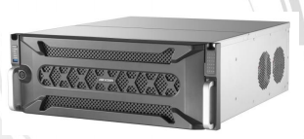

**Features and Functions**

**Specifications**

|  |  |  |
| --- | --- | --- |
| **Video & Audio Input** | IP video input | HNRT00-128/I24:128-ch  HNRT00-256/I24: 256-ch |
| Incoming/outgoing  Bandwidth | HNRT00-128/I24:576 Mbps/512 Mbps  HNRT00-256/I24: 768 Mbps/768 Mbps |
| Incoming/outgoing  Bandwidth (RAID mode) | HNRT00-128/I24:576 Mbps/512 Mbps  HNRT00-256/I24: 768 Mbps/768 Mbps |
| Protocol | Perfect View, ACTi, ARECONT, AXIS, BOSCH, BRICKCOM, CANON, HUNT, ONVIF (Version 2.5), PANASONIC, PELCO, PSIA, RTSP, SAMSUNG, SONY, VIVOTEK, ZAVIO |
| **Video & Audio Output** | HDMI output | Two independent HDMI outputs of 4K resolution. Resolution: 4K (4096 × 2160), 4K (3840 × 2160)/30Hz, 2K (2560 × 1440)/60Hz, 1080p (1920 × 1080)/60Hz, UXGA (1600 × 1200)/60Hz, SXGA (1280 × 1024)/60Hz, 720p (1280 × 720)/60Hz, XGA (1024 × 768)/60Hz |
| VGA Output | 1-ch. Resolution: 1080p (1920 × 1080)/60Hz, UXGA (1600 × 1200)/60Hz, SXGA (1280 × 1024)/60Hz, 720p (1280 × 720)/60Hz, XGA (1024 × 768)/60Hz |
| LCD output (optional) | One 7 inch LCD |
| Audio output | 1-ch. RCA (2.0 Vp-p, 1 KΩ) |
| **Video & Audio decoding** | Decoding format | H.265, H.265+, H.264, H.264+,MPEG4, MJPEG |
| Video resolution | 12 MP/8 MP/7 MP/6 MP/5 MP/4 MP/3 MP/1080p/UXGA/720p/VGA/4CIF/DCIF/2CIF/CIF/QCIF |
| Synchronous playback | Up to 16 channels |
| Capability | 20-ch @ 1080p |
| **HDD** | Interface | 24 SATA interfaces supporting hot-plug |
| Capacity | Up to 8 TB for each HDD |
| **RAID** | RAID Type | RAID0, RAID1, RAID5, RAID 6, RAID10, RAID50, RAID60, and JBOD |
| **Network management** | Protocol | IPv6, HTTPS, UPnP, SNMP, NTP, SADP, SMTP, NFS, iSCSI, PPPoE, DDNS |
| Network interface | 4, RJ45 10M/100M/1000M self-adaptive Ethernet interface |
| **External interface** | Two-way audio input | 1-ch, RCA (2.0 Vp-p, 1 KΩ) |
| Serial port | 1 RS-485, Keyboard |
| USB interface | Front Panel: 2 × USB 2.0; Rear Panel: 2 × USB 3.0 |
| Alarm input/output | 16/8 |
| Extension board (optional) | One extension board is supported with four 10M/100M/1000M optical interfaces (1.25 Gbps SFP module), eight RS-485 interfaces, and alarm interface of 32 alarm inputs and 16 alarm outputs. |
| Decoding board | 1 |
| **General** | Power supply | 100 to 240 VAC, 550W |
| Fan | Redundant dual ball bearing fan; Speed adjustable; Hot-plug |
| Consumption (no HDD) | ≤ 140W |
| Working temperature | 0 °C to + 50 °C (32 °F to 122 °F) |
| Working humidity | 10% to 90% |
| Chassis | 4U |
| Dimensions (WxDxH) | 447 × 528 × 172mm (17.6 × 20.8 × 6.8 inch) |
| Weight (no HDD) | ≤ 23 kg (50.7 lb) |

**Physical Interfaces**

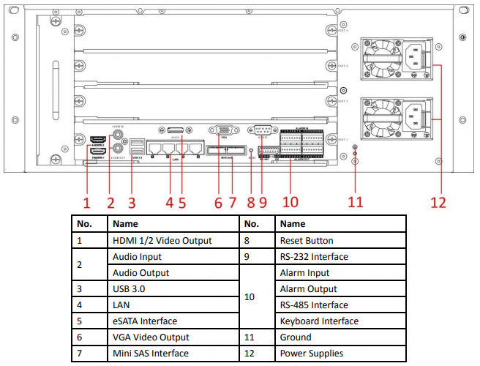

**Available Models**

HNRT00-128/I24 - HNRT00-256/I24

2016.07