

**HTD4136-50**

**Thermal & Optical Bi-spectrum Network Speed Dome**

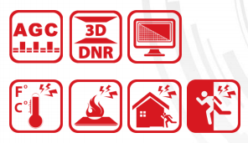 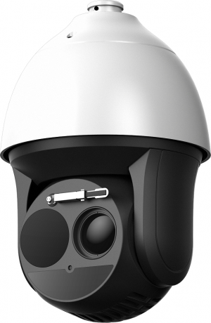

|  |  |
| --- | --- |
| Perfect View HTD4136-50 Thermal & Optical Bi-spectrum Network Speed Dome is applied to perimeter defense and fire-prevention purposes in critical infrastructures such as: airport, railway, prison, power station, 4S stores, and so on. The pre-alarm system helps you discover unexpected events immediately and protects you from property loss. | **Smart Function (Thermal Imaging)**   * Leading image processing technology: Adaptive AGC, DDE, 3D DNR, NETD < 40mk (@25° C, F#=1.0)Up to 2592 × 1944 resolution * Smart tracking: Panorama tracking, Event tracking and Multi-scene patrol tracking * Smart tracking linkage: thermal view and optical view * Powerful behavior analysis algorithm: Line crossing, Intrusion, Region Entrance & Exit * Reliable temperature exception alarm function * Advanced fire detection algorithm   **Thermal Imaging Module Function**   * 384x288 resolution, high sensitivity sensor, support contrast adjustment * Support shutter adjustment in various modes * 3D DNR, 15 palettes of color adjustable, image detail enhancements |

**Specification**

|  |  |  |
| --- | --- | --- |
| **Thermal Module** | | |
| Image Sensor | Vanadium Oxide Uncooled Focal Plane Arrays | |
| Max. Resolution | 384 x 288 | |
| Detector Pitch | 17μm | |
| Response Waveband | 8μm to 14μm | |
| NETD | < 40mk (@25° C,F#=1.0) | |
| Lens (focal length | 50mm | |
| MRAD | 0.34 | |
| Field of View | 7.47°x5.61° | |
| Min. Focusing Distance | 7.5 m | |
| F Number | 1.0 | |
| **Optical Camera** | |  |
| Image Sensor | | 1/1.9’’ Progressive Scan CMOS |
| Min. Illumination | | Color: 0.002 lux @ (F1.5 , AGC On ) B/W : 0.0002 lux @ (F1.5 , AGC On ) |
| Shutter Time | | 1-1/30,000s |
| White Balance | | Auto/Manual /ATW/Indoor/Outdoor/Daylight lamp/Sodium lamp |
| Focal Length | | 5.7-205.2mm, 36x |
| Day & Night | | IR cut filter |
| Digital Zoom | | 16× |
| Privacy Mask | | 24 privacy masks programmable; optional multiple colors and mosaics |
| Focus Mode | | Auto/Semi-automatic/Manual |
| Field of View | | 58.7° - 2.0° (Wide-Tele) |
| Optical Defog | | Yes |
| Enhancement | | 3D DNR |
| WDR | | 120db |
| Aperture Range | | F1.5-F4.5 |
| Min. Working Distance | | 10-1500mm (Wide-Tele) |
| **Smart Function** | | |
| VCA | | Support 4 VCA rule types (Line Crossing, Intrusion, Region Entrance, and Region Exiting), 10 scenes and 8 VCA rules for each scene. |
| Temperature Measurement | | Support 3 temperature measurement rule types, over 256 presets as scene, 21 rules of each scene (10 points, 10 regions, and 1 line) |
| Temperature Range | | -20 ° C to 150 ° C (-4 ° C to 302 ° F) |
| Temperature Accuracy | | ± 8 °C (14.4 ° F) |
| Fire Detection | | Support 10 fire points |
| **PTZ** | | |
| Movement Range (Pan) | | Pan: 360° Continuous Rotate; Tilt: From -15° to + 90° (auto flip) |
| Pan Speed | | Configurable, From 0.1° /s to 160° /s, Preset Speed: 240° /s |
| Tilt Speed | | Configurable, From 0.1° /s to 120° /s, Preset Speed: 200° /s |
| Proportional Zoom | | Yes |
| Presets | | 300 |
| Patrol Scan | | 8 patrols, up to 32 presets for each patrol |
| Pattern Scan | | 4; More Than 10 Minutes Per Pattern |
| Power-off Memory: | | Yes |
| Park Action | | Preset/Pattern Scan/Patrol Scan/Auto Scan/Tilt Scan/Random Scan/Frame Scan/Panorama Scan |
| PTZ Status | | Turn On/Turn Off |
| Scheduled Task | | Preset/Pattern Scan/Patrol Scan/Auto Scan/Tilt Scan/Random Scan/Frame Scan/Panorama Scan/Dome Reboot/Dome Adjust/Aux Output |
| **Smart Features** | | |
| Basic Event Detection | | Motion Detection, Video Tampering, Alarm Input, Alarm Output, Exception |
| Smart Event Detection | | Audio Exception Detection, Face Detection, Intrusion Detection, Line Crossing Detection, Region Entrance Detection, Region Exiting Detection |
| Auto-tracking | | Support |
| Smart Record | | ANR (Automatic Network Replenishment), Dual-VCA |
| **Infrared** | | |
| IR Distance | | Up to 200m |
| IR Intensity and Angle | | Auto Adjust |
| **Network** | | |
| Main Stream | | Optical: 50Hz:25fps(1920× 1080), 25fps(1280× 960), 25fps(1280× 720)  Optical: 60Hz:30fps(1920× 1080), 30fps(1280× 960), 30fps(1280× 720)  Thermal: 50fps(384 × 288) |
| Sub-Stream | | 50Hz:25fps (704 × 576), 25fps (352 × 288), 25fps (176 × 144)  60Hz:30fps (704 × 480), 30fps (352 × 240), 30fps (176 × 120)  Thermal: 50fps (384 × 288) |
| Video Compression | | H.264 (Baseline/Main/High Profile) /MJPEG/MPEG4 |
| Audio Compression | | G.711u/G.711a/G.722.1/MP2L2/G.726/PCM |
| Protocols | | IPv4/IPv6,HTTP,HTTPS,802.1x,Qos,FTP,SMTP,UPnP,SNMP,DNS,DDNS,NTP,RTSP,RTCP,RTP,TCP,UDP,I GMP,ICMP,DHCP, PPPoE, Bonjour |
| Simultaneous Live View | | Up to 20 channels |
| User/Host | | Up to 32 users, 3 levels: Administrator, Operator and User |
| Security Measures | | User authentication (ID and PW), MAC address binding, HTTPS encryption, IEEE 802.1x access control, IP address filtering |
| **System Integration** | | |
| Alarm Input | | Up to 7-ch Input (0-5V DC) |
| Alarm Output | | Up to 2-ch Relay Output; Support Alarm Linkage |
| Alarm Linkage | | Preset/Patrol Scan/Pattern Scan/SD Card Record/Relay Output/Smart capture/FTP upload/Email linkage |
| Audio Input | | LINE_IN Input/MIC Input; Peak: From 2 to 2.4V[p-p]; Output Impedance: 1KΩ±10% |
| Audio Output | | Linear Level; Impedance: 600Ω |
| Network Interface | | Built-in RJ45; 10M/100M Ethernet Interface |
| Storage | | Built-in Micro SD/SDHC/SDXC Card Slot, Up to 64GB; Support Manual/Alarm Recording |
| Analog Video Output | | 1.0V [p-p]/75Ω, PAL/NTSC/BNC |
| RS-485 | | Half-Duplex; PELCO-P and PELCO-D Self-adaptive |
| API | | Open-ended, support ONVIF, ISAPI, and CGI, support Third-Party Management Platform |
| Client | | CMS, Guarding Vision |
| Web Browser | | IE 7+, Chrome 18+, Firefox 5.0+, Safari 5.02+; Multiple Languages |
| **General** | | |
| Power | | 24V AC, 60W |
| Working Temperature | | From -40° C to 60° C (-40° F to 140°F); Humidity: 90% or Less |
| Menu | | English |
| Protection Level | | IP66 Standard; TVS 6000V Lightning Protection, Surge Protection and Voltage Transient Protection |
| Wiper | | Yes |
| Weight | | Approx. 8kg (17.64 lb) |

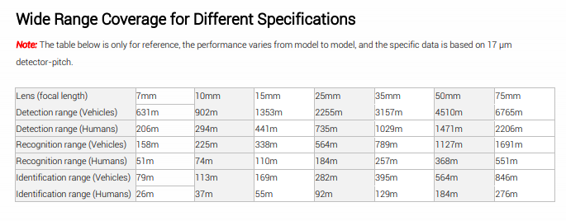

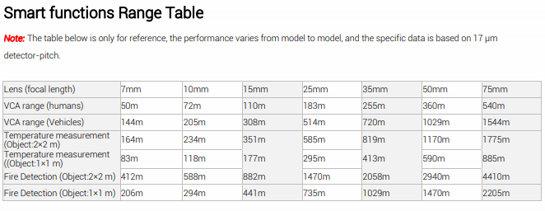

**Order Model**

|  |
| --- |
| HTD4136-50 |

