

**HNC312-MB**

**2 MP IR Network Camera**

* **Up to 1920x1080 resolution**
* **Standard video compression with high compression ratio, ROI (region of interest) encoding**
* **Progressive scan CMOS, capture motion video without incised margin**
* **Dual stream and sub-stream for mobile surveillance**
* **IR cut filter with auto switch**
* **PoE (Power over Ethernet)**
* **Ingress Protection level: IP67**
* **Electronic shutter**
* **Alarm, reset button, mirror**
* **VCA Support**

**Key Features**

|  |  |
| --- | --- |
| **Specifications** | |
| ***Camera*** | |
| Image Sensor | 1/2.8” Progressive Scan CMOS |
| Min. Illumination | Color: 0.01 Lux @ (F1.2, AGC ON), 0.028 Lux @ (F1.6, AGC ON), 0 Lux with IR |
| Shutter Speed | 1/3 s to 1/100,000 s |
| Slow Shutter | Yes |
| Auto-Iris | No |
| Day & Night | IR Cut Filter |
| Digital Noise Reduction | 3D DNR |
| Wide Dynamic Range | Digital WDR |
| 3-Axis Adjustment | Pan: 0° to 360°, tilt: 0° to 90°, rotate: 0° to 360° |
| ***Lens*** | |
| Lens | 4mm @ F2.0, Angle of view: 85° (6mm optional) |
| Lens Mount | Φ12 |
| ***IR*** |  |
| IR Range | 30 meters |
| ***Compression Standard*** |  |
| Video Compression | H.264/ MJPEG |
| Video Bit Rate | 32 Kbps - 8 Mbps |
| ***Image*** | |
| Max. Resolution | 1920 x 1080 |
| Main Stream | 50Hz: 25fps(1920 × 1080), 25fps (1280 × 960), 25fps (1280 × 720)  60Hz: 30fps(1920 × 1080), 30fps (1280 × 960), 30fps (1280 × 720) |
| Sub Stream | 50 Hz: 25 fps (320 x 240), 25 fps (352 x 288), 25 fps (640 x 480), 25fps(704 x 576)  60 Hz: 30 fps (320 x 240), 30 fps (352 x 288), 30 fps (640 x 480), 30fps(704 x 576) |
| Backlight Compensation | Yes, zone optional |
| Image Setting | Rotate mode, saturation, brightness, contrast, sharpness adjustable by client software or web browser |
| ROI | Support |
| ***Network*** | |
| Network Storage | NAS (Support NFS,SMB/CIFS) |
| Alarm Trigger | Tampering alarm, Network disconnect , IP address conflict, Storage exception |
| Protocols | TCP/IP, ICMP, HTTP, HTTPS, FTP, DHCP, DNS, DDNS, RTP, RTSP, RTCP, NTP, UPnP, SMTP, SNMP, IGMP, 802.1X, QoS, IPv6, Bonjour |
| General Function | One-key reset, anti-flicker, three streams, heartbeat, password protection, privacy mask, watermark, IP address filter, Anonymous access |
| Detection | Intrusion detection, Line crossing detection, Motion detection, Dynamic analysis |
| Standard | ONVIF, PSIA, CGI, ISAPI |
| Client | CMS & Guarding Vision |
| Web Browser | IE8+, Chrome 31.0-44, Firefox 30.0-51, Safari 8.0+ |
| ***Interface*** |  |
| Communication Interface | 1 RJ45 10M/100M self-adaptive Ethernet port |
| Reset Button | Yes |
| ***General*** | |
| Operating Conditions | -30 °C to +60 °C (-22 °F to +140 °F), Humidity 95% or less (non-condensing) |
| Power Supply | 12 VDC ± 10%, PoE (802.3af, class 2) |
| Power Consumption and Current | Max 5.2W |
| Protection Level | IP67 |
| Material | Front Cover&Back Cover&Bracket: Metal |
| Dimensions | Φ70×154.2×60.5 mm (2.8” × 6.2” × 2.4”) |
| Weight | 500g (1.1 lbs) |

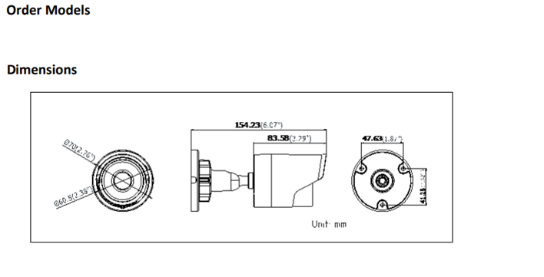

**20170509**

**050401160509**

**050401160405**