

**HNC312-PH**

**2 MP Mini Network Camera**

|  |  |
| --- | --- |
| Without /M model | With /M model |

## Key Features

* 1/2.7" Progressive Scan CMOS

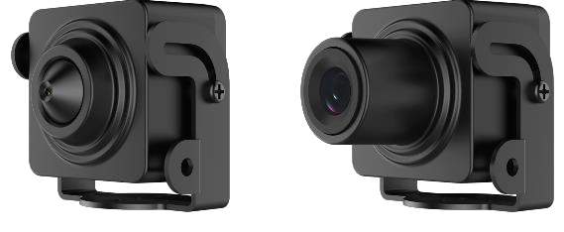

* 1920 × 1080@30 fps
* H.265+, H.265, H.264+, H.264
* 6 Behavior analyses, 2 exception detections and face detection
* 3D DNR/ROI
* Support NAS (NFS, SMB/CIFS)
* 120dB WDR



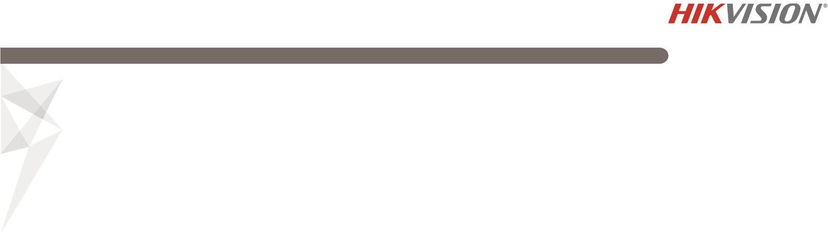

**Specifications**

|  |  |
| --- | --- |
| ***Camera*** | |
| Image Sensor | 1/2.7" Progressive Scan CMOS |
| Min. Illumination | Without /M model:  Color: 0.025 Lux @ (F1.2, AGC ON), Color: 0.109 Lux @ (F2.5, AGC ON) B/W: 0.005 Lux @ (F1.2, AGC ON), B/W: 0.022 Lux @ (F2.5, AGC ON)  With /M model:  Color: 0.025 Lux @ (F1.2, AGC ON), Color: 0.069 Lux @ (F2.0, AGC ON) B/W: 0.005 Lux @ (F1.2, AGC ON), B/W: 0.014 Lux @ (F2.0, AGC ON) |
| Shutter Speed | 1/3 s to 1/100,000 s |
| Slow Shutter | Yes |
| Auto-Iris | No |
| Day & Night | Electronic |
| Digital Noise Reduction | 3D DNR |
| WDR | 120dB |
| ***Lens*** | |
| Focal Length | Without /M model: 3.7 mm With /M model: 2.8 mm, 4 mm |
| Focus | Fixed |
| FOV | Without /M model: 3.7 mm  horizontal FOV: 78°, vertical FOV: 43°, diagonal FOV: 90° With/M model:  2.8 mm  horizontal FOV: 114°, vertical FOV: 62°, diagonal FOV: 135°  4 mm  horizontal FOV: 86°, vertical FOV: 46°, diagonal FOV: 102.5° |
| Lens Mount | M12 |
| ***Compression Standard*** |  |
| Video Compression | H.265/H.264/MJPEG |
| H.264 Type | Baseline Profile/Main Profile/High Profile |
| H.264+ | Yes |
| H.265 Type | Main Profile |
| H.265+ | Yes |
| Video Bit Rate | 32 Kbps to 8 Mbps |
| ***Smart Feature-set*** |  |
| Behavior Analysis | Line crossing detection, intrusion detection, region entrance detection, region exit detection, unattended baggage detection, object removal detection |
| Exception | Scene change detection, defocus detection |
| Face Detection | Yes |
| Region of Interest | Support 1 fixed region for main stream, sub-stream and third stream |
| ***Image*** | |
| Max. Resolution | 1920 × 1080 |
| Main Stream | 50Hz: 25fps (1920 × 1080, 1280 × 960, 1280 × 720)  60Hz: 30fps (1920 × 1080, 1280 × 960, 1280 × 720) |
| Sub-Stream | 50Hz: 25fps (704 × 576, 640 × 480, 352 × 288)  60Hz: 30fps (704 × 480, 640 × 480, 352 × 240) |
| Third Stream | 50Hz: 1fps (1920 × 1080, 1280 × 960, 1280 × 720, 704 × 576, 640 × 480) |



|  |  |
| --- | --- |
|  | 60Hz: 1fps (1920 × 1080, 1280 × 960, 1280 × 720, 704 × 480, 640 × 480) |
| Image Enhancement | 3D DNR |
| Image Settings | Rotate mode, saturation, brightness, contrast, sharpness adjustable by client software or web browser |
| Day/Night Switch | Day/Night/Auto/Schedule |
| ***Network*** | |
| Network Storage | Support NAS (NFS, SMB/CIFS) |
| Alarm Trigger | Motion detection, video tampering, IP address conflict, illegal login |
| Protocols | TCP/IP, ICMP, HTTP, HTTPS, FTP, DHCP, DNS, DDNS, RTP, RTSP, RTCP, PPPoE, NTP, UPnP™, SMTP, SNMP, IGMP, 802.1X, QoS, IPv6, Bonjour |
| General Function | Anti-flicker, heartbeat, mirror, password protection, privacy mask, watermark, IP address filter |
| API | ONVIF (PROFILE S, PROFILE G), ISAPI |
| Simultaneous Live View | Up to 6 channels |
| User/Host | Up to 32 users  3 levels: Administrator, Operator and User |
| Client | iVMS-4200, Hik-Connect, iVMS-5200, iVMS-4500 |
| Web Browser | IE8+, Chrome 31.0-44, Firefox 30.0-51, Safari 8.0+ |
| ***Interface*** |  |
| Audio | 1 input (line in) |
| Communication Interface | 1 RJ45 10M/100M self-adaptive Ethernet port |
| Reset Button | Yes |
| ***General*** | |
| Operating Conditions | -30 °C to +60 °C (-22 °F to +140 °F), Humidity 95% or less (non-condensing) |
| Power Supply | 12 VDC ± 20%, Φ 5.5 mm coaxial plug power |
| Power Consumption and Current | 12 VDC, 0.3 A, max. 3 W |
| Material | Aluminum Alloy |
| Dimensions | Without /M model: 31 mm × 31 mm × 26 mm (1.2" × 1.2" × 1")  With /M model: 31 mm × 31 mm × 39 mm (1.2" × 1.2" × 1.5") |
| Weight | With package: approx. 202 g (0.4 lb.) Camera: approx. 93 g (0.2 lb.) |

## Available Models:

HNC312-PH

**Dimensions**

31.5(1.2")

### Without /M Model

22(0.9")

31.5(1.2")

26.6

(1")

31.5(1.2")

### With /M Model

22(0.9")

31.5(1.2")

39.2(1.5")

### Unit: mm (inch)



**20180716**