

**HNC312-RDW**

**2.0MP Recessed Mount Dome Camera**

* **Up to 1920x1080 high resolution**
* **Full HD1080p real-time video**
* **Efficient encoding capability**
* **Support Micro SD/SDHC/SDXC card slot, up to 128 GB**
* **Dual stream**
* **Tool-free installation**
* **Backlight Compensation**
* **Support DC12V & PoE power supply**
* **Digital WDR**
* **3D digital Noise Reduction**
* **Support EZVIZ Cloud service**
* **Mobile monitoring (CMS or Guarding Vision)**
* **Built-in Wifi optional**

**Key Features**

|  |  |
| --- | --- |
| **Specifications** | |
| ***Camera*** | |
| Image Sensor | 1/3” Progressive Scan CMOS |
| Min. Illumination | 0.01 Lux @ (F1.2, AGC ON |
| Shutter Speed | 1/3 s to 1/100,000 s |
| Day & Night | Electronic |
| Digital Noise Reduction | 3D DNR |
| Wide Dynamic Range | Digital WDR |
| ***Lens*** | |
| Lens | 4 mm fixed lens (2.7/6mm lens optional) |
| Angle of view | 4mm: 85°, 2.8mm: 106°, 6mm: 52° |
| Lens Mount | M12 |
| ***Compression Standard*** | |
| Video Compression | H.264/ MJPEG |
| H.264 Type | Baseline Profile/Main Profile |
| Video Bit Rate | 32 Kbps - 8 Mbps |
| Dual Streams | Support |
| ***Image*** | |
| Max. Resolution | 1920 x 1080 |
| Main Stream | 50Hz: 25fps(1920 × 1080, 1280 x 960, 1280 x 720)  60Hz: 30fps(1920 × 1080, 1280 x 960, 1280 x 720) |
| Backlight Compensation | Support, zone configurable |
| Image Setting | Rotate Mode, Saturation, brightness, contrast, sharpness adjustable by client software or web browser |
| Region of Interest | Support |
| ***Network*** | |
| Network Storage | NAS (Support NFS,SMB/CIFS), ANR |
| Alarm Trigger | Motion detection, Tampering alarm, Network disconnect , IP address conflict, Storage exception |
| Protocols | TCP/IP, UDP, ICMP, HTTP, HTTPS, FTP, DHCP, DNS, DDNS, RTP, RTSP, RTCP, NTP, UPnP, SMTP, SNMP, IGMP, 802.1X, QoS, IPv6, Bonjour |
| General Function | One-key reset, flash-prevention, dual stream, heartbeat, mirror, password protection, privacy mask, watermark, IP address filtering, Anonymous access |
| Standard | ONVIF (Profile S, Profile G), PSIA, CGI, ISAPI |
| D/N Switch | Auto/Schedule/Triggered by Alarm In |
| Client | CMS & Guarding Vision |
| ***Interface*** | |
| Communication Interface | 1 RJ45 10M/100M Ethernet interface |
| On-board Storage | Built-in Micro SD/SDHC/SDXC slot, up to 128GB |
| ***Wi-Fi *only for –W models*** | |
| Wireless Standards | IEEE802.11b, 802.11g, 802.11n |
| Frequency Range | 2.4 GHz ~ 2.4835 GHz |
| Channel Bandwidth | 20/40MHz Support |
| Protocols | 802.11b: CCK, QPSK, BPWK, 802.11g/n: OFDM |
| Security | 64/128-bit WEP, WPA/WPA2, WPA-PSK/WPA2-PSK, WPS |
| Transmit Output Power | 11b: 17±1.5dBm @ 11Mbps  11g: 14±1.5dBm @ 54Mbps  11n: 12.5±1.5dBm |
| Reception Sensitivity | 11b: -90dBm @ 11Mbps (Typical)  11g: -75dBm @ 54Mbps (Typical)  11n: -74dBm (Typical) |
| Transfer Rates | 11b: 11Mbps, 11g: 54Mbps, 11n: up to 150Mbps |
| Wireless Range | 50 meters *The performance varies based on actual environment |
| ***General*** | |
| Operating Conditions | -10 °C to +40 °C (-14 °F to 104 °F), Humidity 95% or less (non-condensing) |
| Power Supply | 12V DC +10%, PoE (802.3af) |
| Power Consumption | Max 4.2W |
| Dimensions | 93.9x121.6 |
| Weight | 200g |

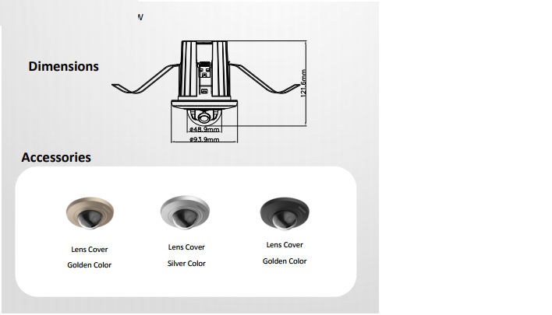

**20170509**

**050401160509**

**050401160405**