

**HNC312-TD**

**2MP Fixed Dome Network Camera**

* **Up to 1920x1080 resolution**
* **Standard video compression with high compression ratio, ROI (region of interest) encoding**
* **Progressive scan CMOS, capture motion video without incised margin**
* **Dual stream and sub-stream for mobile surveillance**
* **High-performance Infrared LED with 10-30 meters IR range**
* **Two-way audio (audio I/O)**
* **Support Wi-Fi**
* **IR cut filter with auto switch**
* **PoE (Power over Ethernet)**
* **Ingress Protection level: IP67**
* **Electronic shutter**
* **VCA Support**
* **Built-in Micro SD/SDHC/SDXC card slot, up to 128 GB**
* **Rotate mode, alarm, mirror, reset button**
* **Intrusion detection and line crossing detection**

**Key Features**

|  |  |
| --- | --- |
| **Specifications** | |
| ***Camera*** | |
| Image Sensor | 1/2.8” Progressive Scan CMOS |
| Min. Illumination | Color: 0.01 Lux @ (F1.2, AGC ON), 0.028 Lux @ (F1.6, AGC ON), 0 Lux with IR |
| Shutter Speed | 1/3 s to 1/100,000 s |
| Day & Night | IR Cut Filter |
| Digital Noise Reduction | 3D DNR |
| Wide Dynamic Range | Digital WDR |
| 3-Axis Adjustment | Pan: 0° to 355°, tilt: 0° to 75°, rotate: 0° to 355° |
| ***Lens*** | |
| Lens | 4mm @ F2.0, Angle of view: 85° (6mm optional)  Angle of view: 106°(2.8mm), 85°(4mm), 52°(6mm) |
| Lens Mount | M12 |
| ***IR*** |  |
| IR Range | 30 meters |
| ***Compression Standard*** |  |
| Video Compression | H.264/ MJPEG |
| H.264 Type | Main Profile |
| Video Bit Rate | 32 Kbps - 8 Mbps |
| Dual Stream | Yes |
| Audio Compression(-S) | G.711/G.722.1/G.726/MP2L2 |
| Audio Bit Rate(-S) | 64Kbps(G.711)/16Kbps(G.722.1)/16Kbps(G.726)/32-128Kbps(MP2L2) |
| ***Image*** | |
| Max. Resolution | 1920 x 1080 |
| Main Stream | 50Hz: 25fps(1920 × 1080), 25fps (1280 × 960), 25fps (1280 × 720)  60Hz: 30fps(1920 × 1080), 30fps (1280 × 960), 30fps (1280 × 720) |
| Backlight Compensation | Yes, zone optional |
| Image Setting | Rotate mode, saturation, brightness, contrast adjustable by client software or web browser |
| ROI | Support |
| ***Network*** | |
| Network Storage | Local storage: Built-in Micro SD/SDHC/SDXC card slot, up to 128 GB.  NAS (Support NFS,SMB/CIFS) |
| Alarm Trigger | Intrusion detection, Line crossing detection, Motion detection, Dynamic analysis, Tampering alarm, Network disconnect , IP address conflict, Storage exception |
| Protocols | TCP/IP, ICMP, HTTP, HTTPS, FTP, DHCP, DNS, DDNS, RTP, RTSP, RTCP, NTP, UPnP, SMTP, SNMP, IGMP, 802.1X, QoS, IPv6, Bonjour |
| General Function | One-key reset, anti-flicker, three streams, heartbeat, password protection, privacy mask, watermark, IP address filter, Anonymous access |
| Standard | ONVIF, PSIA, CGI, ISAPI |
| Client | CMS & Guarding Vision |
| Security | User Authentication, Watermark |
| ***Interface*** |  |
| Communication Interface | 1 RJ45 10M/100M Ethernet interface |
| Alarm interface | N/A |
| Audio interface | N/A |
| ***General*** | |
| Operating Conditions | -30 °C to +60 °C (-22 °F to +140 °F), Humidity 95% or less (non-condensing) |
| Power Supply | 12 VDC ± 10%, PoE (802.3af, class 2) |
| Power Consumption and Current | Max 5.3W |
| Protection Level | IP67 |
| IR Range | 30 meters |
| Impact Protection | IEC60068-2-75Eh, 20J; 3n50102, up to IK10 |
| Dimensions | Φ111 x 82 (4.4” x 3.2”) |
| Weight | 500g (1.1 lbs) |

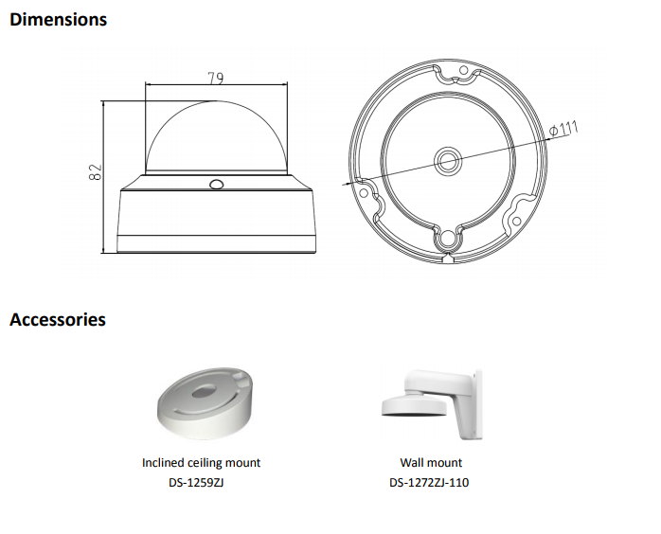

**050401160509**

**050401160405**