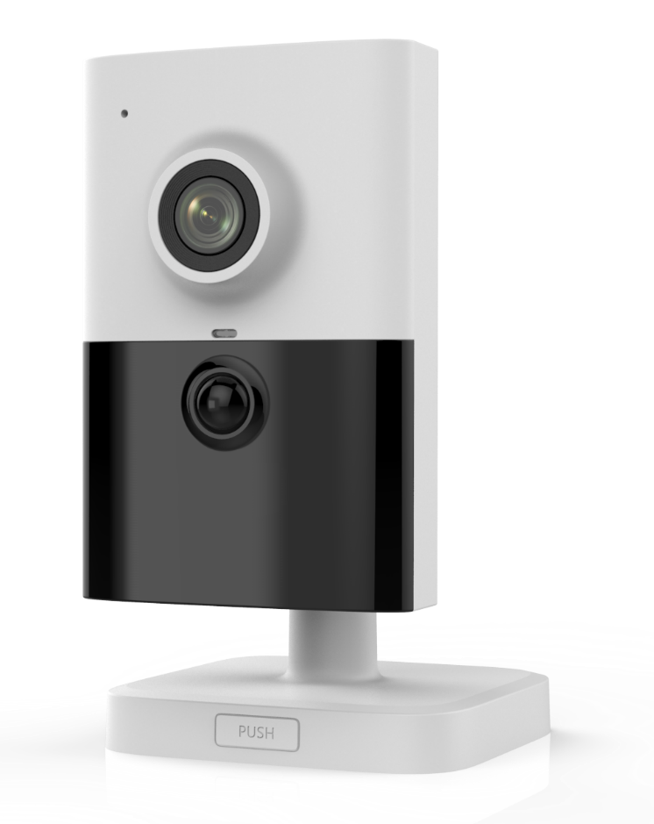

**NC324-CU**

**4 MP IR Fixed Cube Network Camera**

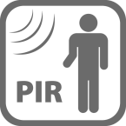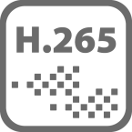

* 2688 × 1520 @ 30fps
* IR: up to 10 m
* PIR: 10 m
* H.265+, H.265, H.264+, H.264
* 120dB WDR
* Built-in MicroSD/SDHC/SDXC slot, up to 128G
* PoE
* BLC/3D DNR/HLC/ROI
* Wi-Fi
* Color: 0.01 Lux @ (F1.2, AGC ON), 0.018 lux @(F1.6, AGC ON), 0 lux with IR

**Key Features**

|  |  |
| --- | --- |
| **Specifications** | |
| ***Camera*** | |
| Image Sensor | 1/3" Progressive Scan CMOS |
| Min. Illumination | Color: 0.01 Lux @ (F1.2, AGC ON), 0.018 lux @(F1.6, AGC ON), 0 lux with IR |
| Shutter Speed | 1/3 s to 1/100,000 s |
| Slow Shutter | Yes |
| Day & Night | IR Cut Filter |
| Digital Noise Reduction | 3D DNR |
| WDR | 120dB |
| 3-Axis Adjustment | Pan: 0° to 360°, tilt: 0° to 90°, rotate: 0° to 360° |
| ***Lens*** | |
| Focal length | 2.8 mm |
| Aperture | F1.6 |
| FOV | 2.8 mm, horizontal FOV: 98°, vertical FOV: 55°, diagonal FOV: 114° |
| Lens Mount | M12 |
| ***IR*** |  |
| IR Range | 10 m |
| Wavelength | 850nm |
| ***PIR*** |  |
| Angle | Horizontal: 90°, Vertical: 80° |
| PIR Range | 10 m |
| ***Compression Standard*** |  |
| Video Compression | Main stream: H.265/H.264  Sub-stream: H.265/H.264/MJPEG  Third stream: H.265/H.264 |
| H.264 Type | Main Profile/High Profile |
| H.264+ | Main stream supports |
| H.265 Type | Main Profile |
| H.265+ | Main stream supports |
| Video Bit Rate | 256 Kbps to 16 Mbps |
| Audio Compression | G722.1/G711ulaw/G711alaw/G726/MP2L2/PCM |
| Audio Bit Rate | 64Kbps(G.711)/16Kbps(G.722.1)/16Kbps(G.726)/32-160Kbps(MP2L2) |
| ***Smart Feature-set*** |  |
| Behavior Analysis | Line crossing detection, intrusion detection |
| Face Detection | Yes |
| Region of Interest | Support 1 fixed region for main stream and sub-stream separately |
| ***Image*** | |
| Max. Resolution | 2688 × 1520 |
| Main Stream | 50Hz: 25fps (2688 × 1520, 2560 × 1440, 2304 × 1296, 1920 × 1080)  60Hz: 30fps (2688 × 1520, 2560 × 1440, 2304 × 1296, 1920 × 1080) |
| Sub-Stream | 50Hz: 25fps (640 × 480, 640 × 360, 320 × 240)  60Hz: 30fps (640 × 480, 640 × 360, 320 × 240) |
| Third Stream | 50Hz: 25fps (1280 × 720, 640 × 360, 352 × 288)  60Hz: 30fps (1280 × 720, 640 × 360, 352 × 240) |
| Image Settings | Rotate mode, saturation, brightness, contrast, sharpness adjustable by client software or web browser |
| Image Enhancement | BLC/3D DNR/HLC |
| Day/Night Switch | Day/Night/Auto/Schedule/Triggered by alarm in |
| ***Network*** | |
| Network Storage | Support Micro SD/SDHC/SDXC card (128G), local storage and NAS (NFS,SMB/CIFS), ANR |
| Alarm Trigger | Motion detection, video tampering, network disconnected, IP address conflict, HDD full, HDD error, PIR, illegal login |
| Protocols | TCP/IP, ICMP, HTTP, HTTPS, FTP, DHCP, DNS, DDNS, RTP, RTSP, RTCP, PPPoE, NTP, UPnP™, SMTP, SNMP, IGMP, QoS, IPv6 |
| General Function | One-key reset, anti-flicker, three streams, heartbeat, mirror, password protection, privacy mask, watermark, IP address filter |
| API | ONVIF (PROFILE S, PROFILE G), ISAPI |
| Simultaneous Live View | Up to 6 channels |
| User/Host | Up to 32 users  3 levels: Administrator, Operator and User |
| Client | CMS, Guarding Vision, Guarding Expert |
| Web Browser | IE8+, Chrome 31.0-44, Firefox 30.0-51, Safari 8.0+ |
| ***Interface*** |  |
| Audio | 1 built-in mic, 1 built-in speaker, mono sound |
| Communication Interface | 1 RJ45 10M/100M self-adaptive Ethernet port |
| On-board storage | Built-in Micro SD/SDHC/SDXC slot, up to 128G |
| SVC | Support H.264 and H.265 encoding |
| Reset Button | Yes |
| ***Wi-Fi (-W)*** |  |
| Wireless Standards | IEEE 802.11b/g/n |
| Frequency Range | 2.412 GHz to 2.4835 GHz |
| Channel Bandwidth | 20M/40M |
| Protocols | 802.11b: DQPSK, DBPSK, CCK 802.11g/n: OFDM/64-QAM, 16-QAM, QPSK, BPSK |
| Security | WPA, WPA2 |
| Transfer Rates | 11b: 11Mbps, 11g: 54Mbps, 11n: up to 150Mbps |
| Wireless Range | 50 m |
| ***Audio*** |  |
| Environment Noise Filtering | Yes |
| Audio Sampling Rate | 8kHz/16kHz/32kHz/44.1kHZ/48kHz |
| ***General*** | |
| Operating Conditions | -10 °C to +40 °C (14 °F to +104 °F), Humidity 95% or less (non-condensing) |
| Power Supply | 12 VDC ± 25%, PoE (802.3af, class 3) |
| Power Consumption and Current | 12 VDC, 0.5 A, max. 6 W, Φ 5.5 mm coaxial plug power  PoE (802.3af, 36V to 57V), 0.2 A to 0.1 A, max. 7W |
| Material | Plastic |
| Dimensions | 102.8 mm × 65.2 mm × 32.6 mm (4.1" × 2.6" × 1.3") |
| Weight | Camera: Approx. 128 g (0.3 lb.) |

**Dimensions**

