**NC324-XD**

**4 MP IR Fixed Turret Network Camera**

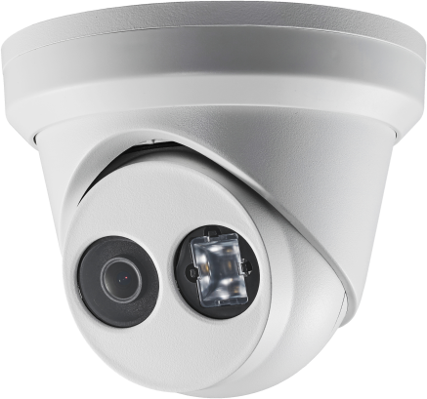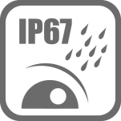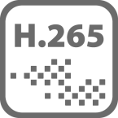

**Key Features**

* BLC/3D DNR/ROI
* IP67
* Built-in micro SD/SDHC/SDXC card slot, up to 128 GB
* 3-Axis adjustment
* 1/3" Progressive Scan CMOS
* 2688 × 1520 @30fps
* 2.8/4/6/8 mm fixed lens
* Color: 0.01 Lux @ (F1.2, AGC ON),

0.018 Lux @ (F1.6, AGC ON), 0 Lux with IR

* H.265+, H.265, H.264+, H.264
* Three streams
* 120dB WDR
* 2 Behavior analyses, and face detection

|  |  |
| --- | --- |
| **Specifications** | |
| ***Camera*** | |
| Image Sensor | 1/3" Progressive Scan CMOS |
| Min. Illumination | Color: 0.01 Lux @ (F1.2, AGC ON), 0.018 Lux @ (F1.6, AGC ON), 0 Lux with IR |
| Shutter Speed | 1/3 s to 1/100,000 s |
| Slow Shutter | Yes |
| Auto-Iris | No |
| Day & Night | IR Cut Filter |
| Digital Noise Reduction | 3D DNR |
| WDR | 120dB |
| 3-Axis Adjustment | Pan: 0° to 360°, tilt: 0° to 75°, rotate: 0° to 360° |
| ***Lens*** | |
| Focal length | 2.8/4/6/8 mm |
| Aperture | F1.6 |
| Focus | Manual |
| FOV | 2.8 mm @ F1.6: horizontal FOV: 103°, vertical FOV: 58°, diagonal FOV: 123°  4 mm @F1.6: horizontal FOV: 83°, vertical FOV: 45°, diagonal FOV: 99°  6 mm @F1.6: horizontal FOV: 51°, vertical FOV: 29°, diagonal FOV: 58°  8 mm @F1.6: horizontal FOV: 39°, vertical FOV: 22°, diagonal FOV: 45° |
| Lens Mount | M12 |
| ***IR*** |  |
| IR Range | Up to 30 m |
| Wavelength | 850nm |
| ***Compression Standard*** |  |
| Video Compression | Main stream: H.265/H.264  Sub-stream: H.265/H.264/MJPEG  Third stream: H.265/H.264 |
| H.264 Type | Main Profile/High Profile |
| H.264+ | Main stream and sub-stream support |
| H.265 Type | Main Profile |
| H.265+ | Main stream and sub-stream support |
| Video Bit Rate | 256 Kbps to 16 Mbps |
| ***Smart Feature-set*** |  |
| Behavior Analysis | Line crossing detection, intrusion detection |
| Face Detection | Yes |
| Region of Interest | 1 fixed region for main stream and sub-stream |
| ***Image*** | |
| Max. Resolution | 2688 × 1520 |
| Main Stream | 50Hz:25fps (2688 × 1520, 2560 × 1440, 2304 × 1296, 1920 × 1080)  60Hz: 30fps (2688 × 1520, 2560 × 1440, 2304 × 1296, 1920 × 1080) |
| Sub-Stream | 50Hz: 25fps (640 × 480, 640 × 360, 320 × 240)  60Hz: 30fps (640 × 480, 640 × 360, 320 × 240) |
| Third Stream | 50Hz: 25fps (1280 × 720, 640 × 360, 352 × 288)  60Hz: 30fps (1280 × 720, 640 × 360, 352 × 240) |
| Image Enhancement | BLC/3D DNR |
| Image Setting | Rotate mode, saturation, brightness, contrast, sharpness adjustable by client software or web browser |
| Target Cropping | No |
| Day/Night Switch | Day/Night/Auto/Schedule |
| ***Network*** | |
| Network Storage | Support Micro SD/SDHC/SDXC card (128G), local storage and NAS (NFS,SMB/CIFS), ANR |
| Alarm Trigger | Motion detection, video tampering, network disconnected, IP address conflict, illegal login, HDD full, HDD error |
| Protocols | TCP/IP, ICMP, HTTP, HTTPS, FTP, DHCP, DNS, DDNS, RTP, RTSP, RTCP, PPPoE, NTP, UPnP™, SMTP, SNMP, IGMP, 802.1X, QoS, IPv6, Bonjour |
| General Function | One-key reset, anti-flicker, three streams, heartbeat, mirror, password protection, privacy mask, watermark, IP address filter |
| API | ONVIF (PROFILE S, PROFILE G), ISAPI |
| Simultaneous Live View | Up to 6 channels |
| User/Host | Up to 32 users  3 levels: Administrator, Operator and User |
| Client | CMS, Guarding vision |
| Web Browser | IE8+, Chrome 31.0-44, Firefox 30.0-51, Safari 8.0+ |
| ***Interface*** |  |
| Communication Interface | 1 RJ45 10M/100M self-adaptive Ethernet port |
| On-board storage | Built-in Micro SD/SDHC/SDXC slot, up to 128 GB |
| SVC | H.264 and H.265 encoding |
| Reset Button | Yes |
| ***General*** | |
| Operating Conditions | -30 °C to +60 °C (-22 °F to +140 °F), Humidity 95% or less (non-condensing) |
| Power Supply | 12 VDC ± 25%, Φ 5.5 mm coaxial power plug  PoE (802.3af, class 3) |
| Power Consumption and Current | 12 VDC, 0.5A, max. 6W  PoE (802.3af, 37V to 57V), 0.2A to 0.1A, max. 7.5W |
| Protection Level | IP67  TVS 2000V Lightning Protection, Surge Protection and Voltage Transient Protection |
| Material | Metal |
| Dimensions | Camera: Φ 127.3 × 95.9 mm (Φ 5.0" × 3.8")  Package: 150 × 150 × 141 mm (5.9" × 5.9" × 5.6") |
| Weight | Camera: Approx. 610 g (1.3 lb.)  With Package: Approx. 880 g (1.9 lb.) |

**Available Model:**

NC324-XD



**Dimensions**

**Accessories**

|  |  |  |
| --- | --- | --- |
|  |  |  |
| 1273ZJ-130-TRL  Wall Mount | 1275ZJ  Vertical Pole Mount | 1276ZJ  Corner Mount |
|  |  |  |
| 1280ZJ-DM8  Junction Box | 1281ZJ-M  Inclined Ceiling Mount |  |

**05050220170909**

**050401160509**

**050401160405**