

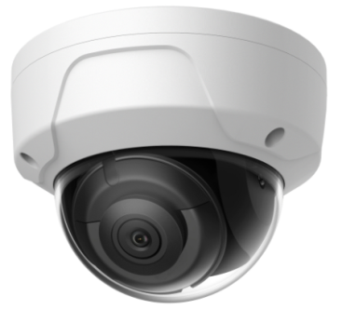DS-2CD2 **HNC344-TD/2.8**

**4 MP IR Fixed Dome Network Camera**

# 146G1-I(S)

**4 MP IR Fixed Dome Network Camera**

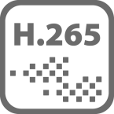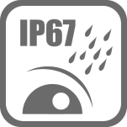

## Key Features

* Max. 2688 × 1520 @ 30fps
* 2.8 mm/4 mm/6 mm fixed lens
* H.265, H.264
* 120dB WDR
* False alarm filter by target classification
* Powered by Darkfighter
* 12 VDC & PoE (802.3af, class 3)
* IR range: Up to 30 m
* Support on-board storage, up to 128 GB
* IP67, IK10
* BLC/3D DNR/ROI
* Color: 0.007 Lux @ (F1.2, AGC ON), 0.012 Lux @ (F1.6, AGC ON)

|  |  |
| --- | --- |
| ***Camera*** | |
| Image Sensor | 1/2.7" Progressive Scan CMOS |
| Min. Illumination | Color: 0.007 Lux @ (F1.2, AGC ON), 0.012 Lux @ (F1.6, AGC ON) |
| Shutter Speed | 1/3 s to 1/100,000 s |
| Slow Shutter | Yes |
| Focal length | 2.8/4/6 mm |
| Focus | Fixed |
| Aperture | F1.6 |
| FOV | 2.8 mm, horizontal FOV: 104°, vertical FOV: 58°, diagonal FOV: 124° 4 mm, horizontal FOV: 83°, vertical FOV: 44°, diagonal FOV: 99°  6 mm, horizontal FOV: 51°, vertical FOV: 28°, diagonal FOV: 58° |
| Lens Mount | M12 |
| Auto-Iris | No |
| Day &Night | IR cut filter |
| DNR | 3D DNR |
| Wide Dynamic Range | 120dB |
| 3-Axis Adjustment | Pan: 0° to 355°, tilt: 0° to 75°, rotate: 0° to 355° |
| ***IR*** |  |
| IR Range | Up to 30 m |
| Wavelength | 850 nm |
| ***Compression Standard*** | |
| Video Compression | Main stream: H.265/H.264  Sub stream: H.265/H.264/MJPEG |
| H.264 Type | Main Profile/High Profile |
| H.264+ | No |
| H.265 Type | Main Profile |
| H.265+ | No |
| Video Bit Rate | 32 Kbps to 16 Mbps |
| SVC | H.265 encoding and H.264 encoding support |
| ***Image*** | |
| Max. Resolution | 2688 × 1520 |
| Main Stream | 50Hz: 25 fps (2688 × 1520, 1920 × 1080, 1280 × 720)  60Hz: 30 fps (2688 × 1520, 1920 × 1080, 1280 × 720) |
| Sub Stream | 50Hz: 25 fps (704 × 576, 640 × 480, 352 × 288)  60Hz: 30 fps (704 × 480, 640 × 480, 352 × 240) |
| Image Enhancement | BLC/3D DNR |
| Image Settings | Saturation, brightness, contrast, sharpness, AGC, white balance adjustable by client software or web browser |
| ROI (Region of Interest) | Support 1 fixed region for main stream and sub stream separately |
| Day/Night Switch | Day/Night/Auto/Schedule/Triggered by Alarm In(-S) |
| ***Audio (-S)*** |  |
| Environment Noise Filtering | Yes |
| Sampling Rate | 8kHz/16kHz |
| Audio Compression | G.711/G.722.1/G.726/MP2L2/PCM |

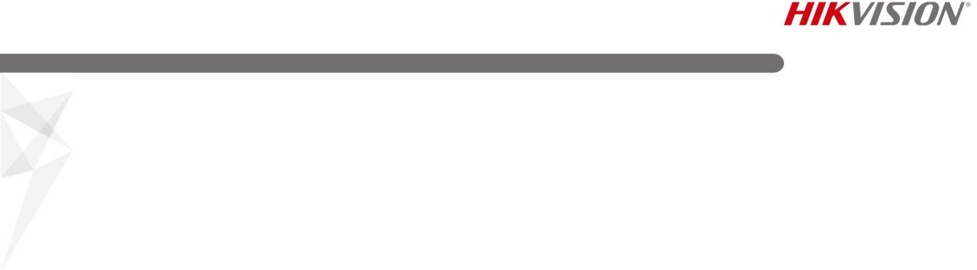

|  |  |
| --- | --- |
| Audio Bit Rate | 64Kbps(G.711)/16Kbps(G.722.1)/16Kbps(G.726)/32-160Kbps(MP2L2) |
| ***Network*** | |
| Network Storage | Support micro SD/SDHC/SDXC card (128G) local storage, NAS (NFS,SMB/CIFS), ANR |
| Alarm Trigger | Tampering alarm, network disconnected, IP address conflict, illegal login, HDDfull, HDD error |
| Protocols | TCP/IP, ICMP, HTTP, HTTPS, FTP, DHCP, DNS, DDNS, RTP, RTSP, RTCP, PPPoE, NTP, UPnP, SMTP, SNMP, IGMP, 802.1X, QoS, IPv6, UDP, Bonjour |
| General Function | One-key reset, anti-filter |
| Firmware Version | V5.5.61 |
| API | ONVIF (PROFILE S, PROFILE G), ISAPI |
| Simultaneous Live View | Up to 6 channels |
| User/Host | Up to 32 users  3 levels: Administrator, Operatorand User |
| Client | iVMS-4200, Hik-Connect, iVMS-5200, iVMS-4500 |
| Web Browser | IE8+, Chrome 31.0-44, Firefox 30.0-51, Safari 8.0+ |
| ***Interface*** |  |
| Communication Interface | 1 RJ45 10M/100M self-adaptive Ethernet port |
| On-board Storage | Built-in micro SD/SDHC/SDXC slot, up to 128 GB |
| Reset Button | Yes |
| Audio (-S) | 1 audio input (line in/micin), 1 audio output, mono sound |
| Alarm (-S) | 1 alarm input, 1 alarm output |
| ***Smart Feature-set*** | |
| Behavior Analysis | Line crossing detection, intrusion detection, region entrance detection, region exit detection, false alarm filter by target classification |
| ***General*** | |
| Operating Conditions | -30 °C to +50 °C (-22 °F to +122 °F), humidity 95% or less (non-condensing) |
| Power Supply | 12 VDC ± 25%, 5.5 mm coaxial power plug PoE (802.3af, class 3) |
| Power Consumption | 12 VDC, 0.7 A, max: 8.5 W  PoE (802.3af, 36 V to 57 V), 0.3 A to 0.2 A, max: 10 W |
| Protection Level | IK10, IP67 (If the camera is installed outdoor, the bracket DS-1253ZJ-M should be used together with other pendant mounting bracket or wall mounting bracket to reduce IR reflective in the rainy day) |
| Material | Front cover: metal, back cover: metal |
| Dimensions | Camera: Φ 121.4 × 92.2 mm (Φ 4.8" × 3.6") |
| Weight | Camera: 600 g (1.3 lb.)  With package: 760 g (1.7 lb.) |

## Available Model

HNC344-TD/2.8



## Dimension

### Camera:

Φ121.4(4.8")

11.3(0.4")

15.7(0.6")

53.4(2.1")

92.2(3.6")

51.1(2")

3-Φ4.2(0.2")

35.4(1.4")

38.6(1.5") 49.9(2")

### Wall Mounting with the Bracket (HTH-272ZJ-120 and HTH-1253ZJ-M):

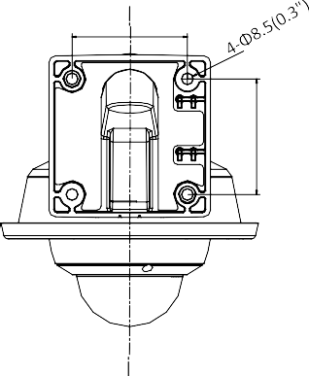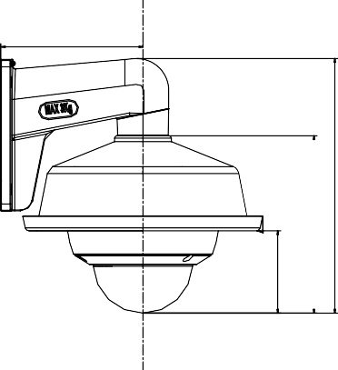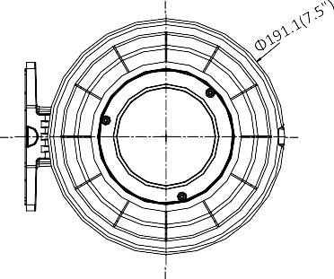112.5(4.4") 85.7(3.4")

141.7(5.6")

203.4(8")

85.7(3.4")

### Pendant Mounting with the Bracket (HTH-1271ZJ-120 and HTH-1253ZJ-M):

65.7(2.6")

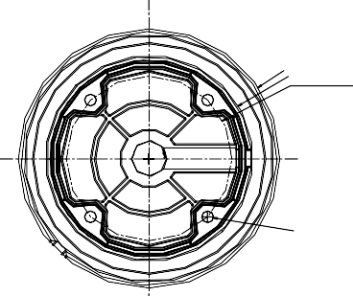Φ191.1(7.5")

409.2(16.1")

Φ151.9(6")

Φ121.1(4.8")

4-Φ8.5(0.3")

65.7(2.6")

141.7(5.6")

Unit: mm(inch)

## Accessory

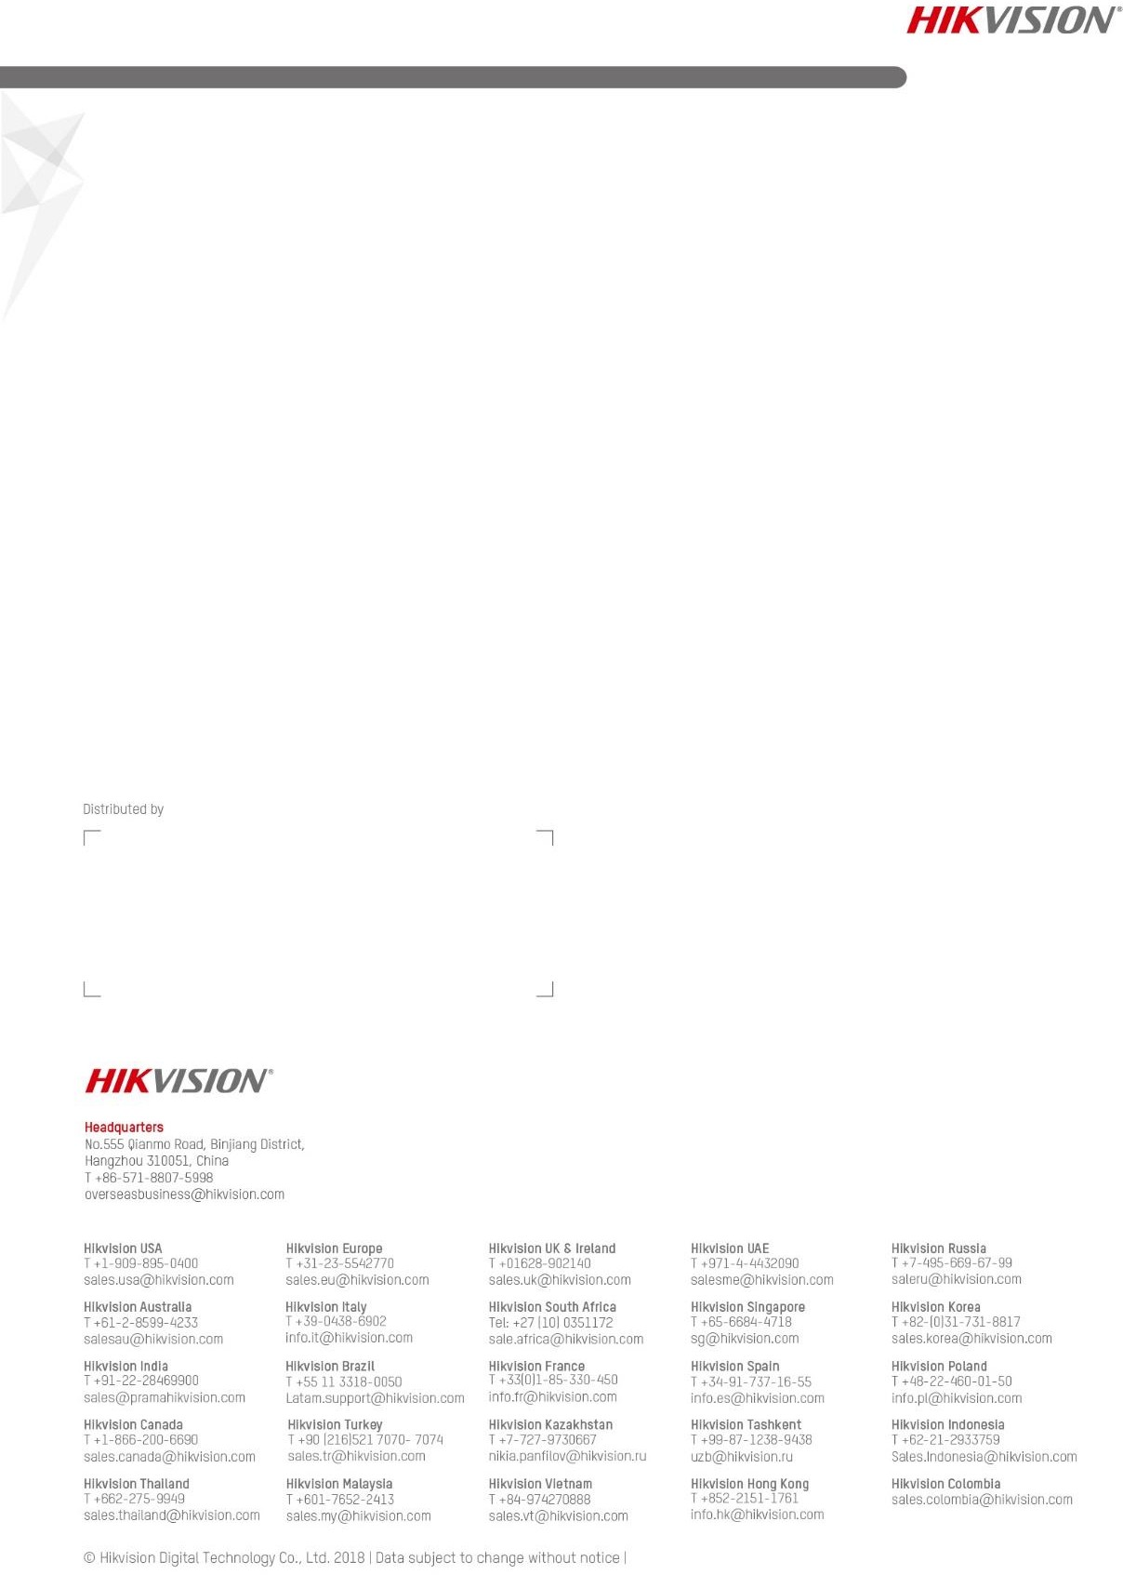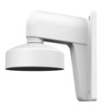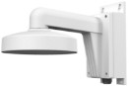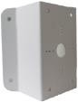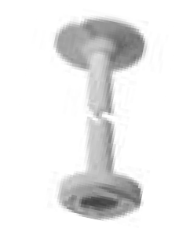

|  |  |  |  |  |
| --- | --- | --- | --- | --- |
| HTH-272ZJ-120  Wall Mount | HTH-272ZJ-120B  Wall Mount | HTH-276ZJ-SUS  Corner Mount | HTH-271ZJ-120  Pendant Mount | HTH-253ZJ-M  Rain Shade |



**05056120181029**