

|  |  |  |
| --- | --- | --- |
| **D****HNC618-VBA**  **8 MP VF Bullet Network CameraCD5A85G0-IZ(H)S**  **8 MP VF Bullet Network Camera** | |  |
|  |  | |
|  | | |
|  |  | |
| * 1/1.8” Progressive Scan CMOS * 3840 × 2160 @ 30fps, MJPEG up to 1920 × 1080 @   30fps   * 2.8 to 12 mm motor-driven lens * Color: 0.007 Lux @ (F1.2, AGC ON) * H.265, H.265+, H.264, H.264+ * 120dB WDR * 3D DNR * IR range up to 50 m | * Five defined streams and up to five custom streams * 6 behavior analyses, 2 exception detection, and face detection * Built-in microSD/SDHC/SDXC card slot, up to 256 GB * Alarm I/O * IP67, IK10 | |



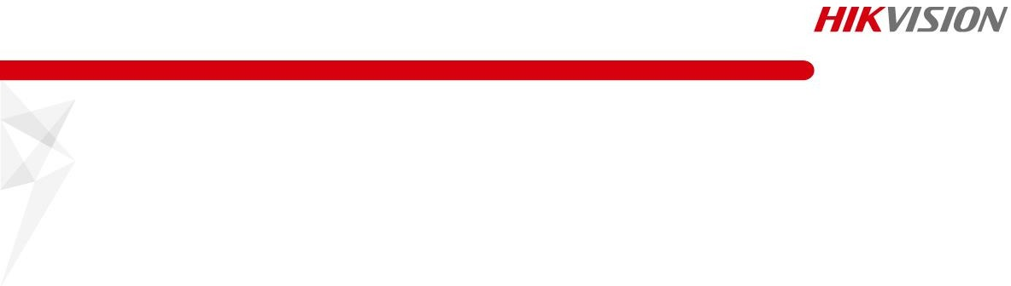

**Specifications**

|  |  |
| --- | --- |
| ***Camera*** | |
| Image Sensor | 1/1.8″ Progressive Scan CMOS |
| Min. Illumination | Color: 0.007 Lux @ (F1.2, AGC ON), 0 Lux with IR |
| Shutter Speed | 1 s to 1/100,000 s |
| Slow Shutter | Yes |
| Day & Night | IR Cut Filter |
| Digital Noise Reduction | 3D DNR |
| WDR | 120 dB |
| Angle Adjustment | Bracket, pan: 0° to 355°, tilt: 0° to 90°, rotate: 0° to 360° |
| ***Lens*** | |
| Focal length | 2.8 to 12 mm |
| Aperture | F1.2 |
| Focus | Auto, semi-auto, manual |
| FOV | 2.8 to 12 mm, horizontal FOV 112.4° to 41°, vertical FOV 58° to 23°, diagonal FOV 137° to 47° |
| Lens Mount | Integrated |
| ***IR*** | |
| IR Range | Up to 50 m |
| Wavelength | 850 nm |
| ***Compression Standard*** |  |
| Video Compression | Main stream: H.265/H.264/H.265+/H.264+  Sub stream/third stream/fourth stream/fifth stream/custom stream: H.265/H.264/MJPEG |
| H.264 Type | Baseline Profile/Main Profile/High Profile |
| H.264+ | Main stream supports |
| H.265 Type | Main Profile |
| H.265+ | Main stream supports |
| Video Bit Rate | 32 Kbps to 16 Mbps |
| Audio Compression | No |
| Audio Bit Rate | No |
| ***Smart Feature-set*** |  |
| Behavior Analysis | Line crossing detection, intrusion detection, region entrance detection, region exiting detection, unattended baggage detection, object removal detection |
| Exception Detection | Scene change detection, defocus detection |
| Statistics | Counting |
| Face Detection | Yes |
| Region of Interest | 4 fixed regions for main stream, sub stream, third stream, fourth stream, and fifth stream, and dynamic face tracking |
| ***Image*** | |
| Max. Resolution | 3840 × 2160 |
| Main Stream | 50Hz: 25fps (3840 × 2160, 3200 × 1800, 2560 × 1440, 1920 × 1080, 1280 × 720)  60Hz: 30fps (3840 × 2160, 3200 × 1800, 2560 × 1440, 1920 × 1080, 1280 × 720) |
| Sub Stream | 50Hz: 25fps (704 × 576, 640 × 480)  60Hz: 30fps (704 × 480, 640 × 480) |

|  |  |
| --- | --- |
| Third Stream | 50Hz: 25fps (1920 × 1080, 1280 × 720, 704 × 576, 640 × 480)  60Hz: 30fps (1920 × 1080, 1280 × 720, 704 × 480, 640 × 480) |
| Fourth Stream | 50Hz: 25fps (1920 × 1080, 1280 × 720, 704 × 576, 640 × 480)  60Hz: 30fps (1920 × 1080, 1280 × 720, 704 × 480, 640 × 480) |
| Fifth Stream | 50Hz: 25fps (704 × 576, 640 × 480)  60Hz: 30fps (704 × 480, 640 × 480) |
| Custom Stream | 50Hz: 25fps (1920 × 1080, 1280 × 720, 704 × 576, 640 × 480)  60Hz: 30fps (1920 × 1080, 1280 × 720, 704 × 480, 640 × 480)  Up to 5 custom streams are supported |
| Image Enhancement | BLC, HLC, 3D DNR, Defog, EIS |
| Image Setting | Rotate mode, saturation, brightness, contrast, sharpness, AGC, and white balance are adjustable by client software or web browser |
| Target Cropping | Yes |
| SVC | H.264 and H.265 encoding |
| Day/Night Switch | Day/Night/Auto/Schedule/Triggered by Alarm In |
| Picture Overlay | LOGO picture can be overlaid on video with 128 × 128 24bit bmp format |
| ***Network*** | |
| Network Storage | microSD/SDHC/SDXC card (256 GB), local storage and NAS (NFS,SMB/CIFS), ANR |
| Alarm Trigger | Motion detection, video tampering alarm, network disconnected, IP address conflict, illegal login, HDD full, HDD error |
| Protocols | TCP/IP, ICMP, HTTP, HTTPS, FTP, DHCP, DNS, DDNS, RTP, RTSP, RTCP, PPPoE, NTP, UPnP, SMTP, SNMP, IGMP, 802.1X, QoS, IPv6, UDP, Bonjour |
| Security Measures | Password protection, HTTPS encryption, IEEE 802.1x port-based network access control, IP address filter, basic and digest authentication for HTTP/HTTPS, WSSE and digest authentication for ONVIF |
| General Function | One-key reset, anti-flicker, 5 streams and up to 5 custom streams, heartbeat, password protection, privacy mask, watermark, IP address filter |
| API | ONVIF (PROFILE S, PROFILE G), ISAPI, SDK |
| Simultaneous Live View | Up to 20 channels |
| User/Host | Up to 32 users. 3 user levels: administrator, operator and user |
| Client | iVMS-4200, Hik-Connect, iVMS-5200, Hik-Central |
| Web Browser | Plug-in required live view: IE8-11, Chrome 41-44, Mozilla Firefox30.0-51, Safari8.0+ Plug-in free live view: Chrome 45+, Mozilla Firefox52+ |
| ***Interface*** |  |
| Audio | No |
| Communication Interface | 1 RJ45 10M/100M/1000M Ethernet port |
| Alarm | 2 inputs, 2 outputs (up to 24 VDC 1A or 110 VAC 500 mA) |
| Video Output | 1 BNC: CVBS analog output (4CIF resolution), internal 1Vp-p composite output (75 Ω/CVBS) |
| On-board storage | Built-in micro SD/SDHC/SDXC slot, up to 256 GB |
| Reset Button | Yes |
| ***Audio*** |  |
| Environment Noise Filtering | No |
| Audio Sampling Rate | No |
| ***General*** | |
| Firmware Version | 5.5.80 |
| Operating Conditions | -30 °C to 65 °C (-22 °F to 149 °F), -H: -40 °C to 65 °C (-40 °F to 149 °F)  Humidity 95% or less (non-condensing) |

|  |  |
| --- | --- |
| Power Supply | 12 VDC ± 20%, two-core terminal block PoE (802.3at, class 4) |
| Power Consumption and Current | -IZS: 12 VDC, 1.0 A, max. 12 W; PoE (802.3at, 42.5 V to 57 V), 0.3 A to 0.2 A  -IZHS: 12 VDC, 1.3 A, max. 15 W; PoE (802.3at, 42.5 V to 57 V), 0.4 A to 0.3 A |
| Protection Level | IP67, IK10 |
| Heater | -H: yes |
| Material | Aluminum alloy |
| Dimensions | Camera: Φ144 × 347 mm (Φ5.7″ × 13.7″)  With package: 405 × 190 × 180 mm (15.9″ × 7.5″ × 7.1″) |
| Weight | Camera: approx. 2.45 kg (5.40 lb.) With package: approx. 2.7 kg (5.95 lb.) |

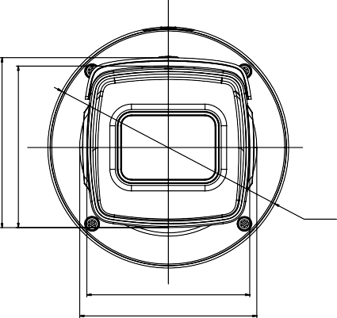* Listed resolutions are only selectable options. It does not mean that all streams can work at their maximum resolution at the same time.



102 [4.0]

97 [3.8]

|  |
| --- |
| **Available Model** |
| *HNC618-VBA* |
| **Dimension** |
| 347 [13.7]  203 [8.0]  Ø144[Ø5.7]  97 [3.8]  181 [7.1] 106 [4.2]  Unit: mm[inch] |

|  |  |
| --- | --- |
| **Accessory** |  |
|  |  |
| HTH-475ZJ-SUS  Vertical Pole Mount | HTH-476ZJ-SUS  Corner Mount |