

|  |  |
| --- | --- |
| **HNC61C-ODA**  **12 MP Outdoor Varifocal Network Dome Camera** | |
|  |  |
|  | |
| * 1/1.7” Progressive Scan CMOS * 4000 × 3000 @ 20fps * 2.8 to 12 mm motor-driven lens * Color: 0.008 Lux @ (F1.2, AGC ON) * H.265, H.265+, H.264, H.264+ * Digital WDR * 3D DNR * IR range up to 30 m | * Five streams and up to five custom streams * 6 behavior analyses, 3 exception detection, and face detection * Built-in microSD/SDHC/SDXC card slot, up to 256 GB * Alarm I/O, Audio I/O * 12 VDC power output * IP67, IK10 |



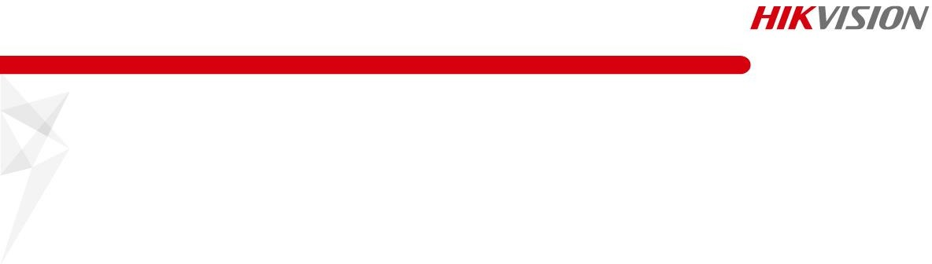

**Specifications**

|  |  |
| --- | --- |
| ***Camera*** | |
| Image Sensor | 1/1.7″ Progressive Scan CMOS |
| Min. Illumination | Color: 0.008 Lux @ (F1.2, AGC ON)  0 Lux with IR |
| Shutter Speed | 1 s to 1/100,000 s |
| Slow Shutter | Yes |
| Day & Night | IR Cut Filter |
| Digital Noise Reduction | 3D DNR |
| WDR | Digital WDR |
| Angle Adjustment | Pan: 0° to 355°, tilt: 0° to 75°, rotate: 0° to 355° |
| ***Lens*** | |
| Focal length | 2.8 to 12 mm |
| Aperture | F1.2 |
| Focus | Auto, semi-auto, manual |
| FOV | 2.8 to 12 mm, horizontal FOV 101° to 36.1°, vertical FOV 72° to 27.2°, diagonal FOV 130° to 45.2° |
| Lens Mount | Integrated |
| ***IR*** | |
| IR Range | up to 30 m IR |
| Wavelength | 850 nm |
| ***Compression Standard*** |  |
| Video Compression | Main stream: H.265/H.264/H.265+/H.264+  Sub stream/third stream/fourth stream/fifth stream/custom stream: H.265/H.264/MJPEG |
| H.264 Type | Baseline Profile/Main Profile/High Profile |
| H.264+ | Main stream support |
| H.265 Type | Main Profile |
| H.265+ | Main stream support |
| Video Bit Rate | 32 Kbps to 16 Mbps |
| Audio Compression | G.711/G.722.1/G.726/MP2L2/PCM |
| Audio Bit Rate | 64Kbps(G.711) / 16Kbps(G.722.1) / 16Kbps(G.726) / 32-160Kbps(MP2L2) |
| ***Smart Feature-set*** |  |
| Behavior Analysis | Line crossing detection, intrusion detection, region entrance detection, region exiting detection, unattended baggage detection, object removal detection |
| Exception Detection | Scene change detection, audio exception detection, defocus detection |
| Statistics | Counting |
| Face Detection | Yes |
| Region of Interest | 4 fixed regions for main stream, sub stream, third stream, fourth stream, and fifth stream, and dynamic face tracking |
| ***Image*** | |
| Max. Resolution | 4000 × 3000 |
| Main Stream | 50Hz: 20fps(4000 × 3000), 25fps (4096 × 2160, 3840 × 2160, 3072 × 1728, 2560 × 1440, 1920 × 1080,  1280 x 720)  60Hz: 20fps(4000 × 3000), 30fps (4096 × 2160, 3840 × 2160, 3072 × 1728, 2560 × 1440, 1920 × 1080,  1280 x 720) |

|  |  |
| --- | --- |
| Sub Stream | 50Hz: 25fps (704 × 576, 640 × 480)  60Hz: 30fps (704 × 480, 640 × 480) |
| Third Stream | 50Hz: 25fps (1920 × 1080, 1280 × 720, 704 × 576, 640 × 480)  60Hz: 30fps (1920 × 1080, 1280 × 720, 704 × 480, 640 × 480) |
| Fourth Stream | 50Hz: 25fps (1920 × 1080, 1280 × 720, 704 × 576, 640 × 480)  60Hz: 30fps (1920 × 1080, 1280 × 720, 704 × 480, 640 × 480) |
| Fifth Stream | 50Hz: 25fps (704 × 576, 640 × 480)  60Hz: 30fps (704 × 480, 640 × 480) |
| Custom Stream | 50Hz: 25fps (1920 × 1080, 1280 × 720, 704 × 576, 640 × 480)  60Hz: 30fps (1920 × 1080, 1280 × 720, 704 × 480, 640 × 480)  Up to 5 custom streams are supported |
| Image Enhancement | BLC, HLC, Defog, EIS, 3D DNR, Lens Distortion Correction |
| Image Setting | Rotate mode, saturation, brightness, contrast, sharpness, AGC, and white balance are adjustable by client software or web browser |
| Target Cropping | Yes |
| SVC | H.264 and H.265 encoding |
| Day/Night Switch | Auto/Schedule/Day/Night/Triggered by Alarm In |
| Picture Overlay | LOGO picture can be overlaid on video with 128 × 128 24bit bmp format |
| ***Network*** | |
| Network Storage | Micro SD/SDHC/SDXC card (up to 256 GB), local storage and NAS (NFS,SMB/CIFS), ANR |
| Alarm Trigger | Motion detection, video tampering alarm, network disconnected, IP address conflict, illegal login, HDD full, HDD error |
| Protocols | TCP/IP, ICMP, HTTP, HTTPS, FTP, DHCP, DNS, DDNS, RTP, RTSP, RTCP, PPPoE, NTP, UPnP, SMTP, SNMP, IGMP, 802.1X, QoS, IPv6, UDP, Bonjour |
| Security Measures | Password protection, HTTPS encryption, IEEE 802.1x port-based network access control, IP address filter, basic and digest authentication for HTTP/HTTPS, WSSE and digest authentication for ONVIF |
| General Function | One-key reset, anti-flicker, five streams, custom streams, heartbeat, mirror, password protection, privacy mask, watermark, IP address filter |
| API | ONVIF (PROFILE S, PROFILE G), ISAPI |
| Simultaneous Live View | Up to 20 channels |
| User/Host | Up to 32 users, 3 levels: Administrator, Operator and User |
| Client | iVMS-4200, iVMS-5200, Hik-Connect, Hik-Central |
| Web Browser | Plug-in required live view: IE8-11, Chrome 41-44, Mozilla Firefox30.0-51, Safari8.0+ Plug-in free live view: Chrome 45+, Mozilla Firefox52+ |
| ***Interface*** |  |
| Audio | 1-ch 3.5 mm input (line in), 1-ch 3.5mm output, mono |
| Communication Interface | 1 RJ45 10M/100M/1000M Ethernet port |
| Alarm | 1-ch input, 1-ch output ( up to 12 VDC 1A or 10 VAC 500 mA) |
| Video Output | 1Vp-p composite output (75 Ω/CVBS) |
| Power Output | 12 VDC, max. 200mA (supported by all power supply types) |
| On-board storage | Built-in micro SD/SDHC/SDXC slot, up to 256 GB |
| Reset Button | Yes |
| ***Audio*** |  |
| Environment Noise Filtering | Yes |
| Audio Sampling Rate | 8 kHz/16 kHz/32 kHz/44.1 kHz/48 kHz |
| ***General*** | |
| Firmware Version | 5.5.80 |

|  |  |
| --- | --- |
| Operating Conditions | -IZS: -30 °C to 65 °C (-22 °F to 149 °F), humidity 95% or less (non-condensing)  -IZHS: -40 °C to 65 °C (-40 °F to 149 °F), humidity 95% or less (non-condensing) |
| Power Supply | Recommended DC input 12 V, voltage range of 10 to 48 VDC allowed, two-core terminal block PoE (802.3at, class 4) |
| Power Consumption and Current | -IZHS:  With extra load: 12 VDC, 1.4 A, max. 17 W; PoE (802.3at, 42.5 V to 57 V), 0.4 A to 0.3 A, class 4  Without extra load: 12 VDC, 1.2 A, max. 15 W; PoE (802.3at, 42.5 V to 57 V), 0.4 A to 0.3 A, class 4 “with extra load” means that an extra device is connected to and powered by the camera.  -IZS:  With extra load: 12 VDC, 1.1 A, max. 12 W; PoE (802.3at, 42.5 V to 57 V), 0.3 A to 0.2 A, class 4  Without extra load: 12 VDC, 0.95 A, max. 10 W; PoE (802.3at, 42.5 V to 57 V), 0.3 A to 0.2 A, class 4 “with extra load” means that an extra device is connected to and powered by the camera. |
| Protection Level | IP67, IK10 |
| Material | Aluminum Alloy |
| Dimensions | Camera: Φ162 × 140.3 mm (Φ6.4″ × 5.5″)  With package: 251 × 215 × 189 mm (9.9″ × 8.5″ × 7.4″) |
| Weight | Camera: 1500 g (3.31 lb.)  With package: 1950 g (4.30 lb.) |

Note: Listed resolutions are only selectable options. It does not mean that all streams can work at their maximum resolution at the same time.

|  |
| --- |
| **Available Model** |
| HNC61C-ODA |

# Dimension

46[1.81]



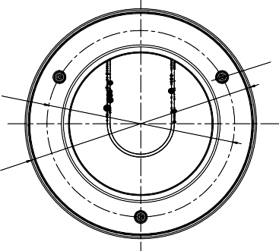6-ø4.5 [0.18]

83.5[3.29]

140.3[5.52]

Unit: mm[inch]



**Accessories**

|  |  |  |  |
| --- | --- | --- | --- |
|  |  |  |  |
| HTH-471ZJ-155  Wall Mount | HTH-473ZJ-155  Pendant Mount | HTH-475ZJ-SUS  Indoor Housing | HTH-476ZJ-SUS  Outdoor Housing |