

# ]

**8 MP** 2C**HNC6924F-A**

**8 MP PanoVu Series Panoramic Dome Camera**



## Key Features

* 1/2.8" Progressive scan CMOS
* 4096 × 1800@30fps in panorama mode
* 4 × 4 mm lens
* 4 × IR LEDs, up to 20 m IR distance
* H.265, H.265+
* IP67, IK10
* 3D DNR
* BLC/ROI/HLC
* Audio and alarm I/O (-S)
* 6 behavior analyses, audio exception detection and face detection



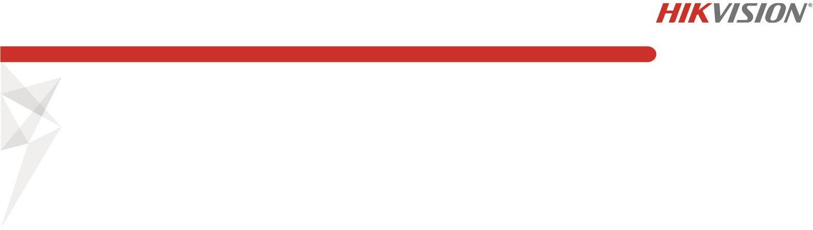

**Specifications**

|  |  |  |
| --- | --- | --- |
| ***Camera*** | | |
| Image Sensor | 1/2.8" Progressive Scan CMOS | |
| Min. Illumination | Color: 0.002 Lux @ (F1.2, AGC ON), 0.007Lux @ (F1.8, AGC ON),  B/W: 0.0008Lux @(F1.2, AGC ON), 0.002Lux @(F1.8, AGC ON), 0 Lux with IR | |
| Shutter Speed | 1/25 s to 1/100,000 s | |
| Slow Shutter | No | |
| Day & Night | IR Cut Filter | |
| Digital Noise Reduction | 3D DNR | |
| WDR | Digital WDR | |
| 2-Axis Adjustment | Pan: 0° to 355°, tilt: 0° to 90° | |
| ***Lens*** | | |
| Focal length | 4 × 4 mm lens | |
| Aperture | F1.8 | |
| Focus | No | |
| FOV | Horizontal field of view: 180° Vertical field of view: 86.7° | |
| Lens Mount | M12 | |
| ***IR*** |  | |
| IR Range | 4 × IR LEDs, up to 20 m | |
| Wavelength | 850nm | |
| ***Compression Standard*** |  | |
| Video Compression | Main stream: H.265/H.264  Sub stream: H.265/H.264/MJPEG | |
| H.264 Type | Baseline Profile/Main Profile/High Profile | |
| H.264+ | Main stream and sub-stream support | |
| H.265 Type | Main Profile | |
| H.265+ | Main stream and sub-stream support | |
| Video Bit Rate | 32 Kbps to 16 Mbps | |
| Audio Compression (-S) | G.711/G.722.1/G.726/MP2L2/PCM/AAC | |
| Audio Bit Rate (-S) | 64Kbps(G.711)/16Kbps(G.722.1)/16Kbps(G.726)/32-192Kbps(MP2L2) | |
| ***Smart Feature-set*** |  | |
| Behavior Analysis | Line crossing detection, intrusion detection, region entrance, region exiting, unattended baggage detection, object removal detection | |
| Exception Detection (-S) | Audio exception | |
| Face Detection | Yes | |
| Region of Interest | Support 4 fixed regions for main stream and sub-stream | |
| ***Image*** | | |
| Max. Resolution | Panorama mode | 4096 × 1800 |
| Original mode | 2160 × 3840 |
| Main Stream | Panorama mode | 50Hz: 25fps (4096 × 1800, 4096 × 1440, 4096 × 1080)  60Hz: 30fps (4096 × 1800, 4096 × 1440, 4096 × 1080) |
| Original mode | 50Hz: 25fps (2160 × 3840, 1080 × 1920)  60Hz: 30fps (2160 × 3840, 1080 × 1920) |



|  |  |  |
| --- | --- | --- |
| Sub Stream | Panorama mode | 50HZ: 25fps (704 × 320)  60HZ: 30fps (704 × 320) |
| Original mode | 50HZ: 25fps (480 × 768, 320 × 512)  60HZ: 30fps (480 × 768, 320 × 512) |
| Image Enhancement | BLC/3D DNR/HLC | |
| Image Setting | Saturation, brightness, contrast, sharpness, AGC and white balance adjustable by client software or web browser | |
| Day/Night Switch | Auto/Schedule/Triggered by Alarm In (with –S model) | |
| Picture Overlay | 128 × 128 24-bit BMP, area optional | |
| ***Network*** | | |
| Network Storage | Support Micro SD/SDHC/SDXC card (128G), local storage and NAS (NFS,SMB/CIFS), ANR | |
| Alarm Trigger | Motion detection, video tampering, network disconnected, IP address conflict, illegal login, HDD full, HDD error, Alarm input, Alarm output | |
| Protocols | TCP/IP, ICMP, HTTP, HTTPS, FTP, DHCP, DNS, DDNS, RTP, RTSP, RTCP, PPPoE, NTP, UPnP, SMTP, SNMP, IGMP, 802.1X, QoS, IPv6, UDP, Bonjour | |
| General Function | One-key reset, anti-flicker, heartbeat, mirror, password protection, privacy mask, watermark, IP address filter | |
| API | ONVIF (PROFILE S, PROFILE G), ISAPI | |
| Simultaneous Live View | Up to 20 channels | |
| User/Host | Up to 32 users  3 levels: Administrator, Operator and User | |
| Client | iVMS-4200, iVMS-5200 | |
| Web Browser | IE8+, Chrome 31.0-44, Firefox 30.0-51, Safari 8.0+ | |
| ***Interface*** |  | |
| Audio I/O (-S) | 1 Input (line in/mic in, 3.5 mm), 1 output(3.5 mm) | |
| Communication Interface | 1 RJ45 10M/100M self-adaptive Ethernet port, RS485  /NFC: 1 1000M FC fiber optical interface | |
| Alarm (-S) | 2 Inputs, 2 outputs (max. 24 VDC, 1 A/110 VAC, 500 mA) | |
| On-board Storage | Micro SD/SDHC/SDXC slot, up to 128 GB | |
| Reset Button | Yes | |
| ***Audio (-S)*** |  | |
| Environment Noise Filtering | Yes | |
| Audio Sampling Rate | Max. 48 kHz | |
| ***Fiber Optical*** |  | |
| Interface Type | FC interface | |
| Optical Type | Single mode, single fiber | |
| Input/output Wavelength | Tx1310nm/1.25G, Rx1550nm/1.25G | |
| Transmission Distance | 20 km | |
| ***General*** | | |
| Operating Conditions | -40 °C to +60 °C (-40 °F to +140 °F), Humidity 95% or less (non-condensing) | |
| Power Supply | 12 VDC ± 20%, PoE: 802.3at, class 4 | |
| Power Consumption and Current | 12 VDC, 1.5A, max. 18W  PoE (802.3at, 42.5V to 57V), 0.6A to 0.4A, max. 25W | |
| Protection Level | IP67, IK10  TVS 2000V Lightning Protection, Surge Protection and Voltage Transient Protection | |
| Dimensions | 190 × 207 × 208 mm (7.5" × 8.2" × 8.2") | |
| Weight | 3500 g (7.7 lb.) | |

## Available Models

HNC6924F-A

**Dimensions**

207.63(8.17")

206.62(8.13") Φ-60

(2.36")

4-Φ5 (0.20")

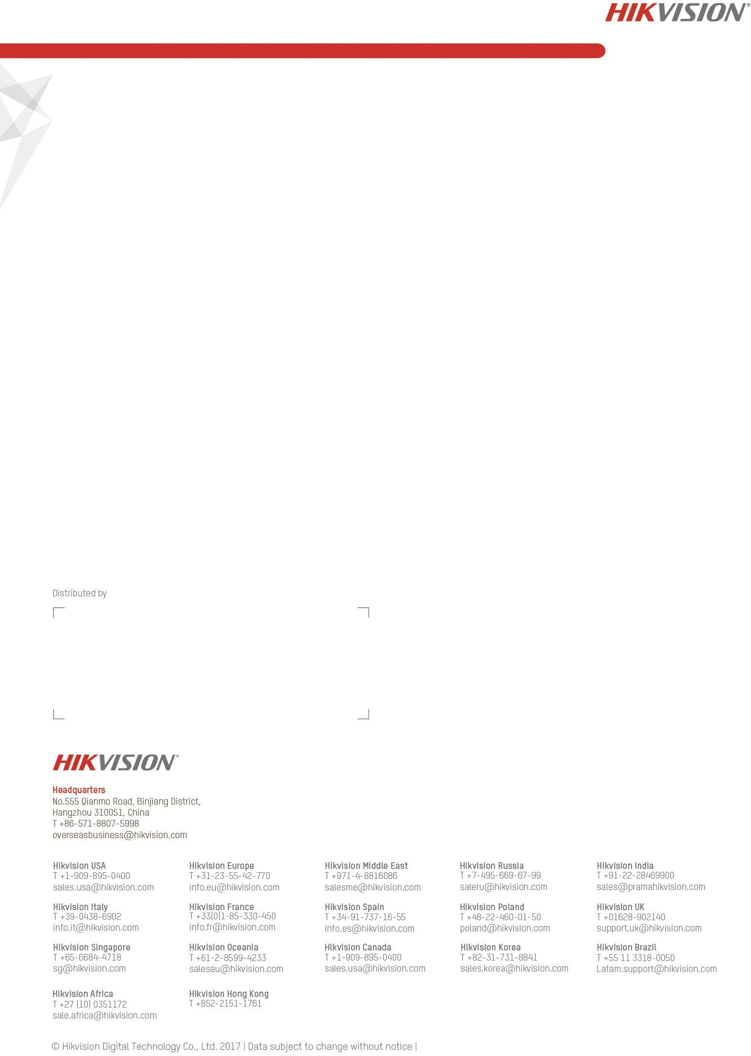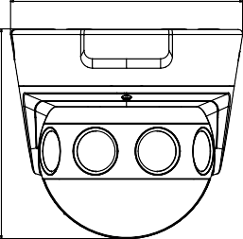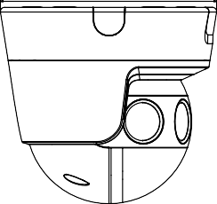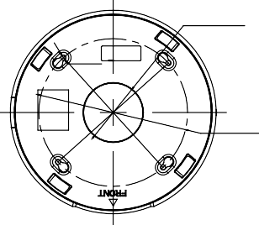

189.5(7.46")

Φ-150 (5.91")

Unit: mm

**Accessories**

|  |  |  |  |
| --- | --- | --- | --- |
|  |  |  |  |
| HTH-602ZJ  Wall Mount | HTH-661ZJ  Pendant Mount | HTH-662ZJ  Pendant Mount | Cap (Included) |



**05040820180821**