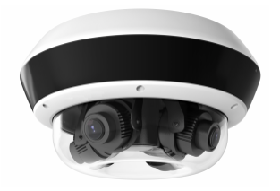

**HNC6D54-IZS**

**EXIR Flexible PanoVu Network Camera**

**Key Features**

* **4 flexible lens**
* **6 behavior analysis, 4 exception detection, and face detection**
* **1/ 2.7” Progressive Scan CMOS**
* **2560x1920 @ 25fps**
* **FOV: horizontal 30° to 101°, vertical 22.4° to 73°, diagonal 37° to 137°**
* **H.265, H.265+, H.264+, H.264**
* **Fiber optical transmission, optional**
* **10 m to 30 m IR range**
* **IP67, IK10**

|  |  |
| --- | --- |
| **Specifications** | |
| ***Camera*** | |
| Image Sensor | 1/ 2.7" Progressive Scan CMOS |
| Min. Illumination | Color: 0.006 Lux @ (F1.2, AGC ON), 0.01 Lux @ (F1.6, AGC ON)  B/W: 0.002 Lux @ (F1.2, AGC ON), 0.003 Lux @ (F1.6, AGC ON)  0 Lux with IR on |
| Shutter Speed | 1 s - 1/100,000 s |
| Auto-Iris | No |
| Day & Night | IR Cut Filter |
| Digital Noise Reduction | 3D DNR |
| WDR | 120dB |
| 3-Axis Adjustment | Four flexible lens in one track, slide range: -180° to 180°, tilt: 0° to 135°, rotate: 0° to 355° |
| ***Lens*** | |
| Focal length | 2.8mm to 12mm |
| Aperture | F1.6 |
| FOV | Horizontal: 30° to 101°  Vertical: 22.4° to 73°  Diagonal: 37° to 137° |
| Lens Mount | Φ14 |
| ***IR*** | |
| IR Range | 10m to 30 m |
| Wavelength | 850 nm |
| ***Compression Standard*** | |
| Video Compression | Main stream: H.265+/H.265/H.264+/H.264  Sub stream: H.265/H.264/MJPEG  Third Stream: H.265/H.264 |
| H.264 Type | Baseline Profile/Main Profile/High Profile |
| H.264+ | Support |
| H.265 Type | Main Profile |
| H.265+ | Support |
| Video Bit Rate | 32 Kbps to 16 Mbps |
| Audio Compression | G.711/G.722.1/G.726/MP2L2/PCM/AAC |
| Audio Bit Rate | 64Kbps(G.711)/16Kbps(G.722.1)/16Kbps(G.726)/32-192Kbps(MP2L2)/16-64Kbps(AAC) |
| ***Smart Feature-set*** | |
| Behavior Analysis | Line crossing detection, intrusion detection, region entrance detection, region exiting detection, unattended baggage detection, object removal detection |
| Exception Detection | Audio exception detection, scene change detection, defocus detection |
| Face Detection | Yes |
| Region of Interest | Support 4 fixed region for each stream |
| ***Image*** | |
| Max. Resolution | 2560x1920 |
| Main Stream | 60Hz: 25 fps (2560x1920) |
| Sub Stream | 50Hz: 25fps (704x576, 640x480)  60Hz: 30fps (704x576, 640x480) |
| Image Enhancement | BLC, 3D DNR, EIS |
| Image Settings | Rotate mode, saturation, brightness, contrast, sharpness, and white balance are adjustable by client software or web browser |
| SVC | H.264 Support |
| Day/Night Switch | Auto/Schedule/Triggered by Alarm In (-S model supports) |
| Picture Overlay | LOGO picture can be overlaid on video with 128x128 24bit bmp format |
| ***Audio*** | |
| Environmental Noise Filtering | Support |
| Sampling Rate | 8kHz/16kHz/32kHz/44.1kHz/48kHz |
| ***Network*** | |
| Network Storage | Support microSD/SDHC/SDXC card slot, up to 128 GB, NAS(NFS, SMB/CIFS), ANR |
| Alarm Trigger | Motion detection, video tampering alarm, network disconnected, IP address conflict, illegal login, HDD full, HDD error |
| Detection | Motion detection, dynamic analysis, intrusion detection, line crossing detection |
| Protocols | TCP/IP, ICMP, HTTP, HTTPS, FTP, DHCP, DNS, DDNS, RTP, RTSP, RTCP, PPPoE, NTP, UPnP, SMTP, SNMP, IGMP, 802.1X, QoS, IPv6, UDP |
| API | ONVIF( Profile S, Profile G), ISAPI |
| Simultaneous Live View | Up to 20 channels |
| User/Host | Up to 32 users  3 levels: Administrator, Operator and User |
| Client | CMS/Guarding Vision Mobile App |
| General Function | One-key reset, anti-flicker, mirror, password protection, privacy mask, IP address filter, heartbeat, watermark |
| Web Browser | IE8+, Chrome31-44, Firefox 30.0-51 |
| ***Interface*** |  |
| Communication Interface | 1 RJ45 10M/100M self-adaptive Ethernet port  1 RS-485 interface (-s)  1 1000M FC fiber optical interface (-/NFC) |
| Audio (-s) | 1-ch 3.5mm input (line in/Mic in), 1-ch 3.5mm output, dual-track, stereo |
| Alarm (-s) | 2 input, 2 output (up to 24 VD, 1A or 110 VAC, 500mA) |
| On-board storage | Built-in Micro SD/SDHC/SDXC slot, up to 128 GB |
| Reset Button | Yes |
| ***Fiber Optical*** | |
| Interface Type | FC interface |
| Optical Type | Single mode, single fiber |
| Input/output Wavelength | TX1310nm/1.25G, RX1550nm/1.25G |
| Transmission Distance | 20km |
| ***General*** | |
| Operating Conditions | -30 °C to 60 °C (-22 °F to +140 °F), -H: -40 °C to 600 °C (-40 °F to +140 °F),  Humidity 95% or less (non-condensing) |
| Power Supply | 12 VDC ± 20%: max 28W/2.3A  24 VDC ± 20%: max 50 to 60 Hz/ 2.5 A (for customization)  -IZ, -IZHS/NFC: Hi-PoE: 42.5 VDC to 57 VDC, max 34W/0.9A to 0.6A  -Z: PoE (802.3at): 42.5 VDC to 57 VDC, max 17W |
| Protection Level | IP67, IK10 |
| Material | Aluminum alloy, engineering plastics |
| Dimensions | Camera: Φ290 mm × 145.5 mm (Φ11.42"× 5.73")  Package: 453 mm × 393 mm x 385 mm (17.8"× 15.47"x 15.16”) |
| Weight | Camera: Approx 4.7 kg (10.3 lbs.)  With package: Approx 7.7 kg (16.8 lbs.) |

**Available Models:**

HNC6D54-IZS

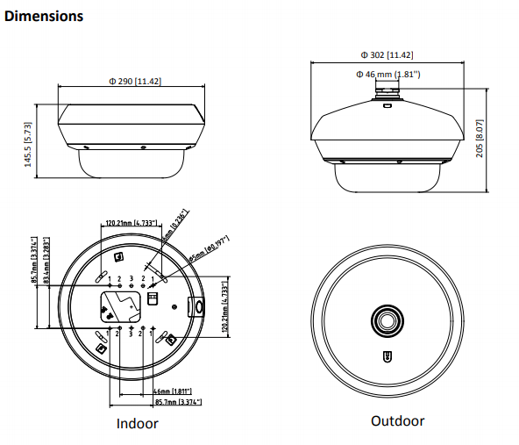

**050401160509**

**050401160405**