**HNCA01-PC**

**Outdoor Dual Lens People Counting Camera**

HNCA01-PC is a specialized people counting camera, supporting separate counting of people entering, exiting, and passing by.



The camera combines various crucial and advanced technologies, including binocular stereo vision, 3D people detection and tracking, and height filtering, to guarantee high accuracy.

* 1/3” Progressive Scan CMOS
* Dual lens, dual CPU, support stereo views
* 2 mm/2.8 mm/4 mm lens, optional
* Max. resolution 640 × 960
* H.264
* Flash memory storing people counting data
* 3D digital noise reduction
* 12 VDC/PoE
* Up to 5 m IR range
* IP66



**Specifications**

|  |  |
| --- | --- |
| ***Camera*** | |
| Image Sensor | 1/3″ Progressive Scan CMOS |
| Shutter Speed | 1/25 s to 1/10,000 s |
| Auto-iris | Manual |
| Digital Noise Reduction | 3D DNR |
| Angle Adjustment | Tilt: 0° to 45° |
| ***Lens*** | |
| Focal length | 2mm, 2.8 mm and 4 mm, optional |
| Aperture | 2.0 mm: F2.2  2.8 mm: F2.0 4 mm: F2.2 |
| FOV | 2 mm: horizontal FOV 105°, vertical FOV 89°  2.8 mm: horizontal FOV 83°, vertical FOV 68° 4 mm: horizontal FOV 63°, vertical FOV 55° |
| Lens Mount | M12 |
| ***IR*** |  |
| IR Range | Up to 5 m |
| ***Compression Standard*** |  |
| Video Compression | Main stream: H.264 Sub-stream: H.264 |
| H.264 Type | Baseline Profile/Main Profile/High Profile |
| Video Bit Rate | 32 Kbps to 8 Mbps |
| ***People Counting*** |  |
| Statistics | Support separate counting of people entering, exiting, and passing by |
| Data Uploading | Support real-time uploading and uploading by statistic cycle |
| Email Report | Daily, weekly, monthly, and annual report supported |
| Height Filter | Support |
| ***Image*** | |
| Max. Resolution | 640 × 960 |
| Main Stream Max. Frame Rate | 50Hz: 25fps (640 × 480)  60Hz: 24fps (640 × 480) |
| Sub-stream Max. Frame Rate | 50Hz: 25fps (640 × 960)  60Hz: 24fps (640 × 960) |
| Image Enhancement | 3D DNR |
| Image Setting | Brightness and sharpness are adjustable by client software or web browser |
| Day/Night Switch | Auto, scheduled, day, and night |
| ***Network*** | |
| Alarm Trigger | Video tampering, alarm input, alarm output, network disconnected, IP address conflict, illegal login |
| Protocols | TCP/IP, ICMP, HTTP, HTTPS, FTP, DHCP, DNS, DDNS, RTP, RTSP, RTCP, NTP, UPnP, SMTP, SNMP, IGMP, 802.1X, QoS, IPv6, UDP, Bonjour |
| General Function | Anti-flicker, heartbeat, password protection, watermark, email data report |
| API | ISAPI, RS-485, HTTP |
| Simultaneous Live View | Up to 6 channels |
| User/Host | Up to 32 users |

|  |  |
| --- | --- |
|  | 3 levels: Administrator, Operator and User |
| Client | iVMS-4200 |
| Web Browser | IE8+, Chrome31-44, Firefox 30.0 - 51 |
| ***Interface*** |  |
| Communication Interface | 1 RJ45 10M/100M Ethernet port 1 RS-485 interface |
| Alarm | 2 inputs, 1 output (up to 24 VDC 1 A, or 110 VAC 500 mA) |
| ***General*** | |
| Operating Conditions | -30°C to +60°C (-22 °F to +140 °F), Humidity 95% or less (non-condensing) |
| Power Supply | 12 VDC ± 25%, terminal block PoE (802.3af, class 3) |
| Power Consumption and Current | 12 VDC, max. 7 W, 0.6A  PoE(802.3af, 36 V to 57 V), max. 7 W, 0.2 A to 0.13 A |
| Protection Level | IP66 |
| Material | Body: metal; enclosure: plastic |
| Dimensions | Camera: 226 × 88 × 64 mm (8.88″ × 3.48″ × 2.50″) Package: 260 × 125 × 125 mm (10.24″ × 4.92″ × 4.92″) |
| Weight | Approx.850 g (1.87 lb.), 1050 g (2.31 lb.) with package |

## Available Models:

HNCA01-PC

**Dimensions：**

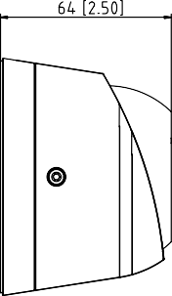

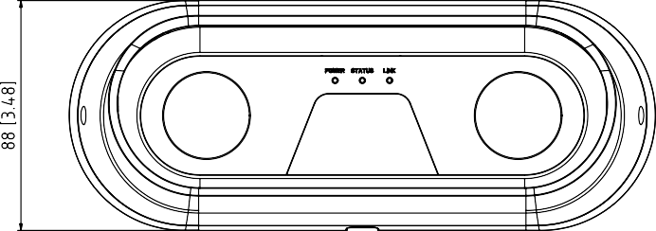

Unit: mm [inch]

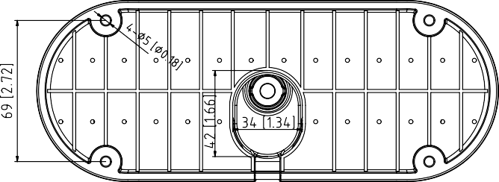

**Accessories：**

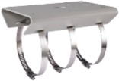

HTH-275ZJ-P1

Horizontal pole mount

## Installation Recommendation

|  |  |  |  |
| --- | --- | --- | --- |
| Mounting Height  Ground  Max. Detection Span | Focal Length  (mm) | Mounting Height  (m) | Max. Detection Span  (m) |
| 2.0 | 2.5 | 1.8 |
| 2.0 | 3.0 | 2.9 |
| 2.0 | 3.5 | 4.0 |
| 2.0 | 4.0 | 5.2 |
| 2.8 | 3.0 | 2.2 |
| 2.8 | 3.5 | 3.1 |
| 2.8 | 4.0 | 4.0 |
| 2.8 | 4.5 | 4.8 |
| 2.8 | 4.7 | 5.2 |
| 4.0 | 4.0 | 2.8 |
| 4.0 | 4.5 | 3.4 |
| 4.0 | 5.0 | 4.0 |
| 4.0 | 5.5 | 4.6 |
| 4.0 | 6.0 | 5.2 |
| Note: Mounting height of 2.0 mm lens camera should be no higher than 4 meters. Mounting height of 2.8 mm lens camera  should be no higher than 4.8 meters. | | |