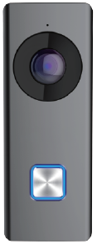
Wi-Fi Video Doorbell

Key Features
Basic Functions
- Video intercom function, supporting the audiovisual communication
with the mobile App directly
- Self-adaptive IR supplement with max. 5-meter IR distance
- High-performance embedded SOC processor
- IP 54 standard
Video/Audio Functions
- HD video surveillance with ultra-wide angle (180º) and high performance CMOS, up to 1080P
- Noise suppression and echo cancellation
- H.264 video compression standard
- Low illumination
- Supports voice prompt
- Volume configuration via App
Other Functions
- Online upgrade via the mobile App
- Supports motion detection and video recording
- Supports the storage and playback via TF card
- Equipped with a backlit call button
- Equipped with a replaceable faceplate
- Supports connecting to the mechanical chime
- Equipped with a reset button

Specifications

System parameters | Processor | High-Performance Embedded SOC Processor
System parameters | Operation system | Embedded Linux Operation System
Camera parameters | Image sensor | CMOS 2MP HD Colorful Camera
Camera parameters | Light sensitivity | Low Illumination
Camera parameters | Lens | f1.96 mm, F 2.2
Camera parameters | Field of view | 180º (Horizontal), 96º (Vertical)
Video parameters | Video compression standard | H.264
Video parameters | Video streaming | Dual Stream  Main Stream: 1080P, Sub-Stream: VGA
Video parameters | Anti-flicker frequency | 50 Hz, 60 Hz
Video parameters | Wide dynamic range | WDR
Audio parameters | Audio streaming | Two-Way, Full Duplex
Audio parameters | Audio input | Built-in Omnidirectional Microphone
Audio parameters | Audio output | Built-in Loudspeaker
Audio parameters | Audio compression standard | G.711 U
Audio parameters | Audio compression rate | 64 Kbps
Audio parameters | Audio quality | Noise Suppression and Echo Cancellation
Light supplement | Light supplement mode | IR Supplement, IR Distance: 5 Meters
Light supplement | Wavelength | 940 nm
Network parameters | Network protocol | TCP/IP, RTSP
Network parameters | Network interface | 1 Wireless Interface (Wireless Network Card), Supporting 2.4 GHz
Event | Motion Detection | Supported
Alarm | Motion Detection Alarm | Supported
Device interfaces | TF card | Max. 128 G
Device interfaces | Button | 1 Call Button, 1 Reset Button
General | Ingress protection level | IP 54
General | Power supply | 16 VAC to 24 VAC
General | Power frequency | 50 Hz to 60 Hz
General | Power consumption | Max. 0.6 A
General | Working temperature | -30° C to +50° C (-22° F to 122° F)
General | Working humidity | 10% to 90%
General | Dimensions | 122.4 mm x 45.9 mm x 28.1 mm (4.82" x 1.81" x 1.11")

Typical Application
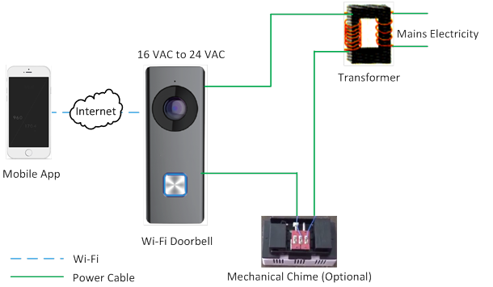
Available Model

HNDB302W

