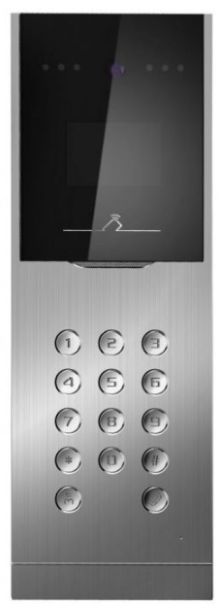
Key Features
Basic Functions
- Video intercom function
- Access control function
- Issues cards via door station, up to Max 2500 cards, via outer door station, up to 50000 (This function will be invalid if the card has been issued via the client.)
- Card readers supported
- Self-adaptive visible light supplement
Video/Audio Functions
- HD video surveillance with high performance CMOS
- Noise suppression and echo cancellation
- H.264 video compression
- Low illumination
Alarm Functions
- Tampering alarm and door magnetic alarm supported
- Auto-uploads alarm message to the master station or the client software once the alarm is triggered
Remote Controls
- Remote unlocking via the client or the app
- Remotely answering the call via the client or the app
Additional Features
- Message notification function
- Auto-uploads captured pictures to FTP or the client

HKD8002-VM
Video Intercom Metal Door Station
Specifications
System Parameters
Processor | High-Performance Embedded SOC Processor
Operation System | Embedded Linux Operation System
Video Parameters
Camera | CMOS Low Illumination 1.3 MP HD Colorful Camera
Video compression standard | H.264
Resolution | 1280x720
Video frame rate | PAL: 25 fps, NTSC: 30 fps
Display Parameters
Display screen | 3.5-inch colorful TFT LCD
Display resolution | 480x320
Operation method | Physical Keypad
Operation interface | LCD Display, Easy Menu
Audio Parameters
Audio input | Built-in Omnidirectional Microphone
Audio Output | Built-in Loudspeaker
Audio compression standard | G.711U
Audio compression rate | 64 Kbps
Audio quality | Noise Suppression and Echo Cancellation
Access Control Parameters
Internal card reader | Built-in IC Card Reader
External card reader | Wiegand 26, Wiegand 34, or RS-485 IC Reader
Door magnetic detection | Detects Door Magnetic Status
Light Supplement
Light supplement mode | Visible Light Supplement
Network Parameters
Alarm input | Door Magnetic Alarm, Tampering Alarm
Protocols | RTP, TCP/IP
Ethernet | 10/100 Mbps Self-Adaptive Ethernet
Device Interface
Network Interface | 1 RJ45 10M/100M self-adaptive Ethernet Interface
RS-485 | 1 RS-485 Half-Duplex Port
I/O input | 8
I/O output | 4
Wiegand | 1 Wiegand Port for Accessing Wiegand IC Card Reader
USB | 1 USB 2.0, Supporting U-Disk
General
Operating Conditions | -40 °C to 60 °C (-40 °F to 140 °F), Humidity 10% to 90%
Power Supply | 12 VDC
Power Consumption | 15 W Max
Material | Aluminum Alloy
Protection level | IP65
Dimensions | 418 mm x 145 mm x 61 mm ( 16.5” x 5.7” x 2.4”)
Certification | FCC, IC, CE, C-TICK, ROHS, REACH, WEEE
Available Models:
HDB301-VP

