

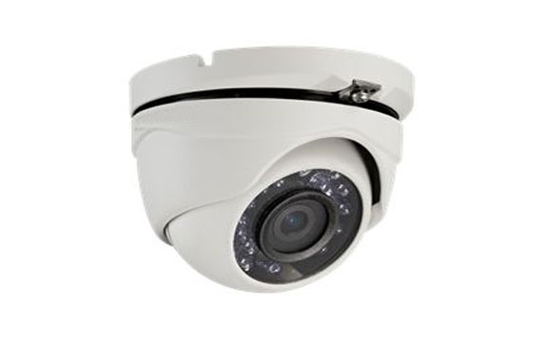



* 1.3 Megapixel high-performance CMOS
* Analog HD output, up to 720P resolution
* True Day/Night
* DNR, Smart IR
* Up to 20m IR distance
* IP66 weatherproof

**Key Features**

**HAC303-MD**

**HD720P IR Turret Camera**

|  |  |
| --- | --- |
| **Specifications** | |
| ***Camera*** | |
| Image Sensor | 1.3MP CMOS Image Sensor |
| Signal System | PAL/NTSC |
| Effective Pixels | 1280(H)*960(V) |
| Min. illumination | 0.01 Lux @ (F1.2,AGC ON),0 Lux with IR |
| Shutter Time | 1/25(1/30)s to 1/50,000s |
| Lens | 2.8mm, 3.6mm, 6mm optional  Angle of View: 74.6°(3.6mm), 92.6°(2.8mm), 49°(6mm) |
| Lens Mount | M12 |
| Day & Night | ICR |
| Angle Adjustment | Pan: 0 - 360°, Tilt: 0 - 180°, Rotation: 0 - 360° |
| Synchronization | Internal Synchronization |
| Video Frame Rate | 720p@25fps/720p@30fps |
| HD Video Output | 1 Analog HD output |
| S/N Ratio | ＞62dB |
| ***General*** | |
| Operating Conditions | -40 °C – 60 °C (-40 °F – 140 °F), Humidity 90% or less (non-condensing) |
| Power Supply | 12 VDC±15% |
| Power Consumption | Max. 4W |
| Protection Level | IP66 |
| IR Range | Up to 20m |
| Impact Protection | N/A |
| Communication | N/A |
| Dimensions | 89.6 × 59.1 mm (3.53” × 2.33”) |
| Weight | 340 g |
|  |  |



**20160119**