

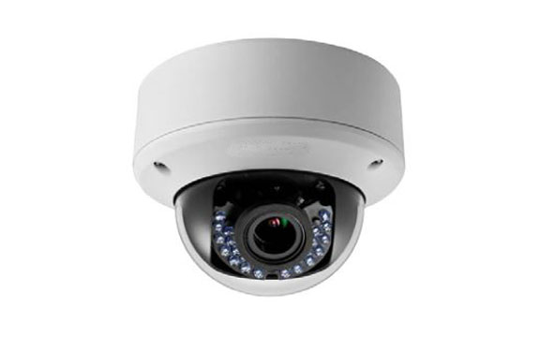



* **2 Megapixel High Resolution**
* **Analog HD output, up to 1080p resolution**
* **2.8-12mm vari-focal lens**
* **True Day/Night**
* **OSD Menu, 3D DNR, Smart IR**
* **Up to 30m IR distance**
* **Up the Coax(Pelco-C protocol)**
* **24V AC/ 12V DC (-A)**

**Key Features**

**HAC304D-ID3**

**HD1080P WDR Indoor Vari-focal IR Dome Camera**

|  |  |
| --- | --- |
| **Specifications** | |
| ***Camera*** | |
| Image Sensor | 2MP CMOS Image Sensor |
| Signal System | PAL/NTSC |
| Effective Pixels | 1944(H)*1092(V) |
| Min. illumination | 0.01 Lux @ (F1.2,AGC ON),0 Lux with IR; 0.014 Lux @ (F1.4,AGC ON),0 Lux with IR |
| Shutter Time | 1/25(1/30)s to 1/50,000s |
| Lens | 2.8-12mm @ F1.4 |
| Lens Mount | φ14 |
| Day & Night | ICR |
| Angle Adjustment | Pan: 0 – 355°, Tilt: 0-75°, Rotation: 0 – 355° |
| Angle of View | 103° - 32.1° |
| CVBS Output | 1Vp-p Composite Output(75/BNC) |
| WDR | 120dB |
| Video Frame Rate | 1080p@25fps/1080p@30fps |
| HD Video Output | 1 Analog HD output |
| S/N Ratio | ＞62dB |
| ***Menu*** | |
| Scene | Indoor, Outdoor, Indoor1, LOW-LIGHT |
| Camera ID | On/off (15 characters, position programmable) |
| AGC | Support |
| D/N Mode | Color/BW/SMART |
| White Balance | ATW/AWC-Set/Manual |
| BLC | Support |
| Functions | HSBLC, Digital noise reduction, Digital zoom(62x), Slow shutter, Mirror, Defog, Defect pixel correction, SMART D-ZOOM |
| Anti-flicker | On/Off |
| Privacy Mask | On/Off, maximum 8 zones |
| Motion Detection | On/Off, maximum 4 zones |
| Language | English, Japanese, CHN1, CHN2, Korean, German, French, Italian, Spanish, Polish, Russian, Portuguese, Dutch, Turkish, Hebrew and Arabic |
| ***General*** | |
| Operating Conditions | -20 °C - 45 °C (-4 °F - 113 °F), Humidity 90% or less (non-condensing) |
| Power Supply | 12 VDC±15%; -A: 12 VDC±15% 24 VAC±15% |
| Power Consumption | Max. 4W; 0A: Max. 6W |
| Protection Level | N/A |
| IR Range | Up to 30m |
| Communication | Up the coax, Protocol: Pelco-C(CVBS Output), Perfect View (TVI-Output) |
| Dimensions | Φ 136 × 101 mm (Φ 5.35” × 3. 98”) |
| Weight | 600 g |
|  |  |



