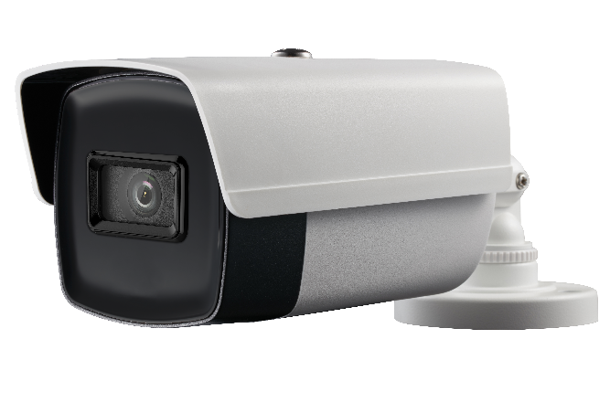

**AC318-FB4**

**8 MP Bullet Camera**

|  |
| --- |
| icon-08 G:\work\work folder\前端\icon red\模拟专用图标red\ICR.png G:\work\work folder\前端\icon red\模拟专用图标red\Digital WDR.png Smart IR |
| E:\Working Folder\work\work\前端\icon red\模拟专用图标red\3-axis Adjustment.png E:\Working Folder\work\work\前端\icon red\icon red\icon\icon-34.png |

|  |
| --- |
| **Key Features**   * 8.29 MP high performance CMOS * 3840 × 2160 resolution * 2.8 mm, 3.6 mm fixed lens * EXIR 2.0, smart IR, up to 60 m IR distance * 4 in 1 video output (switchable TVI/AHD/CVI/CVBS) * IP67 * Up the coax (UTC-C) |

|  |  |
| --- | --- |
| ***Camera*** | |
| Image Sensor | 8.29 megapixel progressive scan CMOS |
| Signal System | PAL/NTSC |
| Frame Rate | TVI: 8MP@12.5fps, 8MP@15fps, 5MP@20fps, 4MP@25fps, 4MP@30fps, 2MP@25fps, 2MP@30fps  CVI: 8MP@12.5fps, 8MP@15fps  AHD: 5MP@20fps  CVBS: 960H P/N |
| Resolution | 3840 (H) × 2160 (V) |
| Min. Illumination | Color: 0.01 Lux@(F1.2, AGC ON), 0 Lux with IR |
| Shutter Time | PAL: 1/12.5 s to 1/50,000 s  NTSC: 1/15 s to 1/50,000 s |
| Lens | 2.8 mm, 3.6 mm fixed lens |
| Horizontal Field of View | 102.2° (2.8 mm), 79° (3.6 mm) |
| Lens Mount | M16 |
| Day & Night | IR cut filter |
| Angle Adjustment (Bracket) | Pan: 0° to 360°, Tilt:0° to 180°, Rotate: 0° to 360° |
| Synchronization | Internal synchronization |
| DWDR (Digital Wide Dynamic Range) | 105 dB |
| ***Menu*** | |
| AGC | Yes |
| Day/Night Mode | Auto/Color/BW (Black and White) |
| White Balance | Auto/Manual |
| BLC (Backlight Compensation) | Yes |
| Language | English |
| Functions | Brightness, Sharpness, DNR, Mirror, Smart IR |
| ***Interface*** | |
| Video Output | 1 HD analog output |
| Switch Button | TVI/AHD/CVI/CVBS |
| ***General*** | |
| Operating Conditions | -40 °C to 60 °C (-40 °F to 140 °F), humidity: 90% or less (non-condensation) |
| Power Supply | 12 VDC ±25% |
| Power Consumption | Max. 5.3 W |
| Protection Level | IP67 |
| Material | Metal |
| IR Range | Up to 60 m |
| Communication | Up the coax, Protocol: UTC-C (TVI output) |
| Dimensions | 81.9 mm × 86.7 mm × 217.9 mm (3.22" × 3.41" × 8.58" ) |
| Weight | Approx. 435 g (0.96 lb.) |

**Specification**

|  |  |  |  |
| --- | --- | --- | --- |
| **Dimension** | | | |
|  | | | |
| **Accessory** | | | |
|  |  |  |  |
| 1280ZJ-XS  Junction Box |  |  |  |

**010000180608**