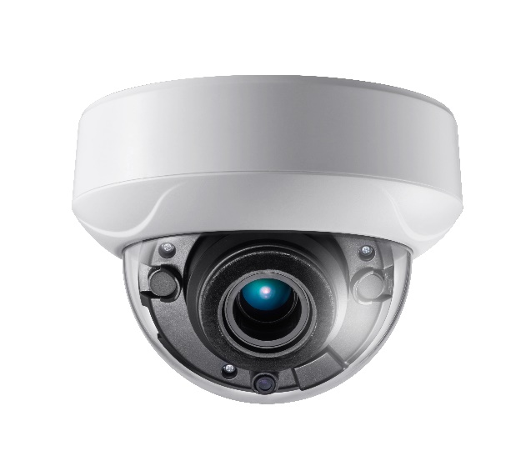

**AC318D-OD4Z**

**8 MP Dome Camera**

|  |
| --- |
| icon-08 D:\04 资料\SPEC模拟专用图标\模拟专用图标red\Auto Focus.png Motorized VF Lens G:\work\work folder\前端\icon red\模拟专用图标red\Digital WDR.png |
| E:\mission\Spec 模板&Icons\icon 新\icon 新\ICR.png Smart IR E:\Working Folder\work\work\前端\icon red\模拟专用图标red\3-axis Adjustment.png E:\Working Folder\work\work\前端\icon red\icon red\icon\icon-34.png |

|  |
| --- |
| **Key Features**   * 8.29 MP high performance CMOS * Auto focus * 3840 × 2160 resolution * 2.7 mm to 13.5 mm motorized vari-focal lens * EXIR 2.0, smart IR, up to 60 m IR distance * OSD menu, DNR, * 4 in 1 video output (switchable TVI/AHD/CVI/CVBS) * IP67 * Up the coax (UTC-C) |

|  |  |
| --- | --- |
| ***Camera*** | |
| Image Sensor | 8.29 megapixel progressive scan CMOS |
| Frame Rate | TVI: 8MP@12.5fps, 8MP@15fps, 5MP@20fps, 4MP@25fps, 4MP@30fps, 2MP@25fps,  2MP@30fps  CVI: 8MP@12.5fps, 8MP@15fps  AHD: 5MP@20fps  CVBS: 960H P/N |
| Resolution | 3840 (H) × 2160 (V) |
| Min. illumination | Color: 0.01 Lux @ (F1.2, AGC ON), 0 Lux with IR |
| Shutter Time | PAL: 1/12.5 s to 1/50, 000 s  NTSC: 1/15 s to 1/50, 000 s |
| Lens | 2.7 mm to 13.5 mm motorized vari-focal lens |
| Horizontal Field of View | 108.1° to 45.6° |
| Lens Mount | Φ14 |
| Day & Night | IR cut filter |
| Angle Adjustment | Pan: 0° to 355°; Tilt: 0° to 75°; Rotate: 0° to 355° |
| Synchronization | Internal synchronization |
| DWDR (Digital Wide Dynamic Range) | 105 dB |
| ***Menu*** | |
| AGC | Yes |
| D/N Mode | Auto/Color/BW (Black and White) |
| White Balance | Auto/Manual |
| BLC | Yes |
| DWDR (Digital Wide Dynamic Range) | Yes |
| Functions | Brightness, Sharpness, DNR, Mirror, Smart IR |
| ***Interface*** | |
| Video Output | 1 HD analog output |
| Switch Button | TVI/AHD/CVI/CVBS |
| ***General*** | |
| Operating Conditions | -40 °C to 60 °C (-40 °F to 140 °F), humidity: 90% or less (non-condensation) |
| Power Supply | 9 VDC to 15 VDC  -A: 9.6 VDC to 14.4 VDC; 19.2 VAC to 28.8 VAC |
| Power Consumption | Max. 6.4 W  -A: Max. 8.2W |
| Protection Level | IP67 |
| Material | Metal |
| IR Range | Up to 60 m |
| Communication | Up the coax, Protocol: UTC-C (TVI output) |
| Dimensions | Ø 145.2 mm × 124.1 mm (Ø 7.1" × 4.9") |
| Weight | Approx. 640 g (1.41lb.) |

|  |
| --- |
|  |
|  |
| **Dimension** |

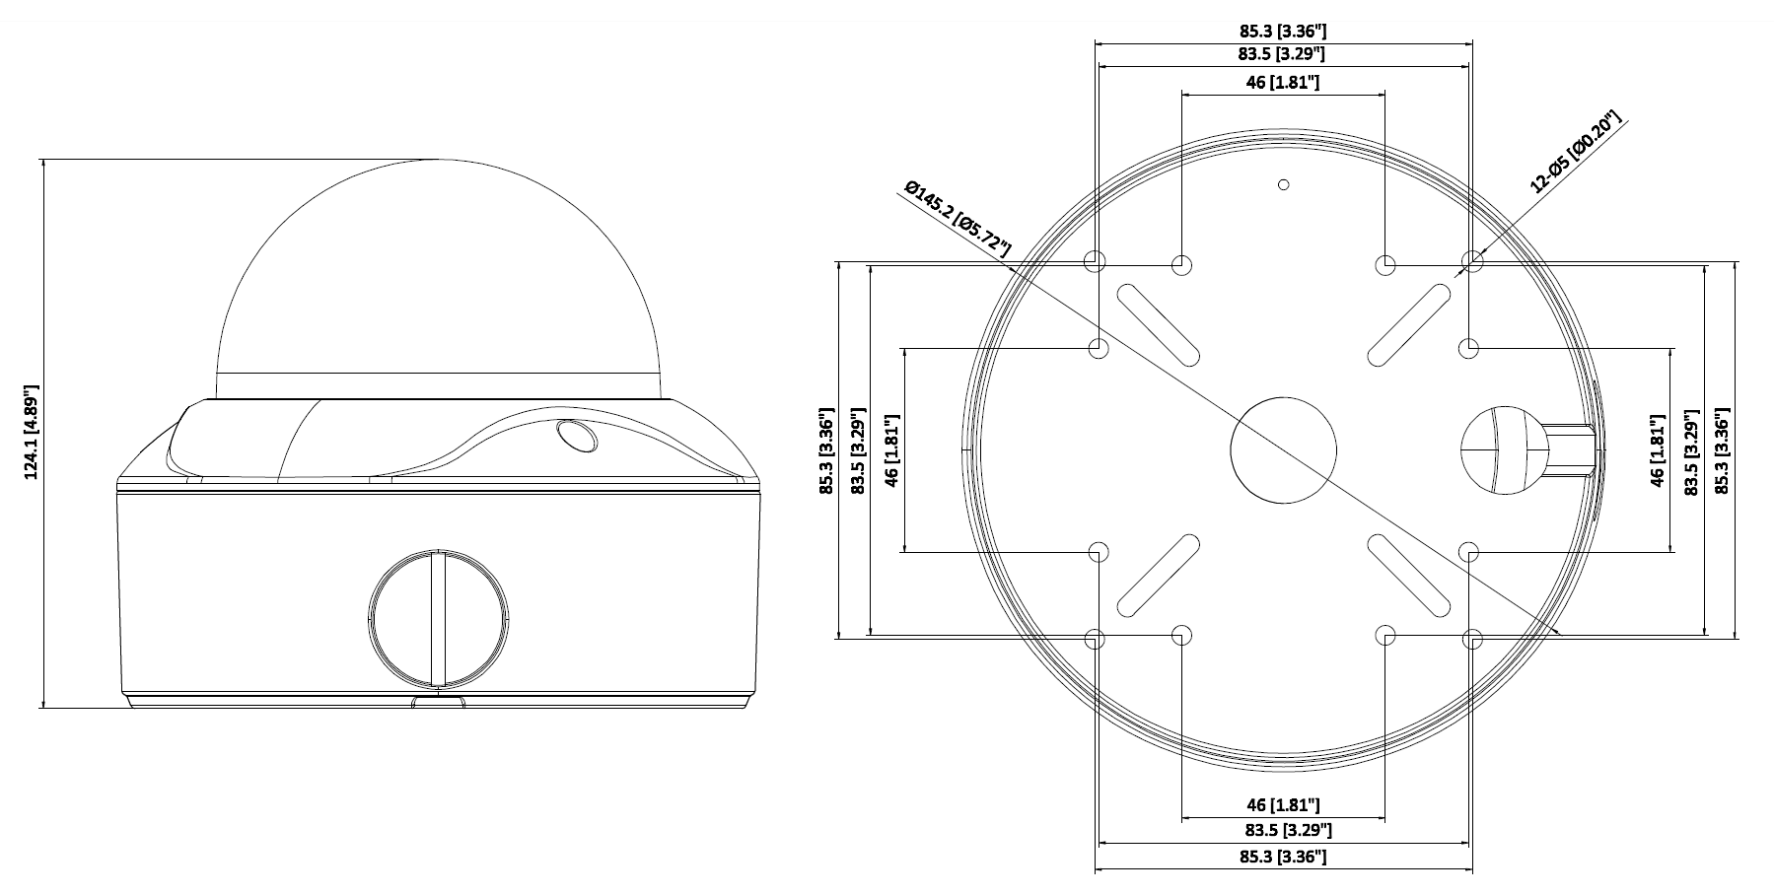

|  |  |  |  |
| --- | --- | --- | --- |
| **Accessory** | | | |
|  | E:\Working Folder\work\work\2018年\201801\H0T 变焦\支架安装示意图\半球45支架高清图\302701533 DS-1275ZJ-SUS_副本.jpg | E:\Working Folder\work\work\2018年\201801\H0T 变焦\支架安装示意图\半球45支架高清图\DS-1276ZJ-SUS_副本.jpg |  |
|  |  |  |  |
| 1273ZJ-140  Wall Mount | 1275ZJ-SUS  Vertical Pole Mount | 1276ZJ-SUS  Corner Mount | 1253ZJ-L  Rain Shade |
|  | E:\Working Folder\work\work\201708\U8T\U8T Spec\DS-1241ZJ.png |  |  |
|  |  |  |  |
| 1273ZJ-140B  Wall Mount | 1241ZJ  In-ceiling Mount | 1240ZJ  Inclined Ceiling Mount |  |

**0100001080605**