

**HAC335-MB**

**3MP WDR EXIR Bullet Camera**

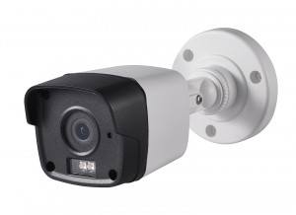

   

   

* 3 Megapixel high-performance CMOS
* Analog HD output, up to 3MP resolution
* 2.8mm, 3.6mm, 6mm lens
* True Day/Night
* OSD menu, DNR, Smart IR
* True WDR, up to 120dB
* EXIR technology, up to 20m IR distance
* IP66 weatherproof
* Up the Coax(HIKVISION-C)

**Key Features**

|  |  |
| --- | --- |
| **Specifications** | |
| ***Camera*** | |
| Image Sensor | 3MP CMOS Image Sensor |
| Effective Pixels | 2052(H)*1536(V) |
| Min. illumination | 0.01 Lux @ (F1.2,AGC ON), 0 Lux with IR |
| Shutter Time | 1/25s to 1/50,000s |
| Lens | 2.8mm, 3.6mm, 6mm lens @ F1.2 |
| Lens Mount | M12 |
| Day & Night | ICR |
| Angle Adjustment | Pan: 0° - 360°; Tilt:0° - 90°; Rotate: 0° - 360° |
| Synchronization | Internal Synchronization |
| WDR | 120dB |
| Video Frame Rate | 1920×1536@18fps |
| HD Video Output | 1 Analog HD output |
| S/N Ratio | ＞62dB |
| ***Menu*** | |
| AGC | Support |
| D/N Mode | Color/BW/SMART |
| White Balance | ATW/ MWB |
| BLC | Support |
| Functions | Wide Dynamic Range, Digital noise reduction, Mirror, SMART IR |
| ***General*** | |
| Operating Conditions | -40 °C – 60 °C (-40 °F – 140 °F), Humidity 90% or less (non-condensing) |
| Power Supply | 12 VDC±15% |
| Power Consumption | Max. 5W |
| Protection Level | IP66 |
| IR Range | Up to 20m |
| Communication | Up the coax, Protocol: HIKVISION-C (TVI output) |
| Dimensions | 58.5mm×55.5mm×153.6mm (2.30”×2.19”×6.05”) |
| Weight | Approx. 370g (0.82lb) |
|  |  |



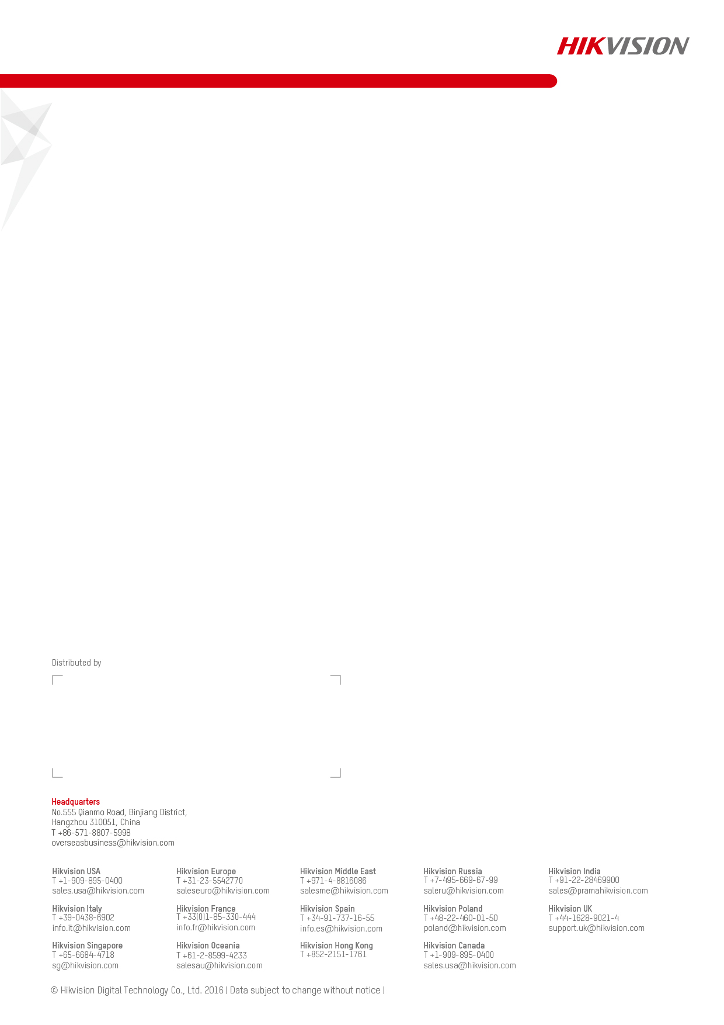



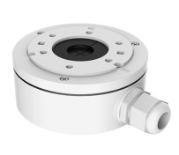  

DS-1280ZJ-XS DS-1H18 X41T

Junction Box Video Balun Camera Tester

**Accessories**

**Dimensions**

DS-2CE16F7T-IT

**Order Models**

**20160127**