

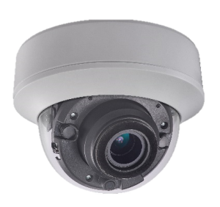

   

   

* 3 Megapixel high-performance CMOS
* Analog HD output, up to 3MP resolution
* 2.8-12mm motorized vari-focal lens
* True Day/Night
* OSD menu, DNR, Smart IR
* True WDR, up to 120dB
* EXIR technology, up to 30m IR distance
* IP65 weatherproof
* Up the Coax(HIKVISION-C)

**Key Features**

**HAC335D-IDZ**

**3MP Motorized VF EXIR Dome Camera**

|  |  |
| --- | --- |
| **Specifications** | |
| ***Camera*** | |
| Image Sensor | 3MP CMOS Image Sensor |
| Effective Pixels | 2052(H)*1536(V) |
| Min. illumination | 0.01 Lux @ (F1.2,AGC ON),0 Lux with IR |
| Shutter Time | 1/25s to 1/50,000s |
| Lens | Motorized VF lens; 2.8 - 12 mm @ F1.2 |
| Lens Mount | φ14 |
| Day & Night | ICR |
| Angle Adjustment | Pan: 0° - 355°; Tilt:0° - 75°; Rotate: 0° - 355° |
| Synchronization | Internal Synchronization |
| WDR | 120dB |
| Video Frame Rate | 1920×1536@18fps |
| HD Video Output | 1 Analog HD output |
| S/N Ratio | ＞62dB |
| ***Menu*** | |
| AGC | Support |
| D/N Mode | Color/BW/SMART |
| White Balance | ATW/ MWB |
| BLC | Support |
| Functions | Wide Dynamic Range, Digital noise reduction, Mirror, SMART IR |
| ***General*** | |
| Operating Conditions | -40 °C – 60 °C (-40 °F – 140 °F), Humidity 90% or less (non-condensing) |
| Power Supply | 12 VDC±15%; -A: 12 VDC±15% 24 VAC±15% |
| Power Consumption | Max. 4.5W; -A: Max. 6.5W |
| Protection Level | IP65 |
| IR Range | Up to 30m |
| Communication | Up the coax, Protocol: HIKVISION-C (TVI output) |
| Dimensions | Φ136mm×102mm (Φ5.35”×4.02”) |
| Weight | Approx. 600g ( 1.32lb) |
|  |  |



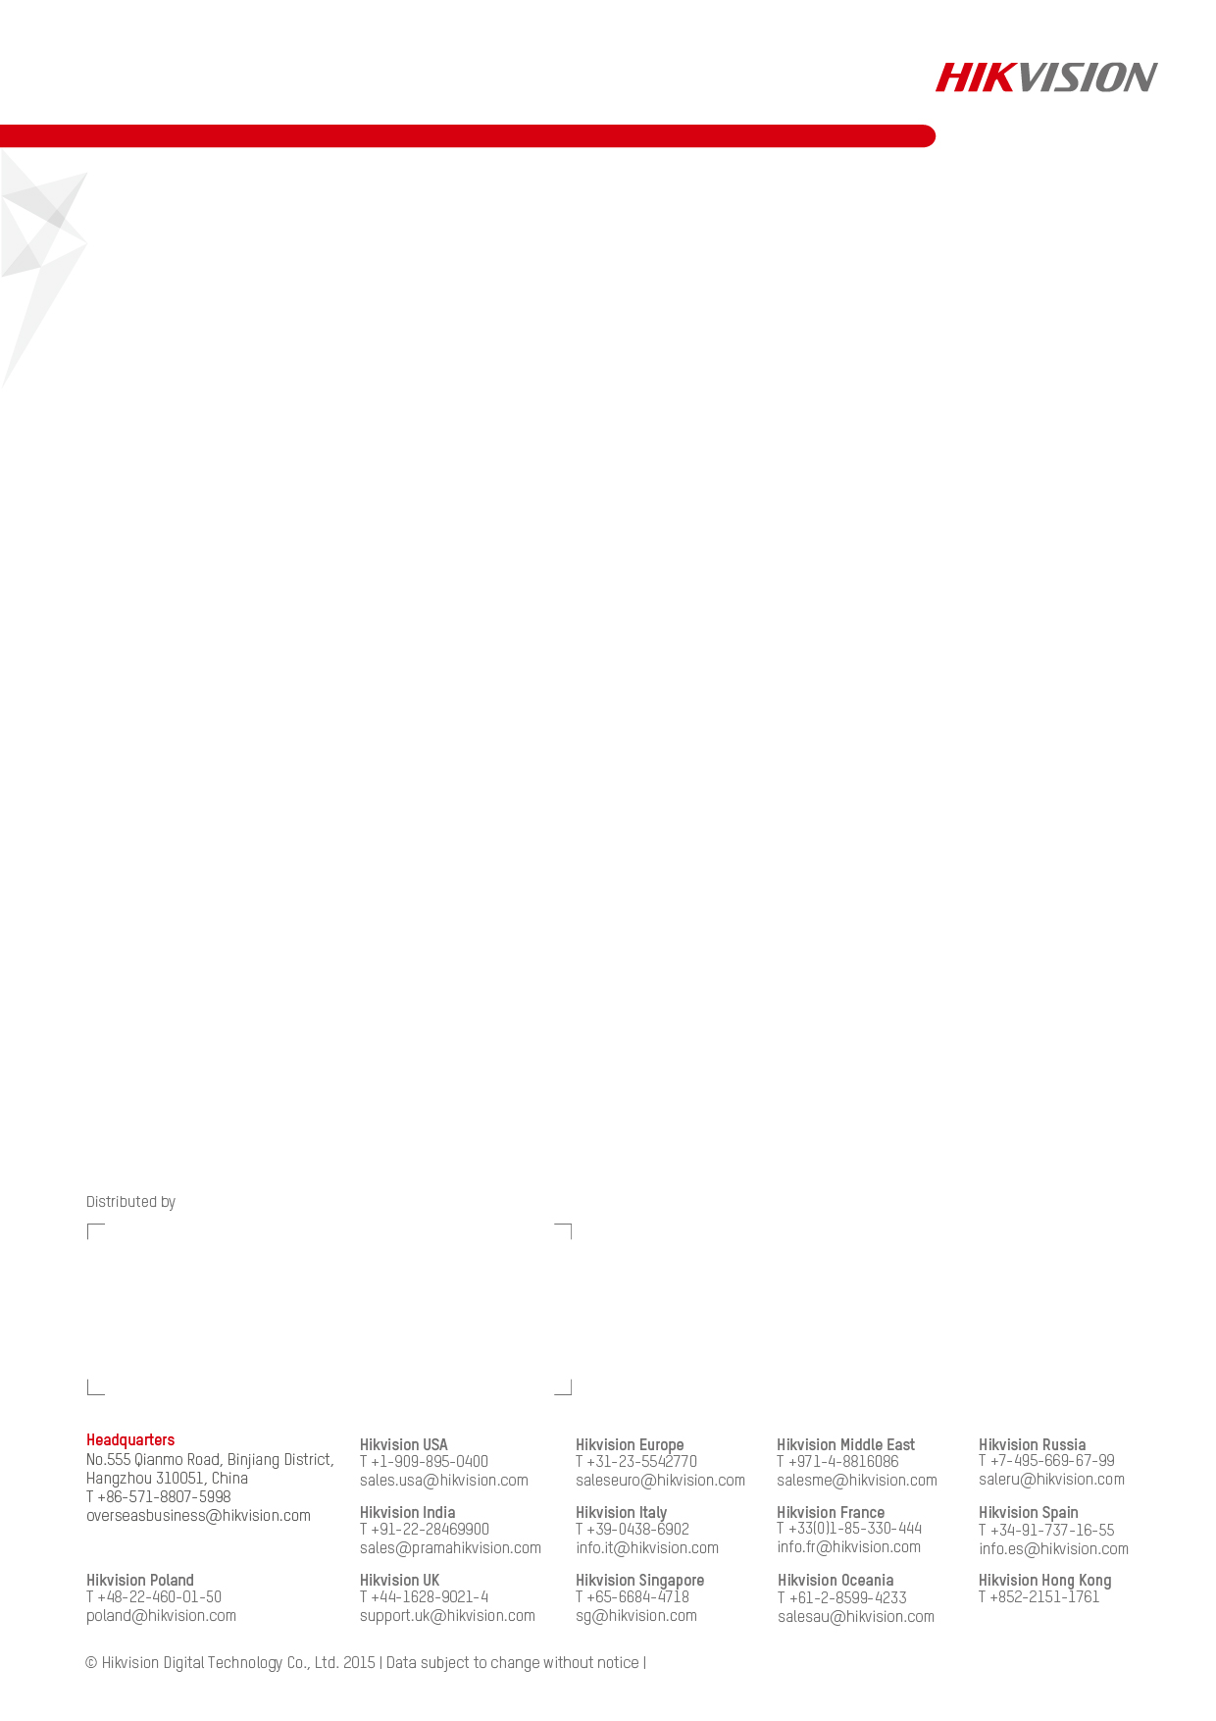



**Accessories**

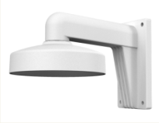

DS-1273ZJ-130

Wall Mounting



DS-1H18

Video Balun



X41T

Camera Tester



DS-1275ZJ

Vertical Pole Mount

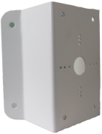 untitled 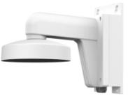 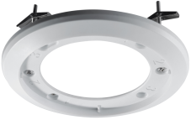

DS-1276ZJ DS-1271ZJ-130 DS-1273ZJ-130B DS-1249ZJ

Horizontal Pole Mount Pendant Mounting Wall Mounting In-ceiling Mounting

**Dimensions**

DS-2CE56F7T-ITZ, DS-2CE56F7T-AITZ

**20160118**

**Order Models**