

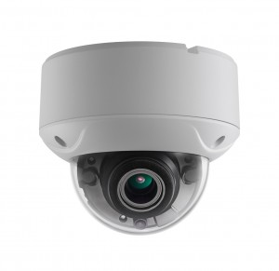

   

   

* 3 Megapixel high-performance CMOS
* Analog HD output, up to 3MP resolution
* 2.8-12mm motorized vari-focal lens
* True Day/Night
* OSD menu, DNR, Smart IR
* True WDR, up to 120dB
* EXIR technology, up to 40m IR distance
* IP66 weatherproof & vandal proof
* Up the Coax(HIKVISION-C)

**Key Features**

**HAC335D-OD4Z**

**3MP Motorized VF Proof EXIR EXIR Dome Camera**

|  |  |
| --- | --- |
| **Specifications** | |
| ***Camera*** | |
| Image Sensor | 3MP CMOS Image Sensor |
| Effective Pixels | 2052(H)*1536(V) |
| Min. illumination | 0.01 Lux @ (F1.2,AGC ON),0 Lux with IR |
| Shutter Time | 1/25s to 1/50,000s |
| Lens | Motorized VF lens; 2.8 - 12 mm @ F1.2 |
| Lens Mount | φ14 |
| Day & Night | ICR |
| Angle Adjustment | Pan: 0° - 340°; Tilt:0° - 75°; Rotate: 0° - 355° |
| Synchronization | Internal Synchronization |
| WDR | 120dB |
| Video Frame Rate | 1920×1536@18fps |
| HD Video Output | 1 Analog HD output |
| S/N Ratio | ＞62dB |
| ***Menu*** | |
| AGC | Support |
| D/N Mode | Color/BW/SMART |
| White Balance | ATW/ MWB |
| BLC | Support |
| Functions | Wide Dynamic Range, Digital noise reduction, Digital zoom(62x), Mirror, Defect pixel correction, SMART IR |
| ***General*** | |
| Operating Conditions | -40 °C – 60 °C (-40 °F – 140 °F), Humidity 90% or less (non-condensing) |
| Power Supply | 12 VDC±15%; -A: 12 VDC/24 VAC±15% |
| Power Consumption | Max. 4.5W; -A: Max. 6.5W |
| Protection Level | IP66 |
| IR Range | Up to 40m |
| Impact Protection | IK10 |
| Communication | Up the coax, Protocol: HIKVISION-C (TVI output) |
| Dimensions | φ145.2mm×124.1mm (φ5.72”×4.89”) |
| Weight | Approx. 1600g ( 3.53lb) |
|  |  |



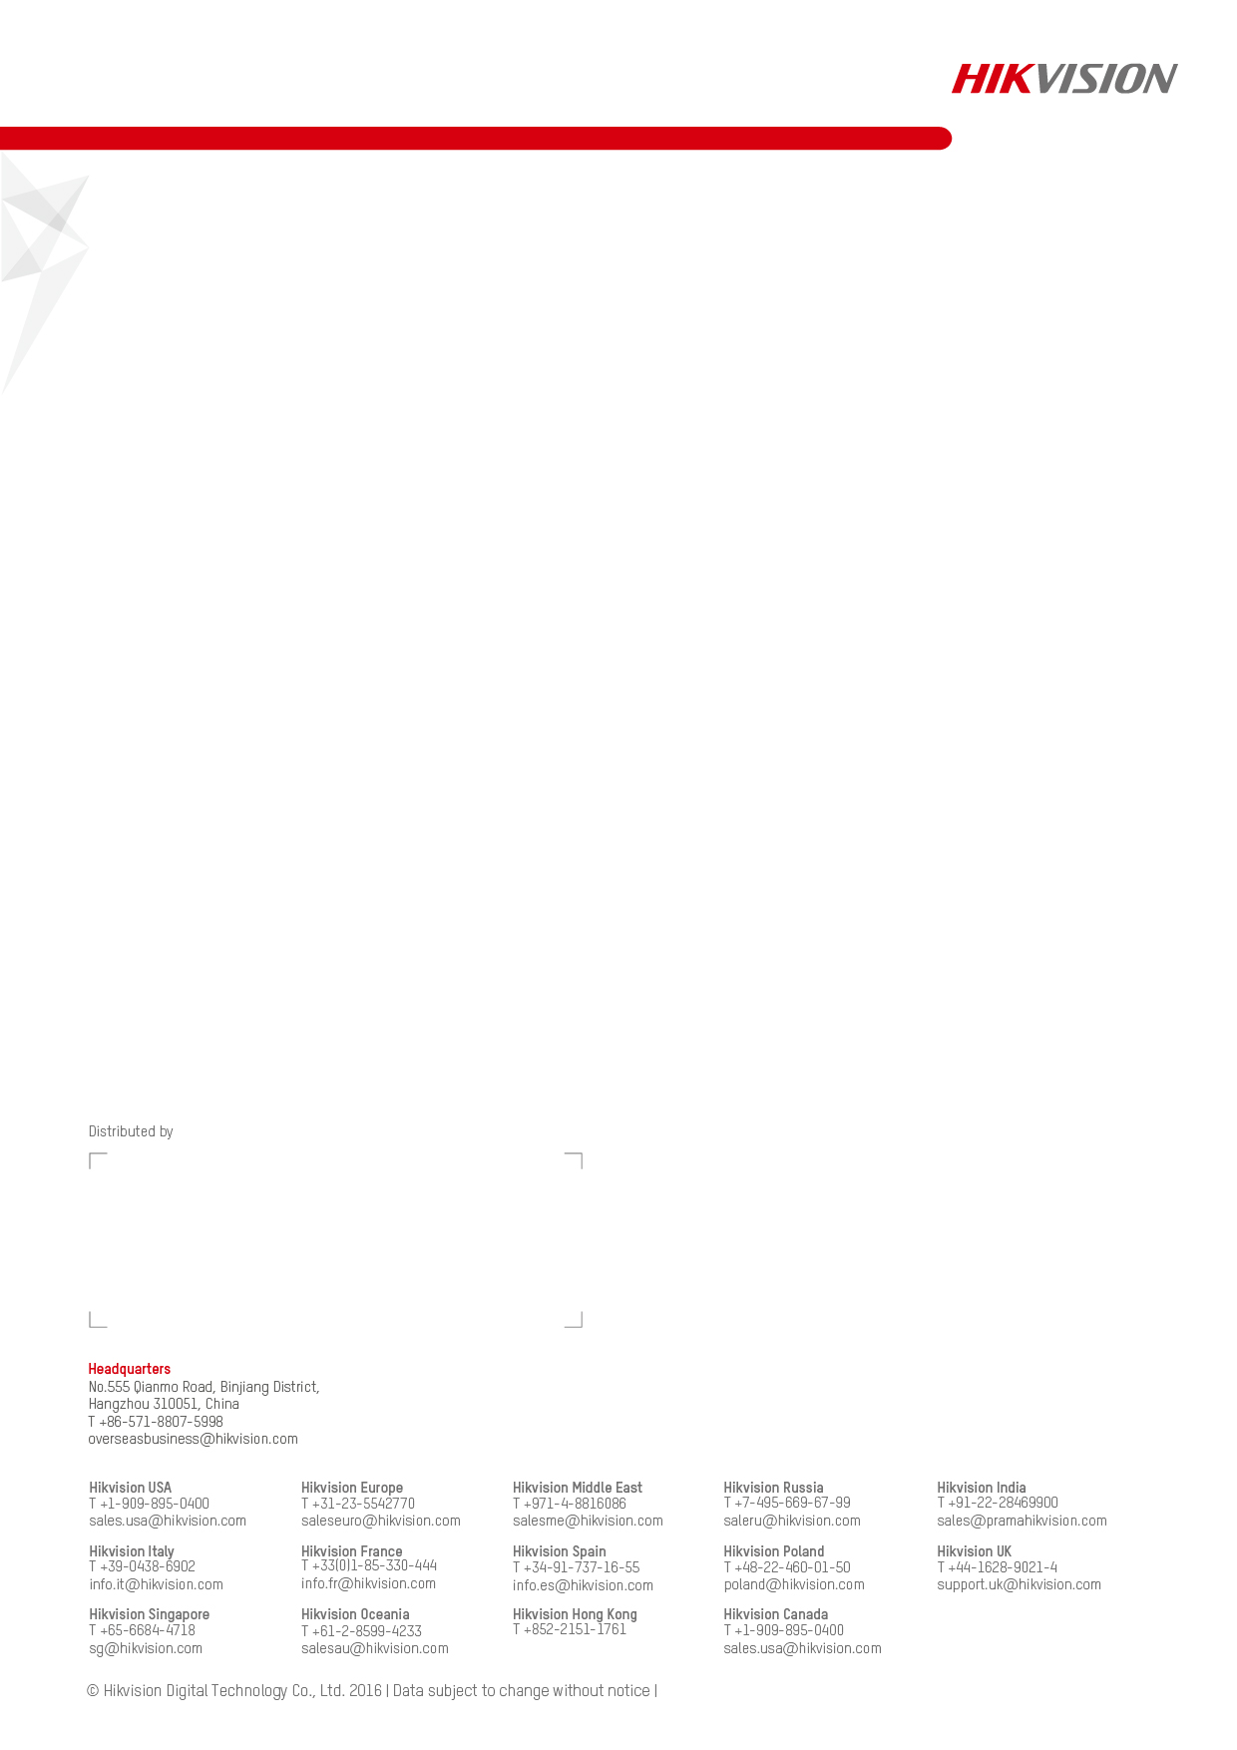

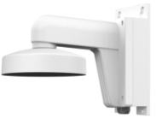 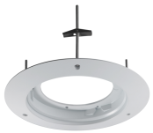 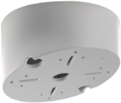

DS-1273ZJ-140B DS-1241ZJ DS-1240ZJ

Wall Mounting In-ceiling Mounting Inclined Ceiling Mounting

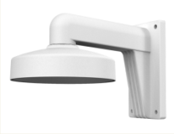 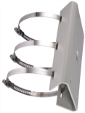 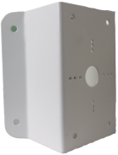 untitled

DS-1273ZJ-140 DS-1275ZJ DS-1276ZJ DS-1271ZJ-140

Wall Mounting Vertical Pole Mounting Corner Mounting Pendant Mounting

**Accessories**



**Dimensions**

DS-2CE56F7T-VPIT3Z, DS-2CE56F7T-AVPIT3Z

**20160127**

**Order Models**