**AC348-FD4M**

**4K Ultra-Low Light Turret Camera**

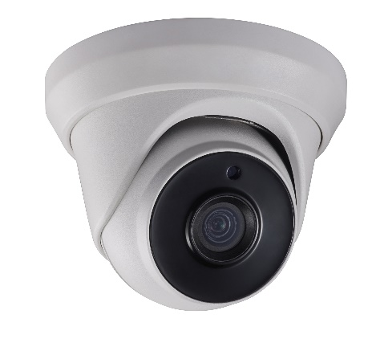

|  |
| --- |
| icon-08 E:\Working Folder\work\work\前端\icon red\模拟专用图标red\Ultra-Low Light.png E:\Working Folder\work\work\前端\icon red\模拟专用图标red\Ture WDR.png Smart IR |
| E:\Working Folder\work\work\前端\icon red\模拟专用图标red\3-axis Adjustment.png E:\Working Folder\work\work\前端\icon red\icon red\icon\icon-34.png |

|  |
| --- |
| **Key Features**   * 8.29 MP high performance CMOS * Ultra-low light * 3840 × 2160 resolution * 2.8 mm, 3.6 mm, 6 mm fixed focal lens * 120 dB true WDR, 3D DNR * EXIR 2.0, smart IR, up to 60 m IR distance * IP67 * Up the coax (UTC-C) |

|  |  |
| --- | --- |
| ***Camera*** | |
| Image Sensor | 8.29 megapixel progressive scan CMOS |
| Signal System | PAL/NTSC |
| Frame Rate | PAL: 8 MP@12.5fps, 5 MP@20fps, 4 MP@25fps, 1080p@25fps  NTSC: 8 MP@15fps, 5 MP@20fps, 4 MP@30fps, 1080p@30fps |
| Resolution | 3840 (H) × 2160 (V) |
| Min. illumination | Color: 0.003 Lux@(F1.2, AGC ON), 0 Lux with IR |
| Shutter Time | PAL: 1/12.5 s to 1/10,000 s  NTSC: 1/15 s to 1/10,000 s |
| Slow Shutter | Max. 16 times |
| Lens | 2.8 mm, 3.6 mm, 6 mm fixed focal lens |
| Horizontal Field of View | 102.2° (2.8 mm), 79° (3.6 mm), 50.8° (6 mm) |
| Lens Mount | M12 |
| Day & Night | IR cut filter |
| Angle Adjustment | Pan: 0° to 360°, Tilt: 0° to 75°, Rotate: 0° to 360° |
| Synchronization | Internal synchronization |
| WDR (Wide Dynamic Range) | 120 dB |
| ***Menu*** | |
| AGC | Support |
| Day/Night Mode | Auto/Color/BW (Black and White) |
| White Balance | Auto/Manual/Natural |
| Privacy Mask | ON/OFF, 4 programmable privacy masks |
| BLC (Backlight Compensation) | Support |
| 3D DNR (Digital Noise Reduction) | Level 1 to 10 |
| Language | English |
| Functions | Contrast, Sharpness, Saturation, Mirror, Defog, HLC |
| ***Interface*** | |
| TVI Video Output | 1 HD analog output |
| CVBS Video Output | 1 CVBS output (75Ω/BNC) |
| ***General*** | |
| Operating Conditions | -40 °C to 60 °C (-40 °F to 140 °F), humidity: 90% or less (non-condensation) |
| Power Supply | 12 VDC ±25% |
| Power Consumption | Max. 4.8 W |
| Protection Level | IP67 |
| Material | Enclosure: Plastic  Main Body: Metal  Mounting Base: Plastic |
| IR Range | Up to 60 m |
| Communication | Up the coax, Protocol: UTC-C (TVI output) |
| Dimensions | Ø 109.8 mm × 96.3 mm (Ø 4.32" × 3.79" ) |
| Weight | Approx. 360 g (0.79 lb.) |

**Specification**

|  |  |  |  |
| --- | --- | --- | --- |
| **Order Models** | | | |
| AC348-FD4M | | | |
| **Dimension** | | | |
|  | | | |
| **Accessory** | | | |
| 1272ZJ-110-TRS  Wall Mount | E:\Working Folder\work\work\2018年\201801\H0T 变焦\支架安装示意图\半球45支架高清图\302701533 DS-1275ZJ-SUS_副本.jpg  1275ZJ-SUS  Vertical Pole Mount | E:\Working Folder\work\work\2018年\201801\H0T 变焦\支架安装示意图\半球45支架高清图\DS-1276ZJ-SUS_副本.jpg  1276ZJ-SUS  Corner Mount | 1280ZJ-S  Junction Box |
| 1281ZJ-S  Inclined Ceiling Mount | 1H18  Video Balun |  |  |

20161122\_Draft