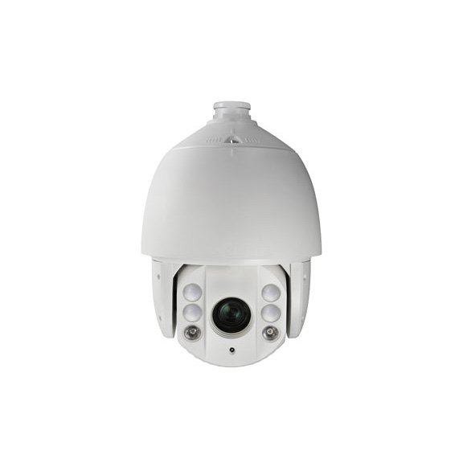

**HAP312-IR-25**

**2 MP IR Turbo 7 Inch Speed Dome**



HAP312-IR-25 IR Turbo 7-Inch Speed Dome is able to capture high quality images in poor light environment. The black anti-reflective glass increases the luminousness which helps IR distance reach up to 150 m.

The embedded CMOS chip makes WDR, and real-time 1920 × 1080 resolution possible. With the help of the 25× optical zoom, and IR cut filter, the camera offers more details over an expansive area.

* 1/2.8" HD progressive scan CMOS
* 1920 × 1080 resolution
* 25× optical zoom, 16× digital zoom
* 120 dB true WDR (Wide Dynamic Range)
* Up to 150 m IR distance
* 3D intelligent positioning
* Switchable TVI/AHD/CVI/CVBS video outputs



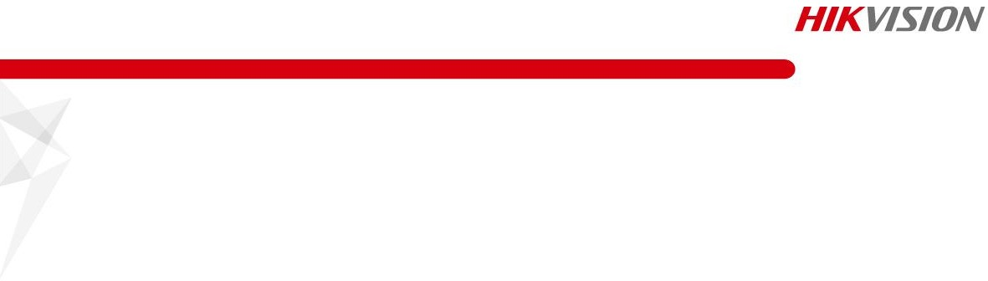

**Specification**

|  |  |
| --- | --- |
| ***Camera*** | |
| Model | HAP312-IR-25 |
| Image Sensor | 1/2.8" progressive scan CMOS |
| Max. Image Resolution | 1920 × 1080 |
| Frame Rate | 50Hz: 25fps @(1920 × 1080)  60Hz: 30fps @(1920 × 1080) |
| Min. Illumination | Color: 0.005 Lux @(F1.6, AGC ON) B/W: 0.001 Lux @(F1.6, AGC ON)  0 lux with IR |
| White Balance | AUTO/MANUAL/HAUTO/ATW/INDOOR/OUTDOOR |
| AGC | AUTO/MANUAL |
| DNR | 3D DNR |
| WDR | ≥ 120 dB |
| Shutter Time | PAL: 1/1 s to 1/10,000 s  NTSC: 1/1 s to 1/10,000 s |
| Day & Night | IR cut filter |
| Digital Zoom | 16× |
| Privacy Mask | 8 programmable privacy masks |
| BLC (Backlight Compensation) | Yes |
| HLC (highlight Compensation) | Yes |
| EIS (Electric Image Stabilization) | Yes |
| Reginal Focus | Yes |
| ***Lens*** | |
| Focus Mode | Auto/Semiauto/Manual |
| Focal Length | 4.8 mm to 120 mm, 25× Optical |
| Aperture Range | F 1.6 to F 3.5 |
| Horizontal Field of View | 57.6° to 2.5° (wide-tele) |
| Min. Working Distance | 10 mm to 1500 mm (wide to tele) |
| Zoom Speed | Approx. 3.6 s (optical, wide to tele) |
| ***Pan and Tilt*** | |
| Pan Range | 360° endless |
| Pan Speed | Pan manual speed: 0.1° to 160°/s  Pan preset speed: 160°/s |
| Tilt Range | -15° to 90° (auto flip) |
| Tilt Speed | Tilt manual speed: 0.1° to 120°/s  Tilt preset speed: 120°/s |
| Proportional Zoom | Rotation speed can be adjusted automatically according to zoom multiples |
| Presets | 256 |
| Patrol | 10 patrols, up to 32 presets per patrol |
| Pattern | 5 patterns, with the total recording time no less than 10 minutes |
| Power-off Memory | Yes |
| Park Action | Preset/Patrol/Pattern/Pan Scan/Tilt Scan/Panorama Scan/Day Mode/Night  Mode/None |
| PTZ Position Display | ON/OFF |
| Preset Freezing | Yes |



|  |  |
| --- | --- |
| Scheduled Task | Preset/Patrol/Pattern/Pan Scan/Tilt Scan/Panorama Scan/Day Mode/Night  Mode/Zero Calibration/None |
| ***Infrared*** | |
| IR Distance | Up to 150 m |
| IR Intensity | Automatically adjusted depending on the zoom ratio |
| ***Input/Output*** | |
| Video Output | Switchable TVI/AHD/CVI/CVBS video output, (NTSC or PAL composite, BNC) |
| RS-485 Interface | Half-duplex mode  Self-adaptive HIKVISION, Pelco-P, Pelco-D protocol |
| UTC function | UTC protocol (or HIKVISION-C protocol in previous DVR) |
| ***General*** | |
| Menu Language | English |
| Power | 24 VAC  Max. 40 W (IR: 14 W) |
| Working Temperature | -30° C to 65° C (-22° F to 149° F) |
| Working Humidity | 90% or less |
| Protection Level | IP66 standard (outdoor dome)  TVS 4,000 V lightning protection, surge protection and voltage transient protection |
| Mounting | Various mounting modes optional |

## Order Model

## HAP312-IR-25

## Dimensions

Ø 47 mm

(1.85" )

353.4 mm (13.91" )

Ø 220 mm (8.66" )

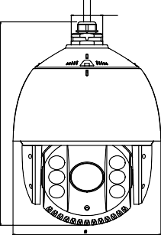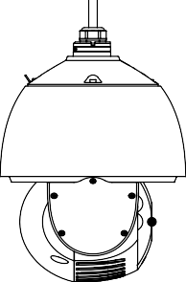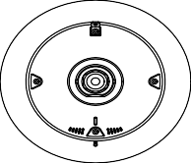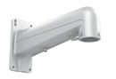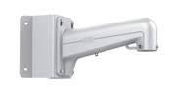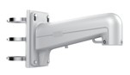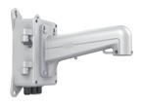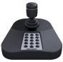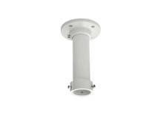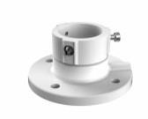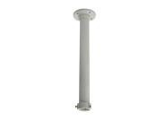

**Accessories**

HTH-602ZJ

Wall Mount

HTH-602ZJ-Conner Conner Mount

HTH-602ZJ-Pole

Pole Mount

HTH-602ZJ-Box

Box Mount

HTH-663ZJ

Celling mount

HTH-661ZJ

Pendant mount

HTH-662ZJ

Pendant mount

HTH-619ZJ

Swan-neck Mount

HTH-005KI

USB Joy-stick