**HAR315 SERIES TVI DVR**

**Features and Functions**

**Video Input and Transmission**

* Connectable to HD-TVI, AHD, network and analog cameras
* Up to 2-ch 4MP ONVIF conformant IP cameras input
* Long distance transmission over twisted-pair cable & coax cable

**Compression and Recording**

* H.264+ compression improves encoding efficiency by up to 50% and reduces data storage costs
* Full channel recording at up to 3MP resolution

**Video Output**

* HDMI output at up to 4K (3840 × 2160) resolution (HAR315-8 and HAR315-16)
* CVBS output improves compatibility at the most possibility

**Storage and Playback**

* One SATA interface for HAR315-4 and two SATA interfaces for HAR315-8 AND HAR315-16(up to 8TB of capacity per HDD)
* HDD quota and group management for flexible recording storage
* 4/8/16-ch synchronous playback
* Smart search for efficient playback
* Supports the 3rd party cloud storage (Dropbox/Google Drive/Microsoft OneDrive)

**Smart Function**

* Supports multiple VCA(Video Content Analytics) events for both analog and smart IP cameras
* VQD(Video Quality Diagnostics)

**Network & Ethernet Access**

* Guarding Vision P2P & DDNS (Dynamic Domain Name System) for easy network management
* Gigabit Ethernet network interface (HAR315-8 and HAR315-16)

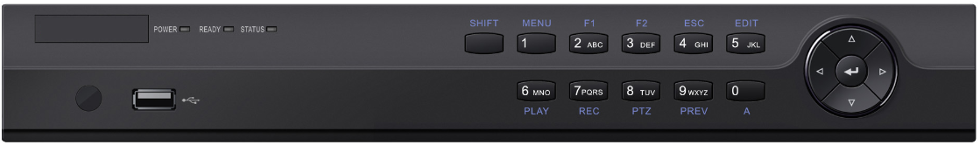

**Specifications**

| **Model** |  | **HAR315-4** | **HAR315-8** | | **HAR315-16** |
| --- | --- | --- | --- | --- | --- |
| **Video/Audio input** | **Video compression** | H.264+/H.264 | | | |
| **Video input** | 4-ch | 8-ch | | 16-ch |
| BNC interface (1.0Vp-p, 75 Ω), supporting coaxitron connection | | | |
| **Supported HDTVI input** | 1080p/25Hz, 1080p/30Hz, 720p/25Hz, 720p/30Hz, 720P/50Hz, 720p/60Hz, 3MP | | | |
| **Supported AHD input** | 1080p/25Hz, 1080p/30Hz,720p/25Hz, 720p/30Hz | | | |
| **CVBS input** | Support | | | |
| **IP video input** | 2-ch | | | |
| Up to 4 MP resolution | | | |
| **Audio compression** | G.711u | | | |
| **Audio input** | 4-ch, RCA (2.0 Vp-p, 1 KΩ) | | | |
| **Video/Audio output** | **CVBS output** | Support | | | |
| **HDMI/VGA output** | **VGA**: 1-ch, 1920 × 1080/60Hz, 1280 × 1024/60Hz, 1280 × 720/60Hz, 1024 × 768/60 Hz | | | |
| **HDMI**: 1-ch, 1920 × 1080/60Hz, 1280 × 1024/60Hz, 1280 × 720/60Hz, 1024 × 768/60Hz | **HDMI**: 1-ch, 4K (3840 × 2160)/30Hz, 2K (2560 × 1440)/60Hz, 1920 × 1080/60Hz, 1280 × 1024/60Hz, 1280 × 720/60Hz, 1024 × 768/60Hz | | |
| **Encoding resolution** | 3MP@15fps/1080p/720p/WD1/4CIF/VGA/CIF | | | |
| **Frame rate** | Main stream: 25 fps (P)/30 fps (N) | | | |
| Sub-stream: WD1/4CIF@12fps (non-real-time); CIF/QVGA/QCIF (real time) | | | |
| **Video bitrate** | 32 Kbps to 10 Mbps | | | |
| **Audio output** | 1-ch, RCA (Linear, 1 KΩ) | | | |
| **Audio bit rate** | 64 Kbps | | | |
| **Dual-stream** | Support | | | |
| **Stream type** | Video, Video & Audio | | | |
| **Synchronous playback** | 4-ch | 8-ch | 16-ch | |
| **Network management** | **Remote connections** | 128 | | | |
| **Network protocols** | TCP/IP, PPPoE, DHCP, Cloud P2P, DNS, DDNS, NTP, SADP, NFS, iSCSI, UPnP™, HTTPS, ONVIF | | | |
| **Hard disk** | **SATA** | 1 SATA interfaces | 2 SATA interfaces | | |
| **Capacity** | Up to 8TB capacity | | | |
| **External interface** | **Two-way audio input** | 1-ch, RCA (2.0 Vp-p, 1 KΩ) (using the audio input) | | | |
| **Network interface** | 1, RJ45 10M/100M self-adaptive Ethernet interface | 1, RJ45 10M/100M/1000M self-adaptive Ethernet interface | | |
| **USB interface** | 2 × USB 2.0 | Front panel: 1× USB 2.0  Rear panel: 1×USB 3.0 | | |
| **Serial interface** | 1; RS-485 serial interface, half-duplex | | | |
| **Alarm in/out** | 4/1 | 8/4 | 16/4 | |
| **General** | **Power supply** | 12 VDC | | | |
| **Consumption**  **(without HDD)** | ≤ 15W | ≤ 20W | ≤ 20W | |
| **Working temperature** | -10 ºC to +55 ºC (14 ºF to 131 ºF) | | | |
| **Working humidity** | 10% to 90% | | | |
| **Dimensions**  **(W × D × H)** | 315 × 242 × 45 mm (12.4 × 9.5 × 1.8 inch) | 380 × 320 × 48 mm (15.0 × 12.6 × 1.9 inch) | | |
| **Weight**  **(without HDD)** | ≤ 1.5 kg (3.3 lb) | ≤ 2 kg (4.4 lb) | ≤ 2 kg (4.4 lb) | |

 For HAR315 series DVR, each two video channels are grouped in sequence, e.g., CH01 and CH02, CH03 and CH04..., and each two channels in the same group must be connected with the same type of video source selected on GUI. For example, when the TVI/CVBS signal mode is selected, then either TVI or CVBS signal input can be connected to the channels in the same group; and when the AHD signal mode is selected, only the AHD signal input can be connected.

|  |  |  |  |
| --- | --- | --- | --- |
| **Index** | **Description** | **Index** | **Description** |
| **1** | VIDEO IN | **8** | RS-485 Serial Interface |
| **2** | AUDIO IN, RCA Connector | **9** | 12 VDC Power Input |
| **3** | AUDIO OUT, RCA Connector | **10** | Power Switch |
| **4** | VGA Interface | **11** | GND |
| **5** | HDMI Interface | **12** | VIDEO OUT |
| **6** | USB Interface | **13** | Alarm in/out |
| **7** | LAN Network Interface |  |  |

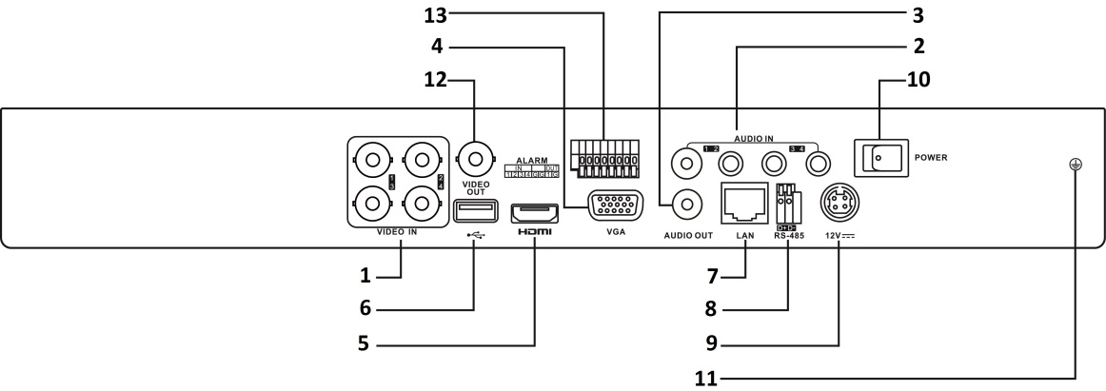

 The rear panels of HAR315-8 and HAR315-16 provide 8 and 16 video input interfaces respectively.

**Available Models**

HAR315-4, HAR315-8, HAR315-16

**Physical Interfaces**