HAR504-24

HD-TVI 720P 24 Ch Digital Video Recorder

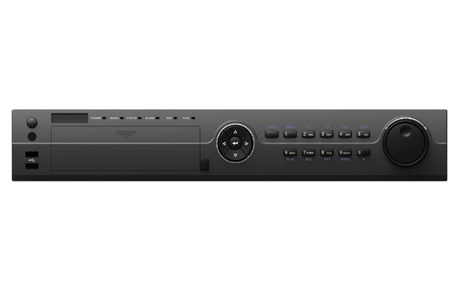

|  |
| --- |
| Features |
| H.264 & Dual-stream video compression |
| Support HD-TVI/analog/IP camera triple hybrid |
| Support both HD-TVI and analog cameras with  adaptive access |
| Full channel@720P resolution real-time recording |
| HDMI and VGA output at up to 1080P resolution |
| Long transmission distance over coax cable |
|  |
|  |
|  |
|  |

**Specification Detail**

Video compression H.264

Analog and HD-TVI video input 24 ch

Supported camera types 720P25, 720P30, 720P50, 720P60, 1080P25, 1080P30, CVBS Audio compression G.711u

Audio input / Two-way audio in 1-ch, RCA (2.0 Vp-p, 1 KΩ)

HDMI / VGA output 1920 × 1080 / 60 Hz,1280 × 1024 / 60 Hz, 1280 × 720 / 60 Hz, 1024 × 768 / 60 Hz

Encoding resolution Main stream: 1080P(non-real-time) / 720P / VGA / WD1 / 4CIF / CIF, Sub-stream: WD1(non-real-time) / 4CIF(non-real-time) / CIF / QCIF / QVGA

Frame rate 30 fps @ 720P per ch/30 fps @ 960H per ch

Video bitrate 32 Kbps-6 Mbps

Audio output 1-ch, RCA (Linear, 1KΩ)

Audio bitrate 64 Kbps

Dual-stream Support

Stream type Video, Video & Audio

Synchronous playback 16-ch

Playback resolution 1080P / 720P / VGA / WD1 / 4CIF / CIF / QVGA / QCIF Remote connections 128

Type 4 SATA interfaces for 4 HDDs; 1 eSATA interface

Network protocols TCP/IP, PPPoE, DHCP, DNS, DDNS, NTP, SADP, SMTP, SNMP, NFS, iSCSI, UPnP™, HTTPS

Capacity Up to 4 TB capacity for each disk

Network interface 1; 10M / 100M / 1000M self-adaptive Ethernet interface

Serial interface 1; standard RS-485 serial interface, half-duplex

USB port 2 × USB2.0

Power supply 12V DC Consumption (without hard disks) ≤ 20W

Working temperature -10 ºC ~+55 ºC (14 ºF ~ 131 ºF)

Working humidity 10% ~ 90%

Chassis 19-inch rack-mounted 1.5U chassis Dimensions (W— D— H) 445 × 390 × 70 mm (17.5 × 15.3 × 2.7 inch) Weight (without hard disks)