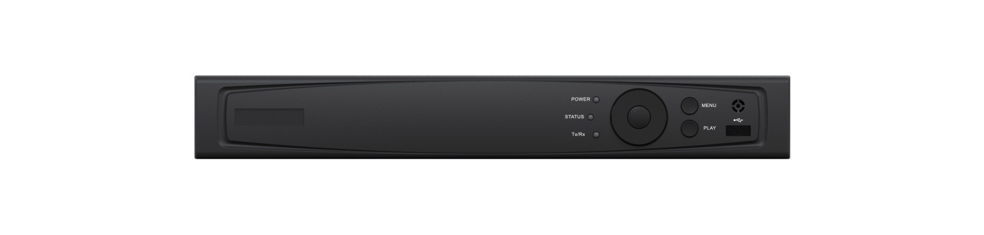

**HAR314 SERIES TURBO HD DVR**

* Connectable to HD-TVI, AHD, network and analog cameras;
* Support HDCAM-C protocol for connecting camera over coax;
* Support enabling H.264+ to ensure high video quality with lowered bitrate;
* Simultaneous HDMI, VGA and CVBS outputs, and HDMI/VGA output at up to 1920×1080p resolution for HAR314-4, HAR314-8 and up to 4K (3840 × 2160) resolution for HAR314-16;
* One-key recording configurable;
* Redundant recording and holiday recording;
* Main stream and sub-stream parameters configurable for simultaneous recording;
* Support channel-zero encoding;
* Support 1080p lite mode enabled to realize the real-time 1080p lite and 720p lite resolution;
* Instant playback for assigned camera during multi-channel live view mode;
* Up to 4/8/16-ch synchronous playback at 1080p resolution;
* Playback at up to 256X speed;
* Main stream and sub-stream selectable for local/remote playback;
* Playback by smart search and VCA search;
* Customization of tags, searching and playing back by tags;
* Manual video quality diagnostics;
* Supports locking and unlocking of video files;
* HDD quota and group management; different capacity can be assigned to different cameras under quota mode;
* One SATA interface provided for HAR314-4/HAR314-8; two SATA interface provided for HAR314-16;
* One RJ45 10M/100Mbps self-adaptive network interface for HAR314-4/HAR314-8 and one RJ45 10M/100M/1000Mbps self-adaptive network interface for HAR314-16;
* Supports access by Guarding Vision P2P;
* Supports DDNS (Dynamic Domain Name System).

**Features and Functions**

| **Model** |  | **HAR314-4** | **HAR314-8** | **HAR314-16** |
| --- | --- | --- | --- | --- |
| **Video/Audio input** | **Video compression** | H.264 | | |
| **Video input** | 4-ch | 8-ch | 16-ch |
| BNC interface (1.0Vp-p, 75 Ω), supporting coaxitron connection | | |
| **Supported HDTVI input** | 1080p/25Hz, 1080p/30Hz, 720p/25Hz, 720p/30Hz, 720P/50Hz, 720p/60Hz | | |
| **Supported AHD input** | 1080p/25Hz, 1080p/30Hz | | |
| **CVBS input** | Support | | |
| **IP video input** | 1-ch | 2-ch | 2-ch |
| Up to 2.0 MP resolution | | |
| **Audio compression** | G.711u | | |
| **Audio input** | 1-ch, RCA (2.0 Vp-p, 1 KΩ) | | |
| **Video/Audio output** | **CVBS output** | Support | | |
| **HDMI/VGA output** | 1-ch, 1920 × 1080/60 Hz, 1280 × 1024/60 Hz, 1280 × 720/60Hz, 1024 × 768/60 Hz | | 1-ch, 4K (3840 × 2160)/30Hz, 2K (2560 × 1440)/60Hz, 1920 × 1080/60 Hz, 1280 × 1024/60 Hz, 1280 × 720/60Hz, 1024 × 768/60 Hz |
| **Encoding resolution** | When 1080p Lite mode not enabled: 1080p(non-real-time)/720p/VGA/WD1/4CIF/CIF;  When 1080p Lite mode enabled: 1080p lite/720p lite/VGA/WD1/4CIF/CIF | | |
| **Frame rate** | Main stream: 1/16 fps to real time frame rate | | |
| Sub-stream: WD1/4CIF@12fps/2CIF (non-real-time); CIF/QVGA/QCIF (real time) | | |
| **Video bit rate** | 32 Kbps to 6 Mbps | | |
| **Audio output** | 1-ch, RCA (Linear, 1 KΩ) | | |
| **Audio bit rate** | 64 Kbps | | |
| **Dual-stream** | Support; | | |
| **Stream type** | Video, Video & Audio | | |
| **Synchronous playback** | 4-ch | 8-ch | 16-ch |
| **Network management** | **Remote connections** | 128 | | |
| **Network protocols** | TCP/IP, PPPoE, DHCP, EZVIZ Cloud P2P, DNS, DDNS, NTP, SADP, NFS, iSCSI, UPnP™, HTTPS, ONVIF | | |
| **Hard disk** | **SATA** | 1 SATA interface | | 2 SATA interface |
| **Capacity** | Up to 6TB capacity | | |
| **External interface** | **Two-way audio input** | 1-ch, RCA (2.0 Vp-p, 1 KΩ) (using the audio input) | | |
| **Network interface** | 1, RJ45 10M/100M self-adaptive Ethernet interface | | 1, RJ45 10M/100M/1000M self-adaptive Ethernet interface |
| **USB interface** | 2 × USB 2.0 | | 1 USB 2.0 on the front panel  1 USB 3.0 on the rear panel |
| **Serial interface** | 1; RS-485 serial interface, half-duplex | | |
| **General** | **Power supply** | 12 VDC | | |
| **Consumption**  **(without HDD)** | ≤ 15 W | ≤ 20 W | ≤ 30 W |
| **Working temperature** | -10 ºC to +55 ºC (14 ºF to 131 ºF) | | |
| **Working humidity** | 10% to 90% | | |
| **Dimensions**  **(W × D × H)** | 315 × 242 × 45 mm (12.4 × 9.5 × 1.8 inch) | |  |
| **Weight**  **(without HDD)** | ≤ 2 kg (4.4lb) | ≤ 2 kg (4.4lb) | ≤ 2 kg (4.4lb) |

Specifications

|  |  |  |  |
| --- | --- | --- | --- |
| **Index** | **Description** | **Index** | **Description** |
| **1** | VIDEO IN | **7** | USB Interface |
| **2** | VIDEO OUT | **8** | LAN Network Interface |
| **3** | AUDIO IN, RCA Connector | **9** | RS-485 Serial Interface |
| **4** | AUDIO OUT, RCA Connector | **10** | 12VDC Power Input |
| **5** | VGA Interface | **11** | Power Switch |
| **6** | HDMI Interface | **12** | GND |

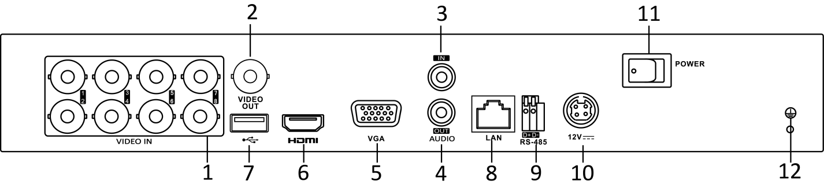

 The rear panel of HAR314-4 and HAR314-16 provide 4 and 16 video input interfaces respectively.

**Physical Interfaces**

**Available Models**

HAR314-4, HAR314-8, HAR314-16