**AR328 SERIES TVI HD DVR**

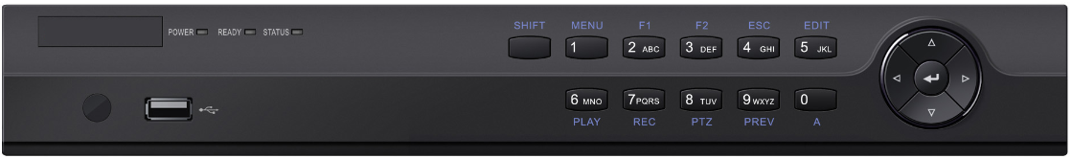

**Features and Functions**

**Video Input and Transmission**

* Self-adaptive HDTVI/HDCVI/AHD/CVBS signal input
* Up to 2/4-ch 8 MP IP cameras input
* 8 MP HDTVI video input and live view
* Defogging function enabled for the supported analog cameras
* Long distance transmission over UTP and coaxial cable: max. 800m for 1080p and 1200m for 720p HDTVI signal

**Compression and Recording**

* H.265+/H.265/H.264+/H.264 encoding for the main stream, and H.265/H.264 for the sub-stream of analog cameras
* Connectable to H.265+/H.265/H.264+/H.264 IP cameras
* H.265+ can be enabled to improve encoding efficiency and reduce data storage costs
* Full channel recording at up to 8 MP resolution

**Video Output**

* HDMI and VGA interfaces can be configured to be simultaneous or independent
* HDMI output at up to 4K (3840 × 2160) resolution
* Separate CVBS output

**Storage and Playback**

* 1/2 SATA interface (up to 8 TB capacity per HDD)
* 4/8-ch synchronous playback
* Smart search for efficient playback
* Supports the 3rd party cloud storage (Dropbox/Google Drive/Microsoft OneDrive)

**Smart Function**

* Supports multiple VCA (Video Content Analytics) events for both analog and smart IP cameras
* Supports line crossing detection and intrusion detection of all channels, and 2-ch sudden scene change detection
* VCA information overlay in live view and smart playback
* VQD (Video Quality Diagnostics)
* Supports PTZ control via Omnicast VMS of Genetec protocol

**Network & Ethernet Access**

* GuardingVision & DDNS (Dynamic Domain Name System) for easy network management
* 1 RJ45 10M/100M/1000M self-adaptive Ethernet interface
* Output bandwidth limit configurable

**Specifications**

| **Model** |  | **AR328-4** | **AR328-8** |
| --- | --- | --- | --- |
| **Video/Audio input** | **Video compression** | H.265+/H.265/H.264+/H.264 | |
| **Analog video input** | 4-ch | 8-ch |
| BNC interface (1.0 Vp-p, 75 Ω), supporting coaxitron connection | |
| **HDTVI input** | 8 MP, 5 MP, 4 MP, 3 MP, 1080p30, 1080p25, 720p60, 720p50, 720p30, 720p25 | |
| **AHD input** | 5 MP, 4 MP, 3 MP, 1080p25, 1080p30, 720p25, 720p30 | |
| **HDCVI input** | 4 MP, 1080p25, 1080p30, 720p25, 720p30 | |
| **CVBS input** | PAL/NTSC | |
| **IP video input** | 2-ch | 4-ch |
| Up to 8 MP resolution | |
| Supports H.265+/H.265/H.264+/H.264 IP cameras | |
| **Audio compression** | G.711u | |
| **Audio input** | 4-ch, RCA (2.0 Vp-p, 1 KΩ) | |
| **Video/Audio output** | **CVBS output** | 1-ch, BNC (1.0 Vp-p, 75 Ω), resolution: PAL: 704 × 576, NTSC: 704 × 480 | |
| **HDMI/VGA output** | **VGA**: 1-ch, 1920 × 1080/60Hz, 1280 × 1024/60Hz, 1280 × 720/60Hz, 1024 × 768/60Hz | |
| **HDMI**: 1-ch, 4K (3840 × 2160)/30Hz, 2K (2560 × 1440)/60Hz, 1920 × 1080/60Hz, 1280 × 1024/60Hz, 1280 × 720/60Hz, 1024 × 768/60Hz | |
| **Encoding resolution** | 8 MP/5 MP/4 MP/3 MP/1080p/720p/WD1/4CIF/VGA/CIF | |
| **Frame rate** | Main stream:  8 MP@12fps, 5 MP@20fps, 3 MP@18fps  4 MP/1080p/720p/WD1/4CIF/VGA/CIF@25fps (P)/30fps (N) | |
| Sub-stream:  WD1/4CIF/CIF@25fps (P)/30fps (N) | |
| **Video bit rate** | 32 Kbps to 16 Mbps | |
| **Audio output** | 1-ch, RCA (Linear, 1 KΩ) | |
| **Audio bit rate** | 64 Kbps | |
| **Dual stream** | Support | |
| **Stream type** | Video, Video & Audio | |
| **Synchronous playback** | 4-ch | 8-ch |
| **Network management** | **Remote connections** | 32 | 64 |
| **Network protocols** | TCP/IP, PPPoE, DHCP, GuardingVision, DNS, DDNS, NTP, SADP, NFS, iSCSI, UPnP™, HTTPS, ONVIF | |
| **Hard disk** | **SATA** | 1 SATA interfaces | 2 SATA interfaces |
| **Capacity** | Up to 8 TB capacity for each disk | |
| **External interface** | **Two-way audio input** | 1-ch, RCA (2.0 Vp-p, 1 KΩ) (using the 1st audio input) | |
| **Network interface** | 1, RJ45 10M/100M/1000M self-adaptive Ethernet interface | |
| **USB interface** | Front panel: 1 × USB 2.0  Rear panel: 1 × USB 3.0 | |
| **Serial interface** | RS-485 (half-duplex) | |
| **Alarm in/out** | 4/1 | 8/4 |
| **General** | **Power supply** | 12 VDC | |
| **Consumption**  **(without HDD)** | ≤ 15 W | ≤ 20 W |
| **Working temperature** | -10 ºC to +55 ºC (+14 ºF to +131 ºF) | |
| **Working humidity** | 10% to 90% | |
| **Dimensions**  **(W × D × H)** | 315 × 242 × 45 mm (12.4 × 9.5 × 1.8 inch) | 380 × 320 × 48 mm (15.0 × 12.6 × 1.9 inch) |
| **Weight**  **(without HDD)** | ≤ 1.5 kg (3.3 lb) | ≤ 2 kg (4.4 lb) |

|  |  |  |  |
| --- | --- | --- | --- |
| **Index** | **Description** | **Index** | **Description** |
| **1** | VIDEO IN | **8** | RS-485 Serial Interface |
| **2** | AUDIO IN, RCA Connector | **9** | 12 VDC Power Input |
| **3** | AUDIO OUT, RCA Connector | **10** | Power Switch |
| **4** | VGA Interface | **11** | GND |
| **5** | HDMI Interface | **12** | VIDEO OUT |
| **6** | USB Interface | **13** | Alarm In/Out |
| **7** | LAN Network Interface |  |  |

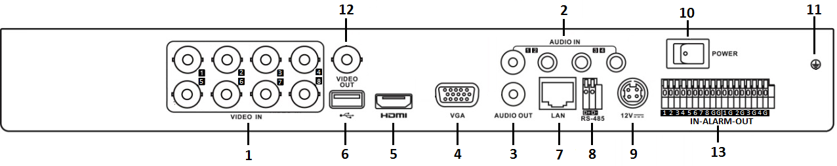

E:\05_流程执行与建设\11_模版制作\图标\note.png

The rear panel of AR328-4 provides 4 video input interfaces, and 4/1 alarm in/out interfaces.

AR328-4, AR328-8

**Available Models**

**Physical Interfaces**