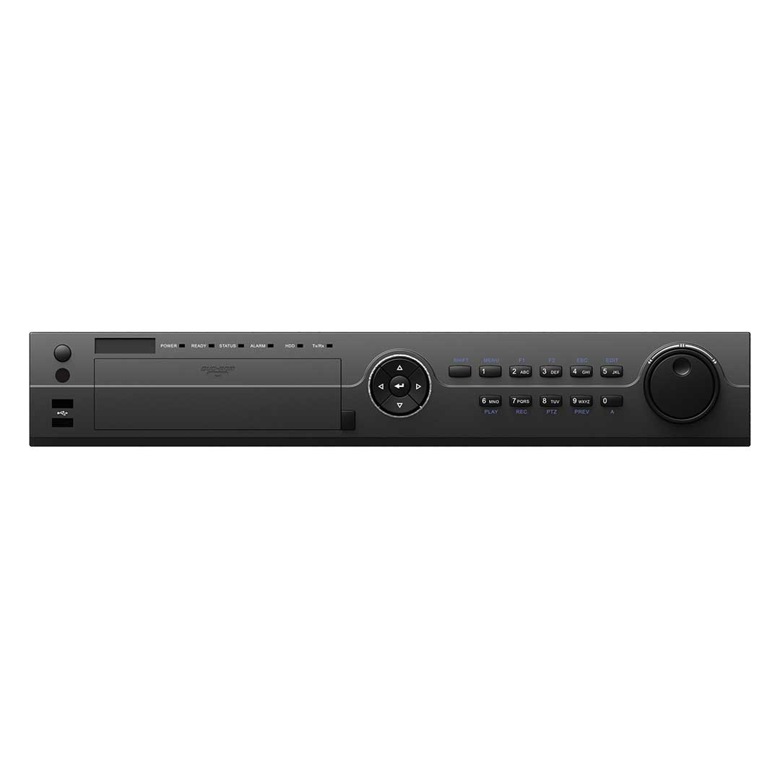

**HAR524-24/**

**HAR524-32**

# Features and Functions

## Appearance Design

* Typical chassis design to guarantee the low noise and environmental protection of the device
* Front slot for insertion of DVD-R/W with bracket to make it more convenient to install and maintain

## Video Input and Transmission

* Self-adaptive HDTVI/HDCVI/AHD/CVBS signal input
* Up to 6 MP IP cameras input
* Long distance transmission over UTP and coaxial cable

## Compression and Recording

* H.265+/H.265/H.264+/H.264 encoding for the main stream, and H.265/H.264 for the sub-stream of analog cameras
* Connectable to H.265+/H.265/H.264+/H.264 IP cameras
* H.265+ can be enabled to improve encoding efficiency and reduce data storage costs
* Supports 4 MP lite
* Supports real-time 1080p lite and when enabled, the image effect is similar with 1080p
* Supports POS triggered recording and POS information overlay

## Video Output

* Simultaneous HDMI1 and VGA output at up to 1920 × 1080 resolution, and independent HDMI 2 output at up to 4K (3840 × 2160) resolution
* Separate CVBS output

## Storage and Playback

* Four SATA interfaces (up to 8 TB capacity per HDD) and 1 eSATA interface
* 16-ch synchronous playback
* Smart search for efficient playback
* Supports playback by main stream, or sub-stream for IP cameras
* Supports third party cloud storage (Dropbox/Google Drive/Microsoft OneDrive)

## Smart Function

* Supports multiple VCA (Video Content Analytics) events for both analog and smart IP cameras
* Supports 4-ch line crossing detection and intrusion detection, and 1-ch sudden scene change detection
* VQD (Video Quality Diagnostics)
* Supports PTZ control via Omnicast VMS of Genetec protocol

## Network & Ethernet Access

* Hik-Connect & DDNS (Dynamic Domain Name System) for easy network management
* One RJ45 10M/100M/1000M Ethernet network interface
* Output bandwidth limit configurable





**Specifications**

|  |  |  |  |
| --- | --- | --- | --- |
| **Model** |  | **HAR524-24** | **HAR524-32** |
| **Video/Audio input** | **Video compression** | H.265+/H.265/H.264+/H.264 | |
| **Analog video input** | 24-ch | 32-ch |
| BNC interface (1.0 Vp-p, 75 Ω), supporting coaxitron connection | |
| **HDTVI input** | 4 MP, 3 MP, 1080p25, 1080p30, 720p25, 720p30, 720p50, 720p60  **Note**: The 3 MP signal input is only available for channel 1/2/3/4. | |
| **AHD input** | 4 MP, 1080p25, 1080p30, 720p25, 720p30 | |
| **HDCVI input** | 1080p25, 1080p30, 720p25, 720p30 | |
| **CVBS input** | PAL/NTSC | |
| **IP video input** | 8-ch (up to 32-ch) | 8-ch (up to 40-ch) |
| Up to 6 MP resolution | |
| Supports H.265+/H.265/H.264+/H.264 IP cameras | |
| **Audio**  **compression** | G.711u | |
| **Audio input** | 4-ch, RCA (2.0 Vp-p, 1 KΩ) | |
| **Video/Audio output** | **CVBS output** | 1-ch, BNC (1.0 Vp-p, 75 Ω), resolution: PAL: 704 × 576, NTSC: 704 × 480 | |
| **HDMI1/VGA**  **output** | 1-ch, 1920 × 1080/60Hz, 1280 × 1024/60Hz, 1280 × 720/60Hz, 1024 × 768/60Hz | |
| **HDMI2 output** | 1-ch, 4K (3840 × 2160)/30Hz, 2K (2560 × 1440)/60Hz, 1920 × 1080/60Hz, 1280 × 1024/60Hz, 1280 ×  720/60Hz, 1024 × 768/60Hz | |
| **Encoding resolution** | When 1080p Lite mode not enabled:  4 MP lite/3 MP/1080p/1080p lite/720p/WD1/4CIF/VGA/CIF When 1080p Lite mode enabled:  4 MP lite/3 MP/1080p lite/720p/720p lite/WD1/4CIF/VGA/CIF | |
| **Frame rate** | Main stream:  When 1080p Lite mode not enabled:  For 4 MP stream access: 4 MP lite@15fps; 1080p lite/720p/WD1/4CIF/VGA/CIF@25fps (P)/30fps (N) For 3 MP stream access: 3 MP/1080p/720p/WD1/4CIF/VGA/CIF@15fps  For 1080p stream access: 1080p/720p@15fps; 720p/WD1/4CIF/VGA/CIF@25fps (P)/30fps (N) For 720p stream access: 720p/WD1/4CIF/VGA/CIF@25fps (P)/30fps (N)  When 1080p Lite mode enabled:  For 4 MP stream access: 4 MP lite@15fps; 1080p lite/720p lite/WD1/4CIF/VGA/CIF@25fps (P)/30fps (N)  For 3 MP stream access: 3 MP/1080p lite/720p lite/WD1/4CIF/VGA/CIF@15fps  For 1080p stream access: 1080p lite/720p lite/WD1/4CIF/VGA/CIF@25fps (P)/30fps (N) For 720p stream access: 720p/WD1/4CIF/VGA/CIF@25fps (P)/30fps (N) | |
| Sub-stream:  WD1/4CIF@12fps; CIF@25fps (P)/30fps (N) | |
| **Video bit rate** | 32 Kbps to 6 Mbps | |
| **Audio output** | 1-ch, RCA (Linear, 1 KΩ) | |
| **Audio bit rate** | 64 Kbps | |
| **Dual stream** | Support | |
| **Stream type** | Video, Video & Audio | |
| **Synchronous playback** | 16-ch | |
| **Network management** | **Remote connections** | 128 | |
| **Network protocols** | TCP/IP, PPPoE, DHCP, Hik-Connect, DNS, DDNS, NTP, SADP, NFS, iSCSI, UPnP™, HTTPS, ONVIF | |
| **Hard disk** | **SATA** | 4 SATA interfaces | |
| **eSATA** | Support | |
| **Capacity** | Up to 8 TB capacity for each disk | |
| **External interface** | **Two-way audio**  **input** | 1-ch, RCA (2.0 Vp-p, 1 KΩ) (independent) | |
| **Network interface** | 1, RJ45 10M/100M/1000M self-adaptive Ethernet interface | |
| **USB interface** | Front panel: 2 × USB 2.0  Rear panel: 1 × USB 3.0 | |
| **Serial interface** | RS-232, RS-485 (full-duplex), Keyboard | |
| **Alarm in/out** | 16/4 | |
| **General** | **Power supply** | 100 to 240 VAC | |
| **Consumption (without HDD)** | ≤ 45 W | |
| **Working temperature** | -10 ºC to +55 ºC (+14 ºF to +131 ºF) | |
| **Working humidity** | 10% to 90% | |
| **Dimensions (W × D × H)** | 440 × 390 × 70 mm (17.3 × 15.4 × 2.8 inch) | |
| **Weight (without HDD)** | ≤ 7 kg (15.4 lb) | |

# Physical Interfaces

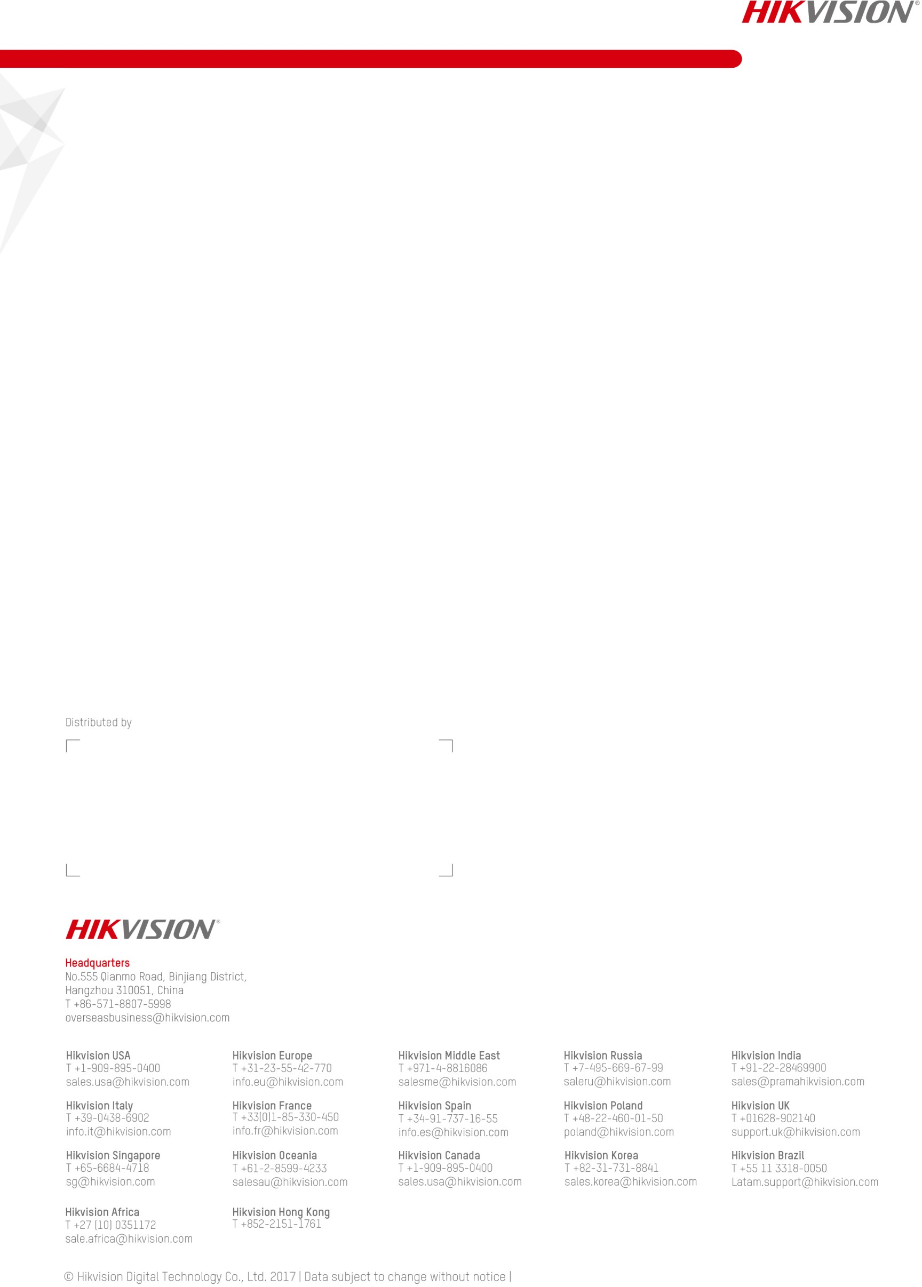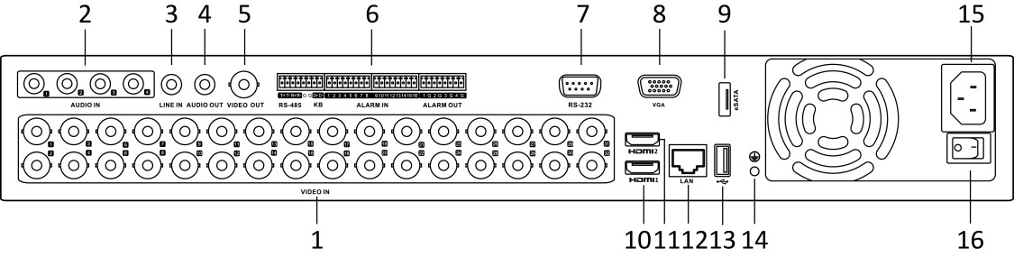

The rear panel of HAR524-24 provides 24 video input interfaces.

|  |  |  |  |
| --- | --- | --- | --- |
| **Index** | **Description** | **Index** | **Description** |
| **1** | VIDEO IN | **9** | eSATA Interface |
| **2** | AUDIO IN, RCA Connector | **10** | HDMI1 Interface |
| **3** | LINE IN | **11** | HDMI2 Interface |
| **4** | AUDIO OUT | **12** | LAN Network Interface |
| **5** | VIDEO OUT | **13** | USB Interface |
| **6** | RS-485 Serial Interface, Keyboard  Interface, ALARM IN and ALARM OUT | **14** | GND |
| **7** | RS-232 Serial Interface | **15** | 100 to 240 VAC Power Input |
| **8** | VGA Interface | **16** | Power Switch |

# Available Models

HAR524-24

HAR524-32

